Serviceberry
Combined Information Sheets

Serviceberry
Online Information Sheet: planteducationproject.com/serviceberry/
Mega Plant Information Sheet (PIS)
Amelanchier arborea (F.Michx.) Fernald · downy serviceberry
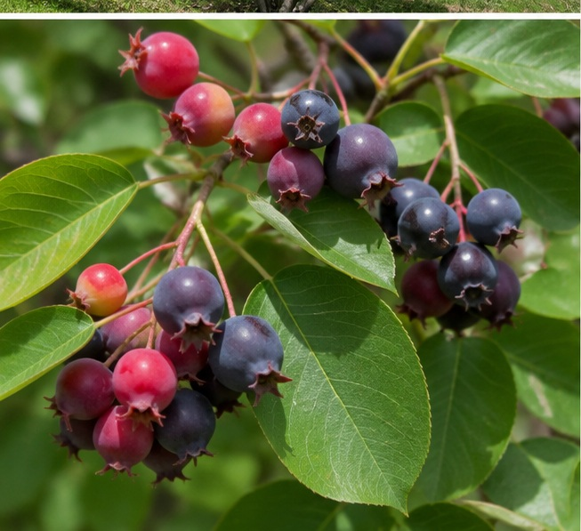
Foliage and ripening fruit. Educational image created for the Plant Education Project.
Plant type: Deciduous small tree or large shrub
Typical size: 15–25 ft tall and wide
Light: Full sun to part shade
Water: Medium; moist, well-drained soil
Edibility: Edible; use ripe, correctly identified fruit
Hardiness: USDA Zones 4–9
U.S. native: Yes
Native to Lafayette area: Yes; a regional native
Invasive: No
Self-seeding: Yes; usually modest

Why serviceberry matters
Downy serviceberry combines early flowers, edible summer fruit, fall color, wildlife food, and a compact woodland-edge form. Its best care follows its natural setting: good drainage, moderate moisture, organic soil, edge light, and room for a multi-stemmed shrub or small tree.

Identification
Look for alternate, finely toothed leaves; young foliage with characteristic hairs beneath; smooth gray young bark; and drooping clusters of five-petaled white flowers before full leaf-out. Small round pomes ripen from green through red to purplish black. Fall foliage commonly turns yellow-orange to red.

Planting and care

Site
Choose full sun to part shade and average to rich, moderately moist, well-drained soil. More sun generally improves flowering and fruiting when moisture is adequate. Allow about 15–25 feet for the natural crown.

Planting
Plant in fall or early spring. Dig broadly but no deeper than the root ball, keep the root flare at or slightly above grade, backfill mainly with native soil, water thoroughly, and apply 2–3 inches of mulch without touching trunks.

Water and feeding
During establishment, wet the root zone deeply, then let the upper soil begin to dry. Established plants tolerate ordinary rainfall variation, but prolonged drought can reduce vigor and fruit. Routine fertilizer is usually unnecessary; investigate drainage, compaction, light, root injury, and soil chemistry before feeding.

Pruning and form
Decide whether to keep a multi-stemmed shrub or train a small tree. Retain suckers for a natural thicket; remove them selectively for a defined trunk. Remove dead, damaged, crossing, or diseased wood, and avoid shearing away the plant’s natural branching pattern.

Flowers, fruit, and human use
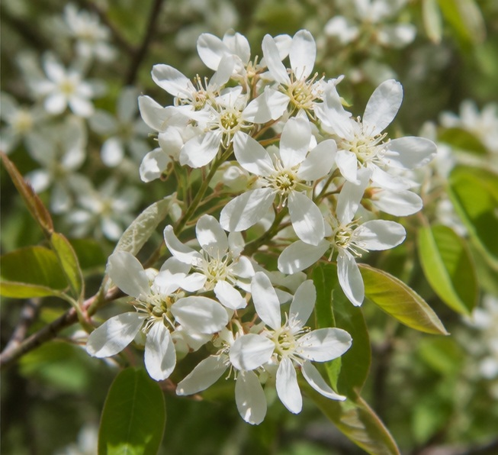
Five-petaled white flowers. Educational image created for the Plant Education Project.
Flowers appear in early spring, followed by fruit that ripens from red to purple-black in summer. Fully ripe, correctly identified, clean fruit can be eaten fresh or used in preserves and baked foods. Avoid fruit exposed to contaminants, and expect birds to harvest quickly.

Propagation
Seed preserves genetic diversity but is slow and requires moist conditioning to overcome dormancy. Softwood cuttings may root under controlled humidity, and well-rooted suckers may sometimes be separated. A locally appropriate nursery-grown plant is the most predictable choice for home landscapes.

Pests and diseases
Possible issues include rust, leaf spot, fire blight, powdery mildew, cankers, sawflies, leafminers, borers, scales, aphids, and spider mites. Identify the cause before treatment. Minor leaf feeding can be part of the plant’s ecological value rather than a threat to health.
Few flowers | Check shade, plant age, and pruning history.
Yellowing or weak growth | Check drainage, compaction, roots, soil pH, and nutrients before fertilizing.
Many basal shoots | Normal suckering; retain for shrub form or selectively remove.
Fruit disappears | Bird feeding; harvest promptly or accept wildlife use.

Environment and native habitat
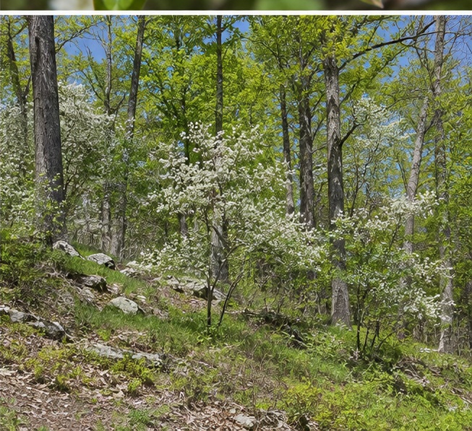
Sunny woodland-edge habitat. Educational image created for the Plant Education Project.
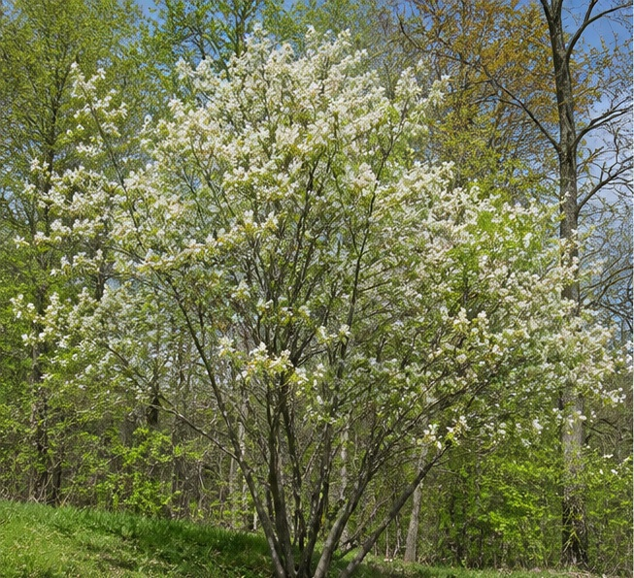
Natural multi-stemmed form in a woodland setting. Educational image created for the Plant Education Project.
See the connected sheets for the climate pattern, woodland-edge habitat, pollinators, birds, and the role of serviceberry in a layered native planting.

Sources
- Royal Botanic Gardens, Kew — Plants of the World Online: Amelanchier arborea
- NC State Extension Plant Toolbox — Downy Serviceberry
- Indiana Department of Natural Resources — Floristic Quality Assessment for Indiana

Related Information Sheets
- Anise Hyssop
- False Indigo
- Rabbit AIS
- Vole AIS
- Plant Health

Sharing and reuse
© 2026 James Taylor · Plant Education Project. The original human-authored text in this Information Sheet is licensed under Creative Commons Attribution–NonCommercial 4.0 International (CC BY-NC 4.0).
You may share and adapt this text for noncommercial purposes. Credit the author and Plant Education Project, link to the source and license, and identify any changes. These permissions cannot be withdrawn from users who comply with the license, including for copies already released.
Photographs, illustrations, logos, quotations, and other third-party material are excluded from this text license and retain their individual rights and permissions. Separately published articles and book manuscripts are not licensed by this notice.

Cold winters, early spring bloom
Online Information Sheet: planteducationproject.com/serviceberry/climate/
Climate Information Sheet (CIS)
Downy serviceberry is well matched to north-central Indiana. Winter hardiness is ample; soil condition and late-spring weather often matter more.
Early flowers appear near leaf-out. Educational image created for the Plant Education Project.

Climate profile
Hardiness | USDA Zones 4–9.
Season | Deciduous, with winter dormancy and early-spring flowering.
Summer | Moderate moisture supports foliage, fruit development, and fall color.
Weather risk | Very early flowers may be affected by an unusually late freeze.
Best exposure | Full sun to part shade; eastern or northern woodland-edge conditions echo its native pattern.

Lafayette translation
Plant in fall or early spring when practical. Water new trees through dry periods, but avoid chronically saturated ground. Mulch moderates summer heat and moisture loss; keep it away from stems. Established plants need no winter protection when appropriately sited.

Seasonal calendar
Late winter | Inspect structure and remove dead or damaged wood.
Early spring | Flowers support early insects; protect roots from compaction.
Summer | Watch fruit color and harvest before birds take the crop.
Dry summer | Deep-water the root zone when soil becomes dry.
Autumn | Planting season; replenish mulch without piling it on bark.

Sources
- NC State Extension Plant Toolbox — hardiness, flowering, and cultivation
- Missouri Botanical Garden — hardiness and landscape culture

Sharing and reuse
© 2026 James Taylor · Plant Education Project. The original human-authored text in this Information Sheet is licensed under Creative Commons Attribution–NonCommercial 4.0 International (CC BY-NC 4.0).
You may share and adapt this text for noncommercial purposes. Credit the author and Plant Education Project, link to the source and license, and identify any changes. These permissions cannot be withdrawn from users who comply with the license, including for copies already released.
Photographs, illustrations, logos, quotations, and other third-party material are excluded from this text license and retain their individual rights and permissions. Separately published articles and book manuscripts are not licensed by this notice.

Flowers for insects, fruit for birds
Online Information Sheet: planteducationproject.com/serviceberry/ecology/
Ecology Information Sheet
Serviceberry links the early-spring pollinator season to the summer fruit season and supports a wider woodland-edge food web.
Early flowers provide pollen and nectar. Educational image created for the Plant Education Project.
Summer fruit attracts birds and mammals. Educational image created for the Plant Education Project.

Ecological relationships
Flower visitors | Early blossoms provide pollen and nectar to bees and other flower-visiting insects.
Birds | Songbirds eat the summer fruit and may disperse seed.
Other wildlife | Mammals also use the fruit.
Food web | Leaf-feeding caterpillars and other insects can become food for breeding birds.
People | Correctly identified, ripe fruit is edible; human harvest shares the crop with wildlife.

Garden practice
Avoid treating every chewed leaf as damage requiring control. First identify the organism and decide whether plant health is actually threatened. Preserve flowers for pollinators, avoid unnecessary pesticide use, and accept some fruit loss as part of the tree’s ecological function.

A layered native planting
Place serviceberry between open lawn or meadow and taller woodland. Combine it with locally appropriate native shrubs and a ground layer of grasses, sedges, and perennials. The result offers more shelter, food, and seasonal continuity than an isolated ornamental tree.

Related topics
- Anise Hyssop
- False Indigo
- Rabbit AIS
- Vole AIS
- Plant Health

Sources
- NC State Extension Plant Toolbox — pollinators, birds, mammals, and edible fruit
- Royal Botanic Gardens, Kew — accepted taxonomy and native range

Sharing and reuse
© 2026 James Taylor · Plant Education Project. The original human-authored text in this Information Sheet is licensed under Creative Commons Attribution–NonCommercial 4.0 International (CC BY-NC 4.0).
You may share and adapt this text for noncommercial purposes. Credit the author and Plant Education Project, link to the source and license, and identify any changes. These permissions cannot be withdrawn from users who comply with the license, including for copies already released.
Photographs, illustrations, logos, quotations, and other third-party material are excluded from this text license and retain their individual rights and permissions. Separately published articles and book manuscripts are not licensed by this notice.

A tree of open woods and edges
Online Information Sheet: planteducationproject.com/serviceberry/environment/
Environmental Information Sheet (EIS)
Downy serviceberry occupies deciduous forest landscapes where broken light, organic soil, moisture, and drainage meet.
Woodland-edge placement recreates the plant’s characteristic environment. Educational image created for the Plant Education Project.

Native setting
The species is native to eastern North America and Indiana. It occurs in open rocky woods, wooded slopes, bluffs, woodland margins, and related sites. This explains why it handles full sun to part shade but is not a deep-shade specialist.

Environmental profile
Light | Edge light, open woods, full sun to part shade.
Soil | Average to rich soil; organic and slightly acidic conditions are especially suitable.
Moisture | Moderately moist, not continuously wet.
Drainage | Roots require oxygen; persistent saturation is a poor match.
Space | Allow 15–25 feet for a natural crown unless a selected form stays smaller.

Landscape placement
Use serviceberry as a specimen small tree, native garden focal point, wildlife-garden plant, shrub border, or transition between lawn or meadow and taller woodland. A layered planting can place canopy trees behind it and locally appropriate shrubs, grasses, sedges, and woodland perennials below.

Related topics
- Anise Hyssop
- False Indigo
- Rabbit AIS
- Vole AIS
- Plant Health

Sources
- Royal Botanic Gardens, Kew — native range and biome
- NC State Extension Plant Toolbox — habitat and growing conditions

Sharing and reuse
© 2026 James Taylor · Plant Education Project. The original human-authored text in this Information Sheet is licensed under Creative Commons Attribution–NonCommercial 4.0 International (CC BY-NC 4.0).
You may share and adapt this text for noncommercial purposes. Credit the author and Plant Education Project, link to the source and license, and identify any changes. These permissions cannot be withdrawn from users who comply with the license, including for copies already released.
Photographs, illustrations, logos, quotations, and other third-party material are excluded from this text license and retain their individual rights and permissions. Separately published articles and book manuscripts are not licensed by this notice.

Sharing and image credits
Original Information Sheet text is licensed under Creative Commons Attribution–NonCommercial 4.0 International (CC BY-NC 4.0). Credit James Taylor and the Plant Education Project, link to the source and license, and identify changes. Photographs and other third-party material retain the rights and permissions stated with each image.

