Rutabaga
Combined Information Sheets

Rutabaga
Online Information Sheet: planteducationproject.com/rutabaga/
🌿 Plant Information Sheet
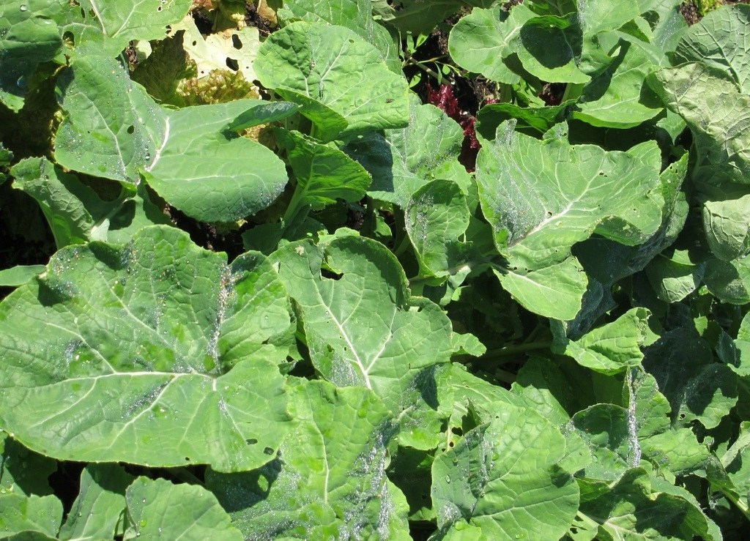
Rutabaga foliage in a cultivated bed. Photo: DewyKohl40, CC BY-SA 2.0. Source · License · Uncropped; sized for the page.
Photograph: DewyKohl40 · Original source · CC BY-SA 2.0. Resized proportionally.
Rutabaga is a cultivated cool-season crop grown mainly for its swollen edible root. It is a different crop from turnip (Brassica rapa), despite similar appearance and overlapping common names.
To understand the care of a plant, understand its native climate and environment.

At a glance
Field | Information
U.S. native | No; cultivated crop of Old World origin.
Tippecanoe County native | No; a planted vegetable crop.
Invasive status | Crop volunteers are possible; this sheet does not classify rutabaga as an Indiana invasive species.
Self-seeding | Limited; plants must survive to flower and mature seed.
Edibility | Roots and young leaves are edible when correctly identified and handled as food.
Cautions | Follow pesticide labels for edible crops and harvest intervals. Do not use lawn weed-and-feed products.

Light, season, and spacing
Use a sunny bed. Plan a summer sowing that matures in cool fall weather, using the cultivar’s days to maturity and local frost timing. Thin seedlings to about 8 inches apart; crowded roots remain small.

Soil and Standard container mix
Garden soil should be loose enough for root expansion and drain well. For a container crop harvested as baby vegetables, use Standard Herb and Vegetable Mix: 2 parts generic potting soil, 1 part compost-rich raised-bed or in-ground soil ingredient, and 1 part coarse perlite by volume. Blend loosely, use a drainage hole, and omit gravel at the bottom. Grow full-size roots in a garden bed; containers are best used for small, early-harvested roots.

Water and feeding
Maintain even moisture; roughly an inch of water per week is a starting point for garden soil, adjusted for rainfall and conditions. Test soil before fertilizer decisions. Excess nitrogen can favor leaves over roots; avoid fresh manure.
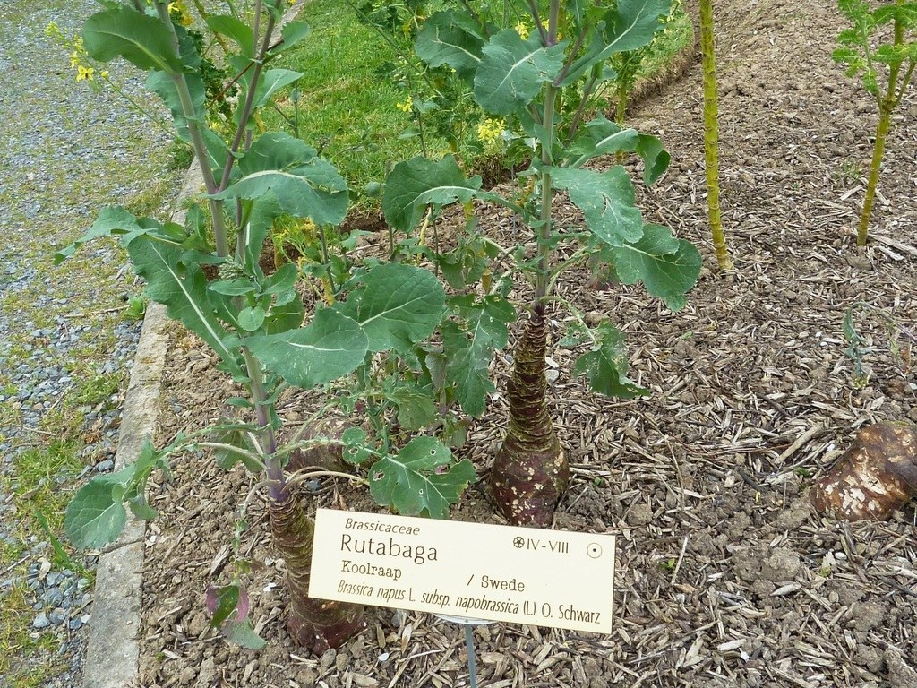
Rutabaga with elongated flowering stems in a labeled cultivated display. Yellow flowers are visible toward the tops of the stems. Photo: Pierre Andre Leclercq, CC BY-SA 4.0. Source · License · Uncropped; sized for the page.
Photograph: Pierre Andre Leclercq · Original source · CC BY-SA 4.0. Resized proportionally.

Flowering and propagation
Propagate the food crop by seed. Rutabaga normally grows vegetatively first and flowers after an appropriate cold period. Seed saving therefore differs from first-season root harvest and requires attention to compatible Brassica crops nearby.

Grooming and troubleshooting
Thin early and control weeds while small. Flea beetles, root maggots, and clubroot can reduce success. Rotate away from cabbage-family crops for several years, especially where disease occurred; diagnose before treatment.

Environment / crop origin
Rutabaga is a domesticated crop, so there is no single wild native habitat to reproduce. Cool-season growth, steady moisture, and a penetrable root zone are more useful care guides than treating it as a tropical houseplant.
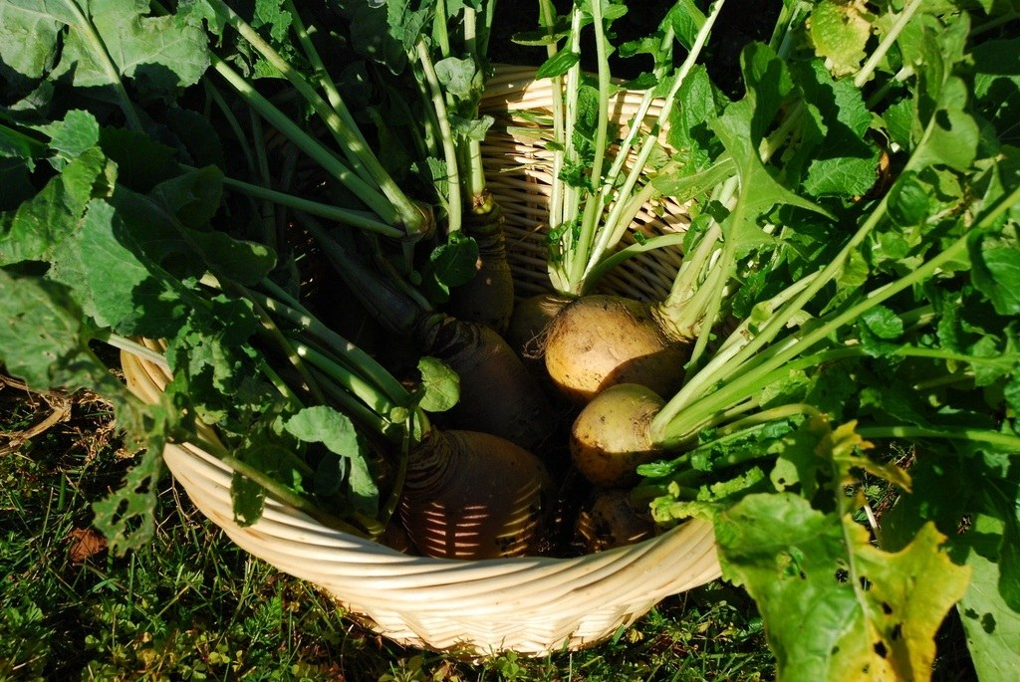
Harvested rutabaga roots with foliage. The swollen storage organ is not a botanical fruit. Photo: Johnathan Nightingale, CC BY-SA 2.0. Source · License · Uncropped; sized for the page.
Photograph: Johnathan Nightingale · Original source · CC BY-SA 2.0. Resized proportionally.

Harvest and seasonal care
Harvest when roots reach the cultivar’s usable size. Remove damaged roots from storage. For longer storage, use cool, humid conditions without freezing; keep clean food roots separate from seed stock and garden chemicals.

Sources and further reading
University of Minnesota Extension — Growing turnips and rutabagas
Royal Horticultural Society — How to grow swedes
NC State Extension — Rutabaga identification and photo credits
Added September 22, 2026 · All Information Sheets

Sharing and reuse
© 2026 James Taylor · Plant Education Project. The original human-authored text in this Information Sheet is licensed under Creative Commons Attribution–NonCommercial 4.0 International (CC BY-NC 4.0).
You may share and adapt this text for noncommercial purposes. Credit the author and Plant Education Project, link to the source and license, and identify any changes. These permissions cannot be withdrawn from users who comply with the license, including for copies already released.
Photographs, illustrations, logos, quotations, and other third-party material are excluded from this text license and retain their individual rights and permissions. Separately published articles and book manuscripts are not licensed by this notice.

Sharing and image credits
Original Information Sheet text is licensed under Creative Commons Attribution–NonCommercial 4.0 International (CC BY-NC 4.0). Credit James Taylor and the Plant Education Project, link to the source and license, and identify changes. Photographs and other third-party material retain the rights and permissions stated with each image.

