Mistletoe Cactus
Combined Information Sheets

Mistletoe Cactus
Online Information Sheet: planteducationproject.com/mistletoe-cactus/
Plant Information Sheet (PIS)
Rhipsalis baccifera (J.S.Muell.) Stearn
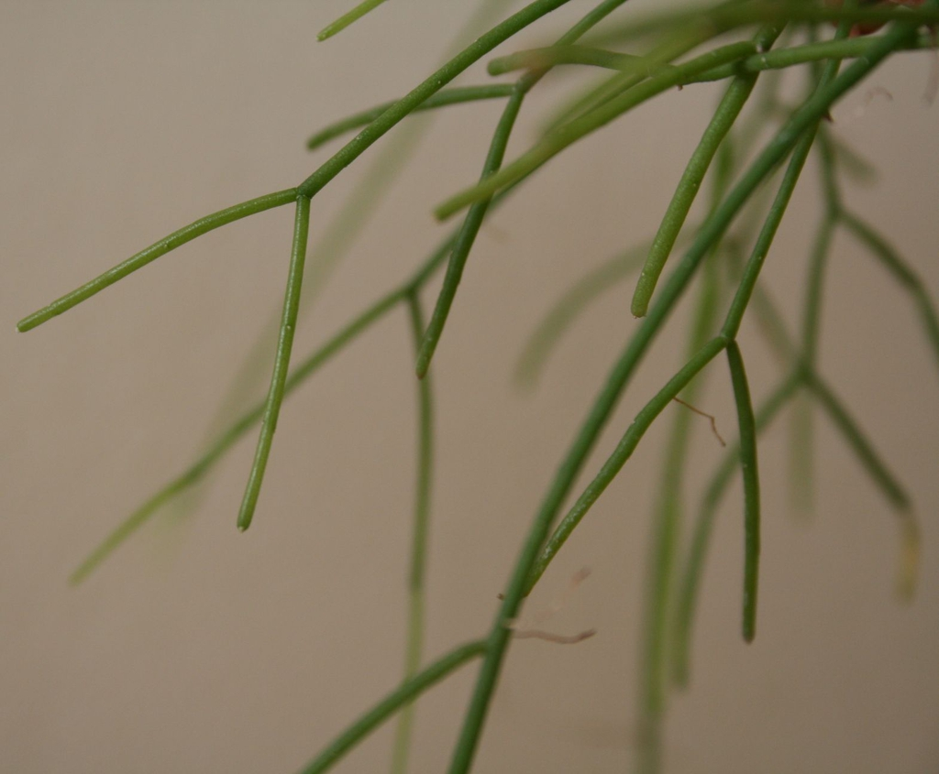
Slender, branching stems. Photo: Sadambio, via NC State Extension, CC BY-SA 2.5.
Plant type: Tropical epiphytic cactus
Light: Bright, indirect light
Water: Water when mix feels dry; reduce in winter
Temperature: About 60–80°F
Edibility: Not recommended
Native to United States: Yes—southern Florida; endangered there
Native to Lafayette area: No
Invasive: No; not persistent outdoors in Indiana
Self-seeding: Limited indoors

Identification
A leafless, usually spineless cactus with many slender, trailing, cylindrical green stems. Young stems may carry woolly bristles at the areoles; mature stems become smooth. Small white to greenish-white flowers appear along the stems, followed by round white or pale-pink berries.
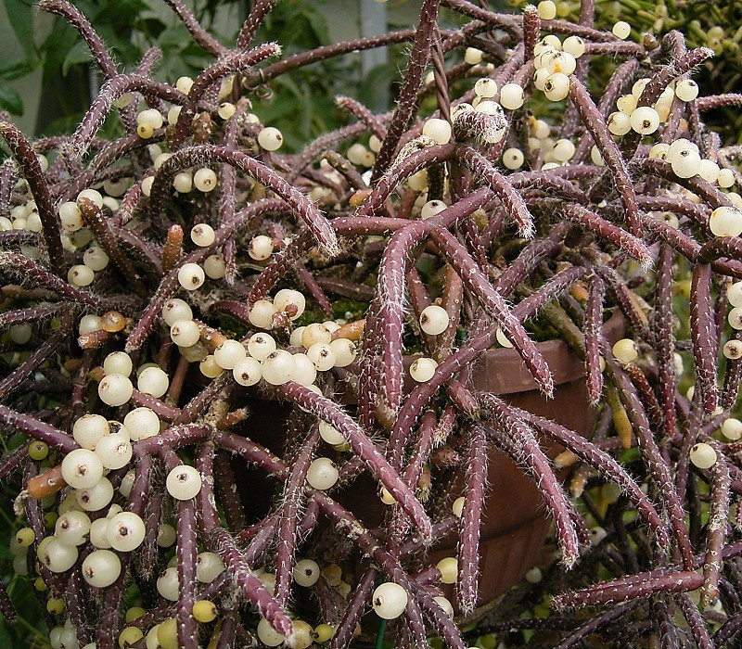
Heavy white fruit set. Photo: Frank Vincentz, CC BY-SA 3.0.
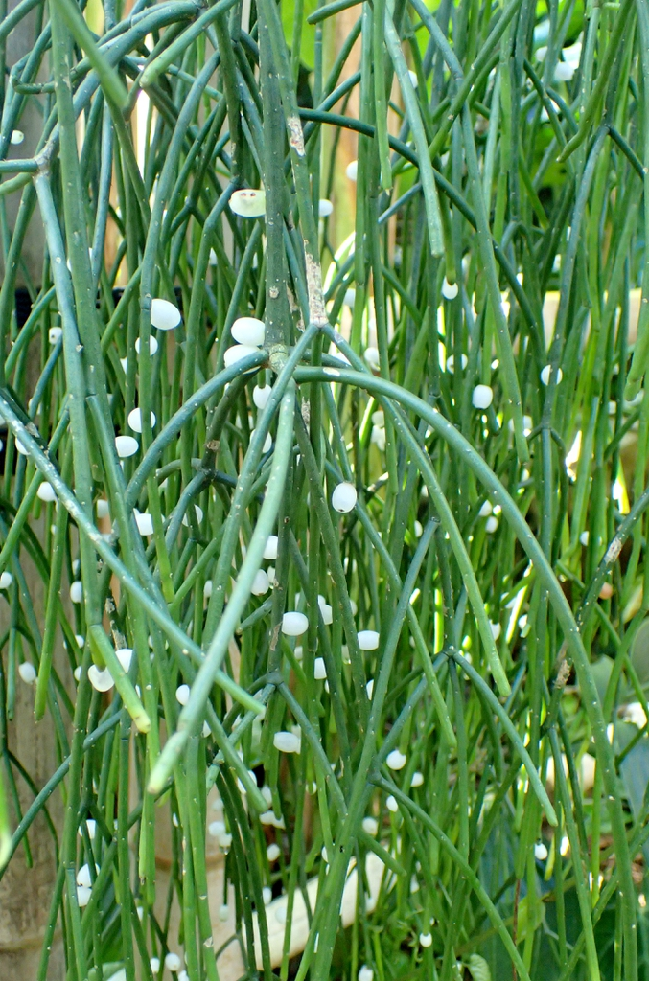
Trailing stems and fruit. Photo: James Steakley, CC BY-SA 3.0.
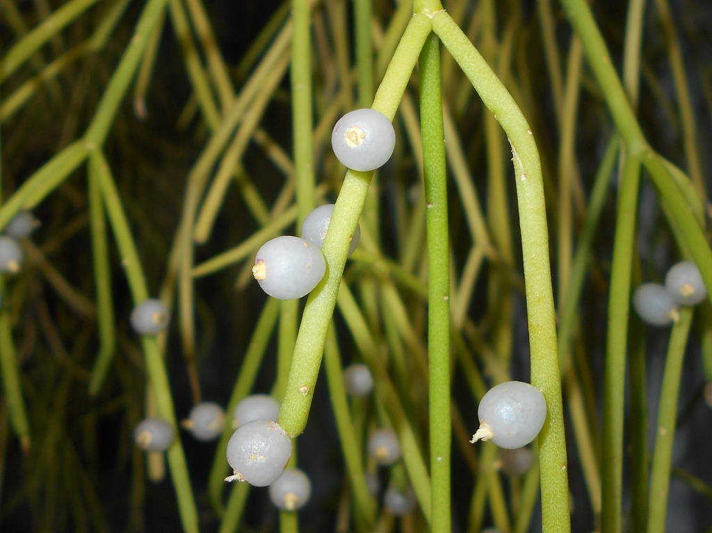
Round white berries. Photo: Krzysztof Ziarnek, Kenraiz, CC BY-SA 4.0.
Branching cylindrical stems. All photographs via NC State Extension.

Care

Light
Provide bright, indirect light. Strong direct sun can scorch the stems. A summer outdoors in sheltered partial shade may strengthen growth and encourage flowering; acclimate gradually and bring indoors before cool weather.

Water and humidity
This forest cactus prefers more even moisture and humidity than desert cacti. Water when the mix feels dry, drain completely, and reduce watering during slower winter growth. Puckered, limp stems suggest thirst; soft, mushy stems point toward excess water and root damage.

Temperature
Keep near 60–80°F, away from frost, cold glass, and drying heat vents. Good air movement matters when humidity is high.

Standard soil mix
Use a loose, slightly acidic, moisture-retentive but well-aerated mix in a container with an open drainage hole: two parts fine orchid bark, one part potting mix, and one part perlite or pumice. The goal is a forest-branch root environment—moisture plus oxygen, never stagnant wetness.

Flowering and fruit
Small solitary white to greenish-white flowers, about 0.4 inch wide, usually appear in late winter or spring. White or pale-pink berries may follow. Consistent bright filtered light, summer growth, and slightly drier winter care can support flowering.

Feeding
Feed lightly during active spring and summer growth with a diluted, balanced fertilizer. Do not feed a dry, stressed, or recently repotted plant, and stop during winter slowdown. The label is the law.

Propagation
Stem cuttings are the practical method. Take healthy segments, allow the cut end to dry briefly, and place in a lightly moist, airy mix under warm, humid conditions with indirect light. Seed is possible but slower.

Seed germination and light
Rhipsalis baccifera needs light for reliable germination. Sow on a moist surface without burying the seeds, and use filtered light rather than hot direct sun. A controlled study found at least 80% germination in light treatments but nearly none in darkness.
Germination source: De La Rosa Manzano and Briones, 2010, International Journal of Plant Sciences, 171, Germination Response of the Epiphytic Cactus Rhipsalis baccifera. Reviewed 2026-09-21.

Native environment and ecology
Mistletoe cactus grows as an epiphyte on understory trees in tropical and subtropical America, tropical Africa, Madagascar, and southern Florida. Its roots anchor in organic debris on bark rather than deep mineral soil. Filtered light, humidity, rainfall followed by drainage, and constant root-zone air explain its indoor needs. The berries are associated with animal dispersal.

Problems
Mushy stems | Overwatering or airless mix; inspect roots and improve drainage.
Brown tips | Low humidity or insufficient water.
Pale or scorched areas | Excess direct sunlight.
Sticky or distorted growth | Check closely for mealybugs, aphids, or spider mites.
Spots in humid conditions | Improve air movement and identify possible fungal disease before treatment.

Source
- NC State Extension Gardener Plant Toolbox — Rhipsalis baccifera

Related Information Sheets
- Lemon Barrel Cactus
- Spiny Pincushion Cactus
- Watering Plants
- Standard Potting Mixes
- Pot Sizing

Sharing and reuse
© 2026 James Taylor · Plant Education Project. The original human-authored text in this Information Sheet is licensed under Creative Commons Attribution–NonCommercial 4.0 International (CC BY-NC 4.0).
You may share and adapt this text for noncommercial purposes. Credit the author and Plant Education Project, link to the source and license, and identify any changes. These permissions cannot be withdrawn from users who comply with the license, including for copies already released.
Photographs, illustrations, logos, quotations, and other third-party material are excluded from this text license and retain their individual rights and permissions. Separately published articles and book manuscripts are not licensed by this notice.

Climate lessons for Mistletoe Cactus
Online Information Sheet: planteducationproject.com/mistletoe-cactus/climate/
Climate Information Sheet (CIS)
Climate sets the limits for water use, seasonal growth, and outdoor survival.

Lafayette translation
Warm frost-free conditions and periodic rain suit growth. Unlike desert cacti, it should not remain bone-dry for long, but weak winter light still reduces water demand.

Care principle
Reproduce the function of the native setting rather than copying a watering calendar. Check light, temperature, root-zone air, drainage, and the plant’s current growth before acting.

Source
- Royal Botanic Gardens, Kew — Plants of the World Online: Rhipsalis baccifera

Sharing and reuse
© 2026 James Taylor · Plant Education Project. The original human-authored text in this Information Sheet is licensed under Creative Commons Attribution–NonCommercial 4.0 International (CC BY-NC 4.0).
You may share and adapt this text for noncommercial purposes. Credit the author and Plant Education Project, link to the source and license, and identify any changes. These permissions cannot be withdrawn from users who comply with the license, including for copies already released.
Photographs, illustrations, logos, quotations, and other third-party material are excluded from this text license and retain their individual rights and permissions. Separately published articles and book manuscripts are not licensed by this notice.

How Mistletoe Cactus works in its habitat
Online Information Sheet: planteducationproject.com/mistletoe-cactus/ecology/
Ecology Information Sheet
Its form and life cycle reflect relationships with water, light, substrate, and animals.

Ecological relationships
Jointed hanging stems spread through tree canopies. Small flowers form berry-like fruits whose seeds can be moved by animals; the plant depends on host trees for support, not food.

Care principle
Reproduce the function of the native setting rather than copying a watering calendar. Check light, temperature, root-zone air, drainage, and the plant’s current growth before acting.

Source
- Royal Botanic Gardens, Kew — Plants of the World Online: Rhipsalis baccifera

Sharing and reuse
© 2026 James Taylor · Plant Education Project. The original human-authored text in this Information Sheet is licensed under Creative Commons Attribution–NonCommercial 4.0 International (CC BY-NC 4.0).
You may share and adapt this text for noncommercial purposes. Credit the author and Plant Education Project, link to the source and license, and identify any changes. These permissions cannot be withdrawn from users who comply with the license, including for copies already released.
Photographs, illustrations, logos, quotations, and other third-party material are excluded from this text license and retain their individual rights and permissions. Separately published articles and book manuscripts are not licensed by this notice.

Native environment of Mistletoe Cactus
Online Information Sheet: planteducationproject.com/mistletoe-cactus/environment/
Environmental Information Sheet (EIS)
Rhipsalis baccifera comes from tropical and subtropical regions of the Americas, Africa, Madagascar, and nearby islands and grows primarily in humid forest as a tree-dwelling epiphyte.

What this means in cultivation
Roots occupy airy organic debris on branches rather than deep ground. Filtered light, humidity, and a loose mix fit that canopy niche.

Care principle
Reproduce the function of the native setting rather than copying a watering calendar. Check light, temperature, root-zone air, drainage, and the plant’s current growth before acting.

Source
- Royal Botanic Gardens, Kew — Plants of the World Online: Rhipsalis baccifera

Sharing and reuse
© 2026 James Taylor · Plant Education Project. The original human-authored text in this Information Sheet is licensed under Creative Commons Attribution–NonCommercial 4.0 International (CC BY-NC 4.0).
You may share and adapt this text for noncommercial purposes. Credit the author and Plant Education Project, link to the source and license, and identify any changes. These permissions cannot be withdrawn from users who comply with the license, including for copies already released.
Photographs, illustrations, logos, quotations, and other third-party material are excluded from this text license and retain their individual rights and permissions. Separately published articles and book manuscripts are not licensed by this notice.

Sharing and image credits
Original Information Sheet text is licensed under Creative Commons Attribution–NonCommercial 4.0 International (CC BY-NC 4.0). Credit James Taylor and the Plant Education Project, link to the source and license, and identify changes. Photographs and other third-party material retain the rights and permissions stated with each image.

