Puffballs
Combined Information Sheets

Puffballs
Online Information Sheet: planteducationproject.com/learn/puffballs/
🌿 Information Sheet
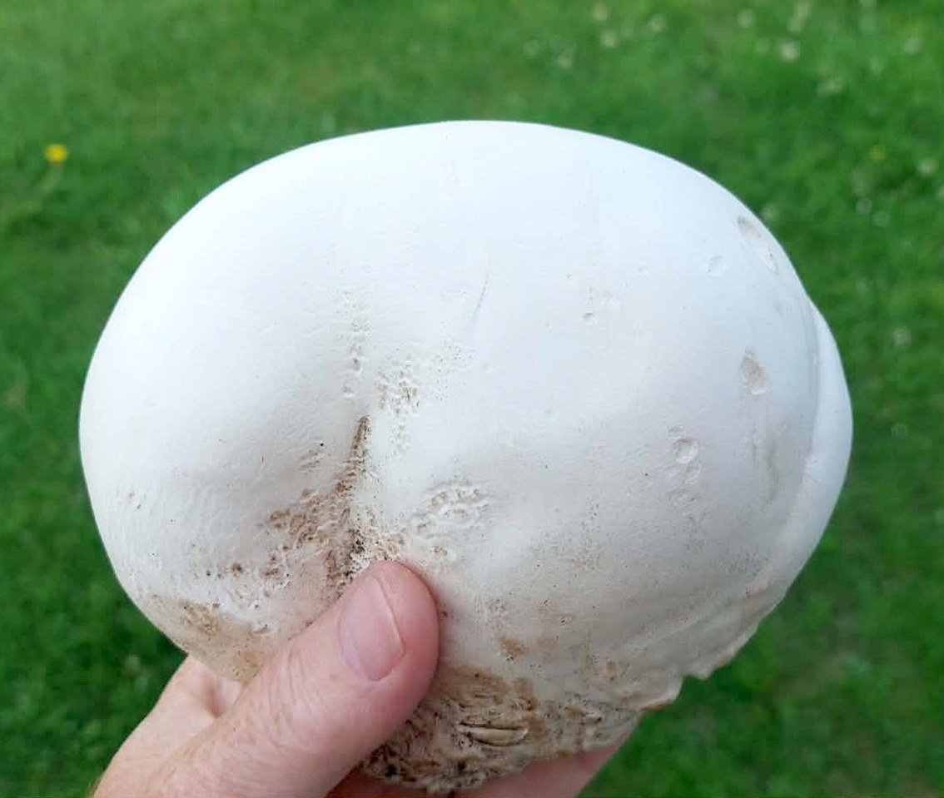
Giant puffball, Calvatia gigantea, photographed in the Chatham Islands, New Zealand, 2026-01-28. An exterior photograph cannot establish food safety. Photo: Peter de Lange. Source · License · Uncropped; sized for the page.
Photograph: Giant puffball, Calvatia gigantea, · Original source · Creative Commons license. Resized proportionally.
Puffballs are fungi whose spores develop inside a rounded fruiting body and are released as the body matures. The name covers several taxa, not one species. This sheet explains their biology and identification limits; it is not sufficient by itself to approve a wild mushroom for eating.

The ball is a reproductive structure
The larger organism is a network of hyphae in its substrate. After suitable conditions, it forms a fruiting body containing spore-producing tissue called the gleba. A young gleba can be firm and pale; with maturity it becomes a powdery mass of spores.
Different species release spores through an opening or through breakdown of the outer wall. Rain impact, wind, and disturbance assist dispersal. Avoid deliberately inhaling spore clouds or using mature puffballs as toys.

Several groups can look similar
Group or example | Useful feature | Limit
Giant puffball, Calvatia gigantea | Can become much larger than a typical mushroom; young interior is uniformly white. | Size and color alone do not confirm identity.
Smaller puffballs | Some have surface spines, ornamentation, or a distinct sterile base. | Species identification may require mature features and microscopy.
Earthballs, Scleroderma species | Often have a tough outer wall and a darker interior as they develop. | They are not edible substitutes for puffballs.
Immature gilled mushrooms | Some begin inside an enclosing veil. | A lengthwise section may reveal a developing cap, gills, or stem; deadly Amanita can be involved.

A safety screen is not a complete identification
Cutting a specimen from top to bottom is an important examination step: developing gills, cap, or stem rule out a true puffball. A uniformly white interior is still not sufficient to establish species, safe condition, or suitability to eat. Young look-alikes and specimen variation require expert judgment.
Do not taste an unidentified specimen. Do not use a photograph, phone application, or this sheet as the sole identification method. Keep children and pets from eating unknown fungi. If ingestion occurs and poisoning is possible, contact Poison Control at 1-800-222-1222; call emergency services for severe symptoms.

Ecological role depends on the actual fungus
Many true puffballs decompose organic matter and return nutrients to the soil. They can occur in lawns, pastures, woodland edges, or decaying wood, depending on species. The presence of a fruiting body does not by itself show that a tree is diseased.
Record substrate, attachment, surface texture, internal structure, size, and whether fruiting bodies occur singly or in groups. Photograph before disturbing. A spore print or microscopic examination may be useful, but it does not make a novice identification automatically reliable.

Food use requires a separate confident identification
Some puffball species are edible when correctly identified, young, and in suitable condition. Other similar fungi are toxic or unsuitable. Contamination, deterioration, and individual reactions are additional concerns. Have the actual collection checked by a qualified local identifier before considering food use.

Sources and further reading
Missouri Department of Conservation Giant Puffball
North American Mycological Association mushroom poisoning resources
Additional photograph reference (not the image above): Hans Hillewaert, Giant puffball, CC BY-SA 4.0
Added September 22, 2026 · All Information Sheets

Sharing and reuse
© 2026 James Taylor · Plant Education Project. The original human-authored text in this Information Sheet is licensed under Creative Commons Attribution–NonCommercial 4.0 International (CC BY-NC 4.0).
You may share and adapt this text for noncommercial purposes. Credit the author and Plant Education Project, link to the source and license, and identify any changes. These permissions cannot be withdrawn from users who comply with the license, including for copies already released.
Photographs, illustrations, logos, quotations, and other third-party material are excluded from this text license and retain their individual rights and permissions. Separately published articles and book manuscripts are not licensed by this notice.

Sharing and image credits
Original Information Sheet text is licensed under Creative Commons Attribution–NonCommercial 4.0 International (CC BY-NC 4.0). Credit James Taylor and the Plant Education Project, link to the source and license, and identify changes. Photographs and other third-party material retain the rights and permissions stated with each image.

