Fiddle-leaf Fig
Combined Information Sheets

Fiddle-leaf Fig
Online Information Sheet: planteducationproject.com/fiddle-leaf-fig/
🌿 Plant Information Sheet
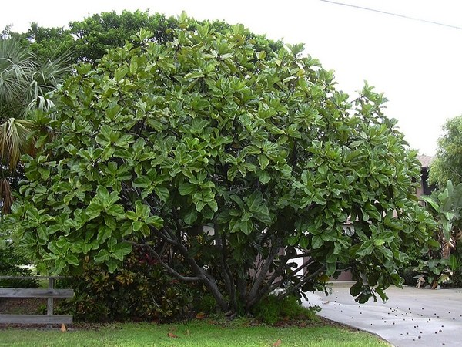
Fiddle-leaf fig growing outdoors in a developed setting; not a verified native-habitat view. Photo: Forest and Kim Starr; CC BY 2.0; source. Unmodified.
Photograph: Forest and Kim Starr · Original source · CC BY 2.0. Resized proportionally.
A tropical tree recognized by its large, leathery, violin-shaped leaves. Container plants remain much smaller than mature trees in their native range.
To understand the care of a plant, understand its native climate and environment.

At a glance
Field | Information
U.S. native | No; native to tropical western and central Africa.
Tippecanoe County native | No; an indoor ornamental in Indiana.
Invasive status | Local invasive status not established by this sheet; frost prevents normal outdoor overwintering.
Self-seeding | Limited; normal indoor plants do not set viable seed.
Edibility | Not a food fig; do not eat its leaves or fruit.
Cautions | Milky sap can irritate skin and eyes. Harmful if chewed by pets; wash hands after pruning.

Light and water
Provide bright indirect light. Water after the upper mix dries, thoroughly wet the root ball, and empty drainage water. Keep away from cold drafts and temperatures below about 55°F (13°C).

Standard potting mix
Use Standard Tropical Foliage Mix: 1 part generic potting soil plus 1 part coarse perlite by volume. No bark or coir is added in this approved version. Moisten dusty ingredients lightly and blend without compression. Use a drainage hole and no gravel layer. Choose a container only modestly larger than the root ball; a large wet volume is harder to manage indoors.

Feeding and grooming
Feed during active growth at the product’s labeled houseplant rate. Pause when growth slows. Wipe dusty leaves with a damp cloth. Use clean tools for pruning and prevent sap contact.
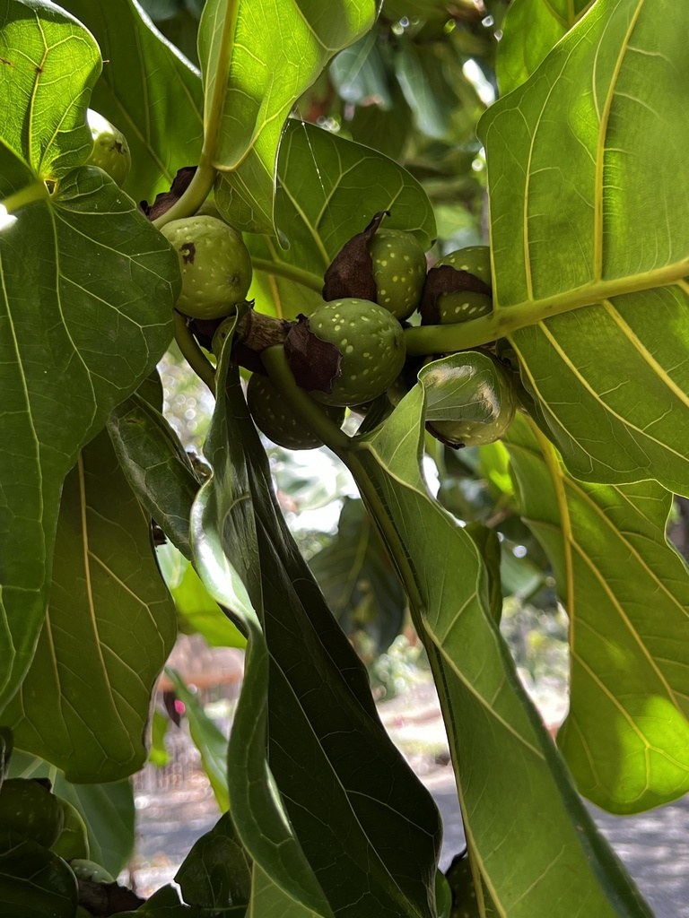
Ficus lyrata syconia in Hawaiʻi, 2024-06-10. Each fig encloses many tiny flowers; this exterior view shows the structure, not the flowers inside. Hawaiʻi is outside the species’ African native range.
Photograph: Djibo Zanzot · Original source · CC BY-SA. Resized proportionally.

Flowering
Fig flowers are enclosed inside a specialized structure called a syconium. Ordinary indoor plants are grown for foliage, not blooms or fruit; successful seed production depends on the appropriate pollinator.

Propagation
Propagate with healthy stem cuttings. Use clean tools, an airy rooting medium, and gloves to avoid contact with the milky sap.

Environment / native habitat
Its African tropical-forest origin provides a warmer, brighter, more humid setting than many interiors. Translate that into stable warmth, adequate light, and an oxygenated root zone; constant saturation is not a substitute for humidity.

Troubleshooting and seasonal care
Brown spots have several possible causes. Check roots, watering, light, and pest signs before treating. Acclimate gradually if moving outdoors for summer and return inside before cold nights. Avoid repeated relocations during recovery.

Sources and further reading
NC State Extension Plant Toolbox — Ficus lyrata
Added September 22, 2026 · All Information Sheets

Sharing and reuse
© 2026 James Taylor · Plant Education Project. The original human-authored text in this Information Sheet is licensed under Creative Commons Attribution–NonCommercial 4.0 International (CC BY-NC 4.0).
You may share and adapt this text for noncommercial purposes. Credit the author and Plant Education Project, link to the source and license, and identify any changes. These permissions cannot be withdrawn from users who comply with the license, including for copies already released.
Photographs, illustrations, logos, quotations, and other third-party material are excluded from this text license and retain their individual rights and permissions. Separately published articles and book manuscripts are not licensed by this notice.

Sharing and image credits
Original Information Sheet text is licensed under Creative Commons Attribution–NonCommercial 4.0 International (CC BY-NC 4.0). Credit James Taylor and the Plant Education Project, link to the source and license, and identify changes. Photographs and other third-party material retain the rights and permissions stated with each image.

