Cattleya Orchid
Combined Information Sheets

Cattleya Orchid
Online Information Sheet: planteducationproject.com/cattleya-orchid/
🌿 Plant Information Sheet
Cattleya spp. and hybrids
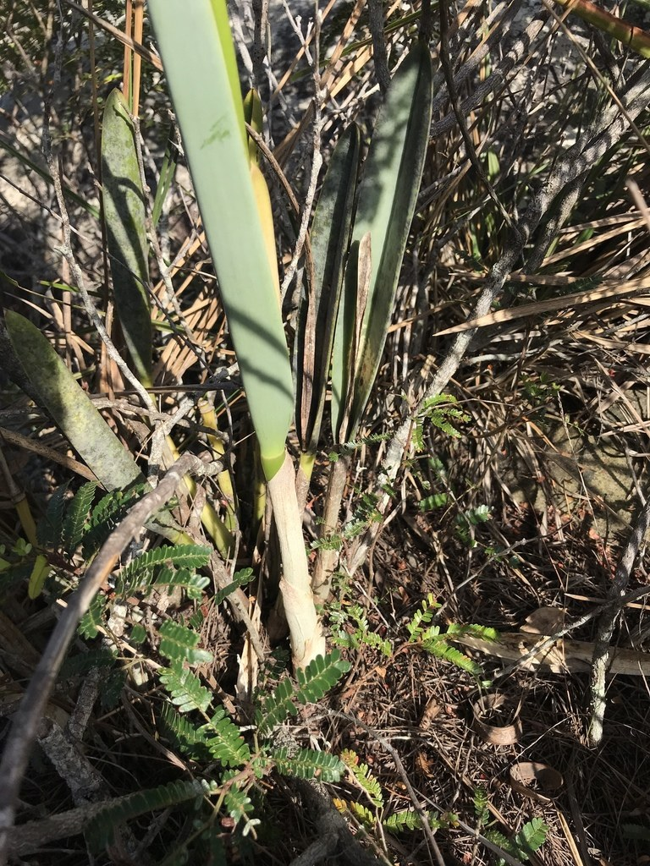
Vegetative growth of Cattleya rupestris, Botumirim, Minas Gerais, Brazil, 2019-06-04. No open flowers are visible in this view; a separate photograph in the same observation shows flowers.
Photograph: william_hoyer · Original source · CC BY. Resized proportionally.

“To understand the care of a plant, understand its native climate and environment.”

Key Point
Cattleya roots need ample air. Select an orchid-appropriate medium instead of assuming the general foliage recipe will be suitable.

At-a-Glance Growing Specifications
CARE FACTOR | PRACTICAL GUIDANCE
Botanical name | Cattleya spp. and hybrids
Family | Orchidaceae
Light | Very bright filtered light; gentle direct morning sun. Medium green leaves are a useful target.
Water | Drench roots, drain completely, then allow the medium to approach dryness before watering again.
Temperature | 65–85°F days, 55–65°F nights; avoid cold wet roots.
Feeding | ¼-strength orchid fertilizer weekly or ½-strength every two weeks during growth; flush monthly.
Potting mix | Stock Tropical Foliage Standard Mix: 1 part generic potting soil + 1 part coarse perlite, by volume. This recipe is recorded for inventory completeness; it is not an established epiphytic-orchid medium. A species-appropriate coarse, well-aerated orchid medium is preferable. No suitable orchid-specific Standard mix has been validated from the present stock list.
Toxicity | Generally considered non-toxic to cats and dogs.

Native status, spread and safety
Field | Status
Native to Tippecanoe County, Indiana | No. Native species are tropical American plants outside Indiana.
Native to the United States | No for Cattleya in the scope of this sheet.
Invasive status | No Indiana invasive determination was established; manage as a container ornamental.
Self-seeding | No in ordinary home conditions; seed propagation requires specialist methods.
Edibility and cautions | Not a food plant. Non-toxic ornamental status is not proof of human edibility.

Care
- Very bright filtered light; gentle direct morning sun. Medium green leaves are a useful target.
- Drench roots, drain completely, then allow the medium to approach dryness before watering again.
- Use a container with an unobstructed drainage hole. Do not add a gravel layer under the mix. Increase only one pot size when repotting.
- Rotate the pot periodically for even growth, inspect leaf axils and roots, and quarantine new plants before adding them to a collection.

Standard Potting Mix
Stock Tropical Foliage Standard Mix: 1 part generic potting soil + 1 part coarse perlite, by volume. This recipe is recorded for inventory completeness; it is not an established epiphytic-orchid medium. A species-appropriate coarse, well-aerated orchid medium is preferable. No suitable orchid-specific Standard mix has been validated from the present stock list.
Mix by volume using the same scoop. Premoisten dusty ingredients and keep the blend loose.
ORCHID CAUTION: Fine soil can suffocate orchid roots even in a slotted pot. Do not interpret a smaller pot or less frequent watering as proof that an unsuitable medium is safe.

Feeding
¼-strength orchid fertilizer weekly or ½-strength every two weeks during growth; flush monthly. Feed only moist, healthy roots. Reduce or stop fertilizer when growth pauses, and occasionally flush the pot with plain water to limit soluble salts.

Flowering
Large fragrant flowers usually arise from a sheath on mature pseudobulbs; timing varies by parentage.
- Provide the correct light and seasonal rhythm; fertilizer cannot compensate for inadequate light.
- Remove spent flowering structures with clean tools unless seed or wildlife value is desired.

Propagation and Self-Seeding
Divide only a well-established plant, retaining at least 3–4 pseudobulbs per division.
Self-seeding: No in ordinary home conditions; seed propagation requires specialist methods.
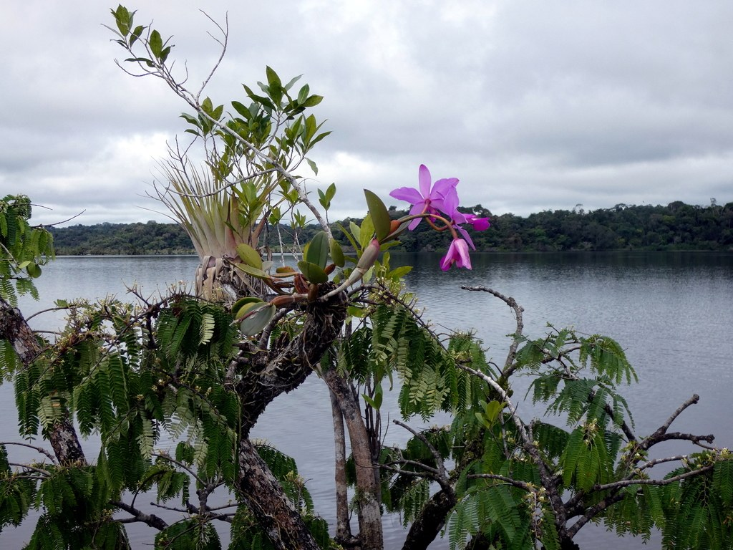
Cattleya violacea growing on a riverside tree in Putumayo, Ecuador, 2019-07-16. Recorded as wild; exposed roots receive air and rapid drainage.
Photograph: Kai Squires · Original source · CC BY. Resized proportionally.
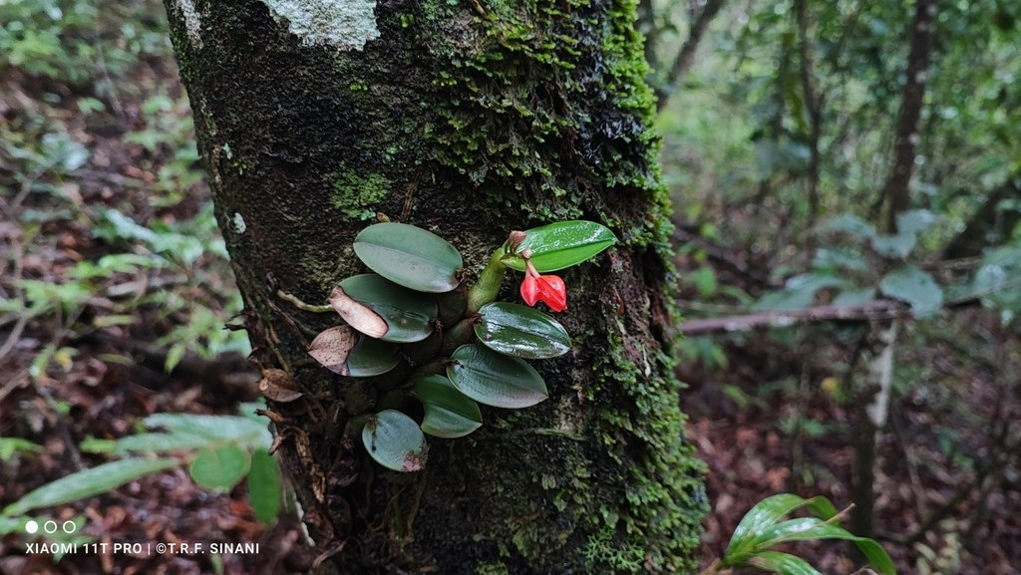
Cattleya cernua attached to a forest tree at Corumbá, Mato Grosso do Sul, Brazil, 2024-04-12. Recorded as wild; a second native-region setting.
Photograph: Thomaz Ricardo Favreto Sinani · Original source · CC BY. Resized proportionally.

Environment / Native Habitat
Tropical Americas; typically epiphytic on branches where roots receive heavy rain, rapid drainage, air, and seasonal drying.
Cultivation translation: reproduce the habitat’s drainage, air movement, light pattern, and seasonal change rather than copying only its average temperature.

Troubleshooting
Dark leaves and no blooms mean insufficient light. Accordion growth suggests irregular water. Black roots or foul medium indicate rot.
CARE FACTOR | PRACTICAL GUIDANCE
Plant declines after watering | Inspect roots and crown; remove rot, improve aeration, and extend the dry interval.
Pests | Isolate first. Check for mealybugs, scale, mites, aphids, or fungus gnats; begin with physical removal and the least-toxic labeled control.
Weak or distorted growth | Recheck light, root health, temperature, and fertilizer before adding more water or feed.

Quick Reference
CARE FACTOR | PRACTICAL GUIDANCE
Light | Very bright filtered light; gentle direct morning sun. Medium green leaves are a useful target.
Water | Drench roots, drain completely, then allow the medium to approach dryness before watering again.
Temperature | 65–85°F days, 55–65°F nights; avoid cold wet roots.
Standard mix | Stock Tropical Foliage Standard Mix: 1 part generic potting soil + 1 part coarse perlite, by volume. This recipe is recorded for inventory completeness; it is not an established epiphytic-orchid medium. A species-appropriate coarse, well-aerated orchid medium is preferable. No suitable orchid-specific Standard mix has been validated from the present stock list.
Propagation | Divide only a well-established plant, retaining at least 3–4 pseudobulbs per division.
Self-seeding | No in ordinary home conditions; seed propagation requires specialist methods.

Reliable References
NC State Extension — cattleya
- Internal standard: Minimal Standard Potting Mixes and Stock Inventory Information Sheet (2026).
Educational reference. Species, cultivar, climate, container, and household conditions may require adjustment.
Added September 22, 2026 · All Information Sheets

Sharing and reuse
© 2026 James Taylor · Plant Education Project. The original human-authored text in this Information Sheet is licensed under Creative Commons Attribution–NonCommercial 4.0 International (CC BY-NC 4.0).
You may share and adapt this text for noncommercial purposes. Credit the author and Plant Education Project, link to the source and license, and identify any changes. These permissions cannot be withdrawn from users who comply with the license, including for copies already released.
Photographs, illustrations, logos, quotations, and other third-party material are excluded from this text license and retain their individual rights and permissions. Separately published articles and book manuscripts are not licensed by this notice.

Sharing and image credits
Original Information Sheet text is licensed under Creative Commons Attribution–NonCommercial 4.0 International (CC BY-NC 4.0). Credit James Taylor and the Plant Education Project, link to the source and license, and identify changes. Photographs and other third-party material retain the rights and permissions stated with each image.

