Ruby-throated Hummingbird
Combined Information Sheets

Ruby-throated Hummingbird
Online Information Sheet: planteducationproject.com/animals/ruby-throated-hummingbird/
🌿 Animal Information Sheet
Archilochus colubris
Indiana’s regular breeding hummingbird is a native seasonal visitor to Lafayette. Identify it by plumage and shape, then support it with flowers, insects and safe feeding places. [IN, ID]
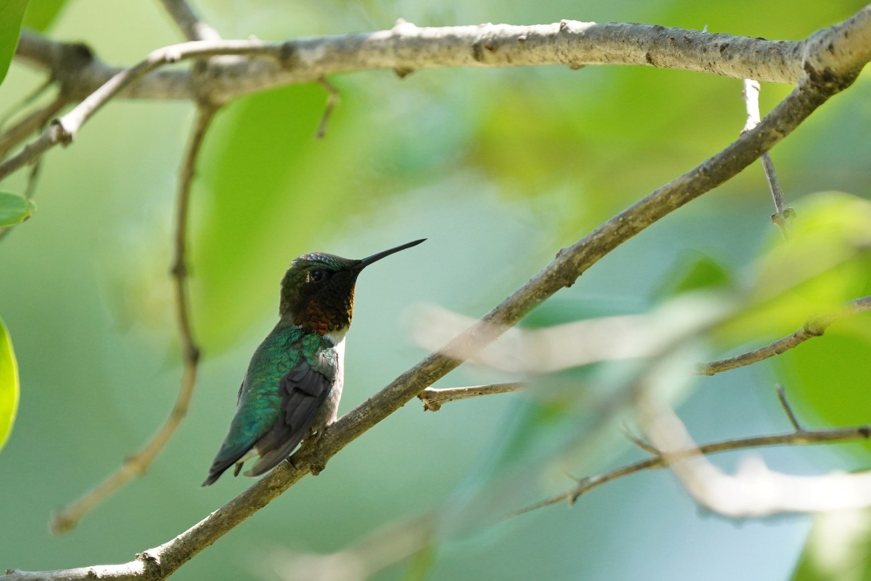
Adult male on a branch. The throat can look dark when the light is unfavorable. Courtney Celley/USFWS. Public domain.
Photograph: Courtney Celley/USFWS · Original source · Public domain. Resized proportionally.

At a Glance
Feature | Details
Native status | Native to the United States and Indiana; breeds statewide. [IN]
Lafayette season | Spring through early fall; occasional late migrants. Not a regular winter resident. [IN, Aud]
Size | Length 7–9 cm (2.8–3.5 in); mass 2–6 g; wingspan 8–11 cm. [ID]
Food | Flower nectar plus small insects and spiders. [Life]
Human use | Wildlife for observation; not a pet or food animal. Non-invasive in Indiana.

Identification
Both sexes have green upperparts and a long, narrow bill. An adult male has an iridescent ruby throat, which may look black in shade. Females have a pale throat and white tips on the outer tail feathers. Young males can resemble females and may show only scattered red throat feathers. [ID]
A hummingbird moth has antennae and six legs; the bird has a feathered body, bill and two feet. An unfamiliar hummingbird late in fall deserves careful photographs and identification rather than an assumption based only on location.
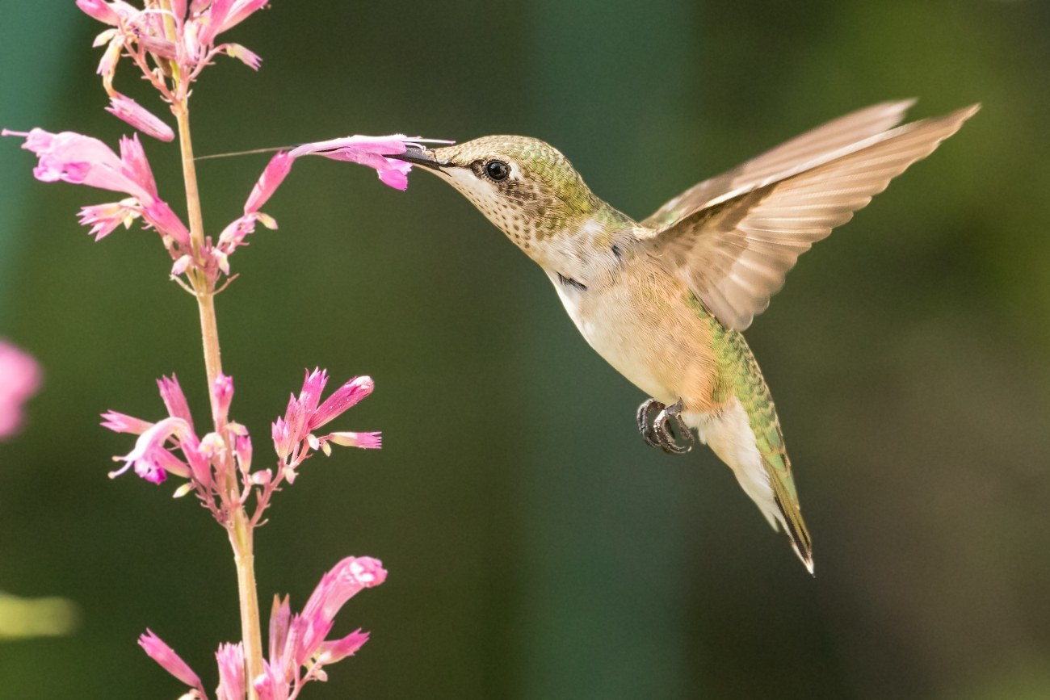
Female Ruby-throated Hummingbird feeding at a flower. Mike Carlo/USFWS. Public domain.
Photograph: Mike Carlo/USFWS · Original source · Public domain. Resized proportionally.

Reproduction
The female builds the nest, incubates the eggs and feeds the young. Usually two white eggs hatch after about 12–14 days; nestlings leave roughly 18–22 days after hatching. A nest is a small cup of plant down and spider silk, often decorated with lichens. [Life, Aud]
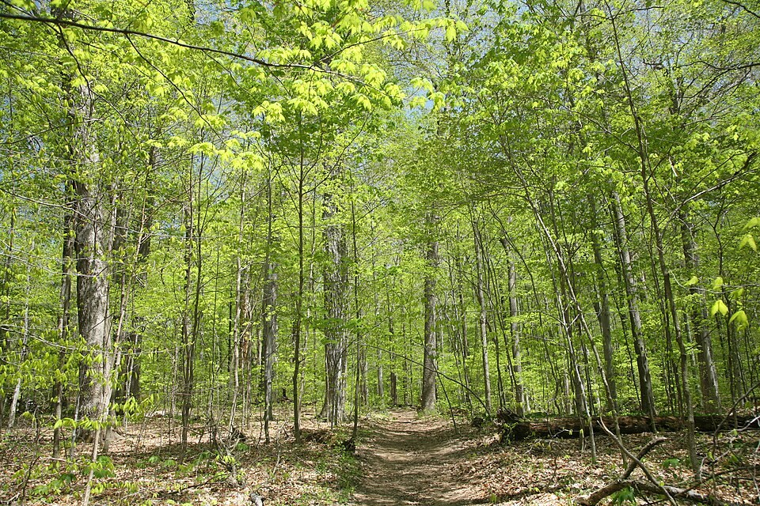
Deciduous woodland at Turkey Run State Park in Indiana. Habitat example; no hummingbird is shown. Daniel Schwen. CC BY-SA 4.0.
Photograph: Daniel Schwen · Original source · CC BY-SA 4.0. Resized proportionally.
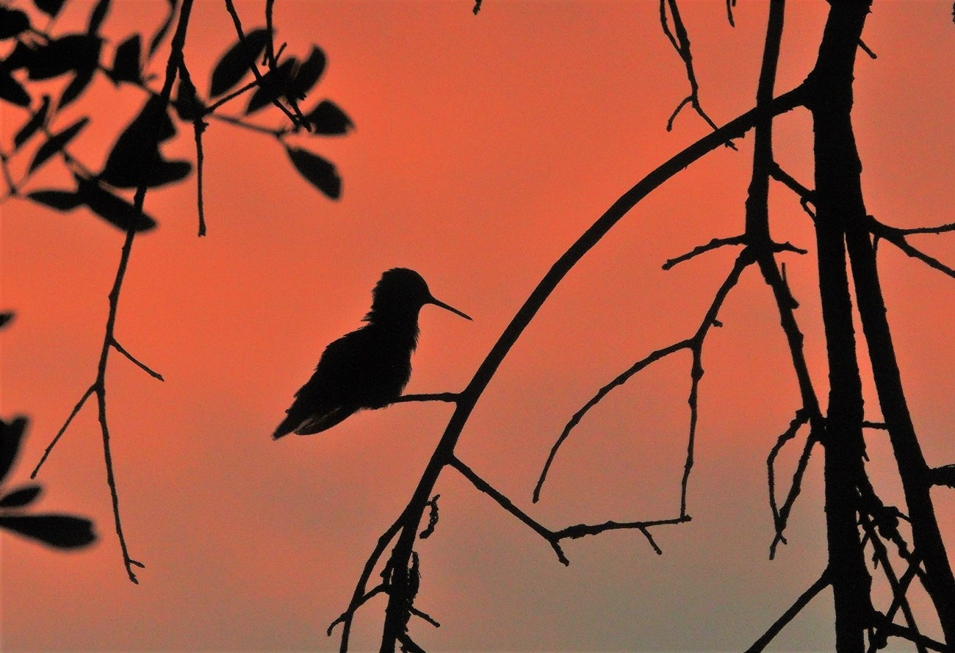
A Ruby-throated Hummingbird at Lower Suwannee National Wildlife Refuge in Florida. Larry A. Woodward/USFWS. Public domain.
Photograph: Larry A. Woodward/USFWS · Original source · Public domain. Resized proportionally.

Environment and native habitat
Woodland edges, stream margins and gardens combine sheltered branches with feeding openings. Most birds spend winter in Mexico and Central America. The accompanying Environment and Climate sheets explain how these seasonal needs shape a Lafayette garden. [Life, Aud]

Safe feeder care
Mix 1 part refined white sugar with 4 parts water by volume: ¼ cup sugar plus 1 cup water. Dissolve completely. Use no dye, honey or sugar substitutes. Change the solution and thoroughly clean the feeder every other day; in hot weather, inspect daily and replace sooner if needed. Refrigerate extra nectar for no more than one week. [Feed]
Place feeders where cats cannot ambush birds and where glass does not create a collision hazard. Leaving a clean feeder out in fall does not prevent migration. [Bird, Feed]

Protect the bird
Observe nests from a distance. Do not capture or keep a hummingbird; protected migratory birds require authorization for capture or possession. Seek a licensed wildlife rehabilitator for an injured bird. [Law]
[IN] Indiana Audubon species account
[Life] Cornell Lab life history
[Aud] Audubon species and migration account
[Feed] Smithsonian nectar recipe and feeder care
[Bird] Cornell Lab species overview
[Law] US Fish and Wildlife Service migratory bird protection
Courtney Celley/USFWS photograph — Public domain.
Mike Carlo/USFWS photograph — Public domain.
Daniel Schwen photograph — CC BY-SA 4.0. License
Larry A. Woodward/USFWS photograph — Public domain.

Related Information Sheets
Environment sheet | Climate sheet | Ecology sheet
Added September 22, 2026 · All Information Sheets

Sharing and reuse
© 2026 James Taylor · Plant Education Project. The original human-authored text in this Information Sheet is licensed under Creative Commons Attribution–NonCommercial 4.0 International (CC BY-NC 4.0).
You may share and adapt this text for noncommercial purposes. Credit the author and Plant Education Project, link to the source and license, and identify any changes. These permissions cannot be withdrawn from users who comply with the license, including for copies already released.
Photographs, illustrations, logos, quotations, and other third-party material are excluded from this text license and retain their individual rights and permissions. Separately published articles and book manuscripts are not licensed by this notice.

Ruby-throated Hummingbird — Climate
Online Information Sheet: planteducationproject.com/animals/ruby-throated-hummingbird/climate/
🌿 Climate Information Sheet
Archilochus colubris
Ruby-throated Hummingbirds connect Indiana’s warm growing season with warmer winter habitats farther south. Plan for arrivals, breeding and departing migrants rather than year-round local residence. [IN, Aud]
A Ruby-throated Hummingbird at Lower Suwannee National Wildlife Refuge in Florida. Larry A. Woodward/USFWS. Public domain.
Photograph: Larry A. Woodward/USFWS · Original source · Public domain. Resized proportionally.

Two seasonal settings
Setting | Seasonal conditions and bird use
Lafayette and eastern breeding range | Temperate growing season; flowers and insects support breeding. Cold winters greatly reduce those food resources. [ADW]
Mexico and Central America | Main wintering region; open tropical habitats, dry woodland, scrub and edges continue to provide food. Conditions vary across the large range. [Aud, Life]

A Lafayette planning calendar
Period | What to expect or do
April to May | Watch for returning birds. Have a maintained feeder ready in April and retain spring flowers.
May to July | Watch breeding-season activity. Protect quiet vegetation and keep summer flowers available.
August to September | Expect southbound movement. Adult males may depart before females and young. Keep late flowers and fresh nectar available.
October | Some late birds may pass through. Continue a clean feeder while birds are using it; document unusual visitors.
November to March | The species is normally absent locally. Plan habitat improvements for the next growing season.

Migration and energy
Some migrants cross the Gulf of Mexico; others travel around its western edge. Avoid assuming every bird takes the same route. A sequence of feeding and resting sites supports the journey. [Aud]
Torpor is a controlled reduction in body temperature and metabolism that saves energy, especially during cold nights. It helps a tiny bird survive a temporary energy shortage; it does not turn Indiana into normal winter habitat for this species. [ADW]

Responding to difficult weather
During heat, check nectar daily and replace it promptly; warmth speeds spoilage. During a dry spell, monitor the soil in moisture-loving plantings and water as needed to sustain flowers. Keep clean late-season feeders available for migrants rather than removing them to force departure. [Bird, Lob, Feed]

Track seasonal change
Record first and last sightings, bloom dates, dry spells and observation time. Compare several years before judging a trend. Track flowering and bird arrival separately to identify possible gaps in food availability.
[Aud] Audubon species and migration account
[ADW] University of Michigan Animal Diversity Web
[Life] Cornell Lab life history
[Feed] Smithsonian nectar recipe and feeder care
[Bird] Cornell Lab species overview
[Lob] NC State Extension cardinal flower
Larry A. Woodward/USFWS photograph — Public domain.

Related Information Sheets
Animal sheet | Environment sheet | Ecology sheet
Added September 22, 2026 · All Information Sheets

Sharing and reuse
© 2026 James Taylor · Plant Education Project. The original human-authored text in this Information Sheet is licensed under Creative Commons Attribution–NonCommercial 4.0 International (CC BY-NC 4.0).
You may share and adapt this text for noncommercial purposes. Credit the author and Plant Education Project, link to the source and license, and identify any changes. These permissions cannot be withdrawn from users who comply with the license, including for copies already released.
Photographs, illustrations, logos, quotations, and other third-party material are excluded from this text license and retain their individual rights and permissions. Separately published articles and book manuscripts are not licensed by this notice.

Ruby-throated Hummingbird — Ecology
Online Information Sheet: planteducationproject.com/animals/ruby-throated-hummingbird/ecology/
🌿 Ecology Information Sheet
Archilochus colubris
Ruby-throated Hummingbirds link flowers, small arthropods and woody vegetation. Supporting these relationships makes a garden useful for more than a brief feeder visit.
Female Ruby-throated Hummingbird feeding at a flower. Mike Carlo/USFWS. Public domain.
Photograph: Mike Carlo/USFWS · Original source · Public domain. Resized proportionally.

How the bird helps flowering plants
As a hummingbird reaches for nectar, its head or bill may contact pollen-bearing anthers and later a receptive stigma. This can move pollen between flowers. Pollination success depends on the fit between bird and flower and on what the bird touches; a visit alone is not proof of successful pollination. [ADW]
Cardinal flower offers a useful example of a tubular flower visited by hummingbirds. Eastern columbine supplies a spring nectar resource, while later flowers extend feeding opportunities. Red is useful for attracting attention, but hummingbirds also visit flowers of other colors. [Lob, Col, Bird]

Relationships to watch
Relationship | What it means in the garden
Nectar and flight | Flowers supply sugar used as an energy source; feeders offer a supplemental sugar source.
Arthropods and nutrition | Small insects and spiders are food. Nectar alone is not the complete diet.
Spider silk and nesting | The female uses silk to bind a flexible nest.
Woody plants and shelter | Branches support nests, resting sites and lookout perches.

Competition and predation
A male often guards a rich patch of flowers or a feeder and chases competitors. Spread feeding opportunities across the garden, using vegetation to interrupt direct sight lines. Count how many birds can feed, not simply how much nectar disappears. [Life]
Cats and window collisions create preventable hazards around feeding sites. Keep cats indoors or in enclosed outdoor spaces and make nearby glass visible to birds. Hummingbirds eat some mosquitoes, but attracting hummingbirds should not be treated as an effective mosquito-control program. [Bird]

Observe without disturbing
Watch the same flower patch for ten minutes at a consistent time. Record weather, open flowers, visits, chases and visible contact with flower parts. Count visits separately from individual birds: repeated trips by one bird are not evidence of a larger population.
Compare flower patches on several dates and include sessions with no visits. Note whether a bird feeds, rests or simply passes through. Avoid following it to a nest or changing vegetation around an active nest to improve a photograph.

What garden success looks like
Look for continuity of flowers and safe use of the site through the season. A feeder crowded with birds is only one observation. Flower visitation, insect feeding and undisturbed resting provide a fuller picture of habitat use. Retain records so that next year’s planting decisions follow evidence.
[Life] Cornell Lab life history
[Lob] NC State Extension cardinal flower
[Col] NC State Extension eastern columbine
[Bird] Cornell Lab species overview
Mike Carlo/USFWS photograph — Public domain.

Related Information Sheets
Animal sheet | Environment sheet | Climate sheet
Added September 22, 2026 · All Information Sheets

Sharing and reuse
© 2026 James Taylor · Plant Education Project. The original human-authored text in this Information Sheet is licensed under Creative Commons Attribution–NonCommercial 4.0 International (CC BY-NC 4.0).
You may share and adapt this text for noncommercial purposes. Credit the author and Plant Education Project, link to the source and license, and identify any changes. These permissions cannot be withdrawn from users who comply with the license, including for copies already released.
Photographs, illustrations, logos, quotations, and other third-party material are excluded from this text license and retain their individual rights and permissions. Separately published articles and book manuscripts are not licensed by this notice.

Ruby-throated Hummingbird — Environment
Online Information Sheet: planteducationproject.com/animals/ruby-throated-hummingbird/environment/
🌿 Environment Information Sheet
Archilochus colubris
A useful hummingbird garden supplies food through the season and keeps sheltered branches nearby. Match plants to the light and moisture already present on the site.
Deciduous woodland at Turkey Run State Park in Indiana. Habitat example; no hummingbird is shown. Daniel Schwen. CC BY-SA 4.0.
Photograph: Daniel Schwen · Original source · CC BY-SA 4.0. Resized proportionally.

Habitat structure
Retain trees and shrubs beside flowering areas. Hummingbirds use wooded edges and semi-open habitats rather than requiring a completely open flower bed. Keep quiet cover for nesting and resting, and leave room to approach flowers in flight. [Life, Aud]

Flowers for different garden conditions
These eastern North American plants offer complementary flowering periods. The seasonal windows below are broad planning guides; weather, cultivar and growing conditions change local bloom dates. They are garden candidates, not a county occurrence inventory.
Plant | Season | Suitable conditions
Eastern columbine  Aquilegia canadensis [Col] | Spring | Partial shade; moist, well-drained soil.
Wild bergamot  Monarda fistulosa [Mon] | Summer | Sun to partial shade; good drainage; tolerates some dryness.
Cardinal flower  Lobelia cardinalis [Lob] | Summer to early fall | Sun to partial shade; consistently moist soil.
Spotted jewelweed  Impatiens capensis [Jew] | Summer to fall | Moist, shaded ground; annual that reseeds.

Plant several of each suitable species and track gaps in bloom. Cardinal flower is a strong choice for a damp bed; do not put it in a dry location and expect occasional watering to compensate. Jewelweed suits a naturalized patch where reseeding is acceptable. [Lob, Jew]
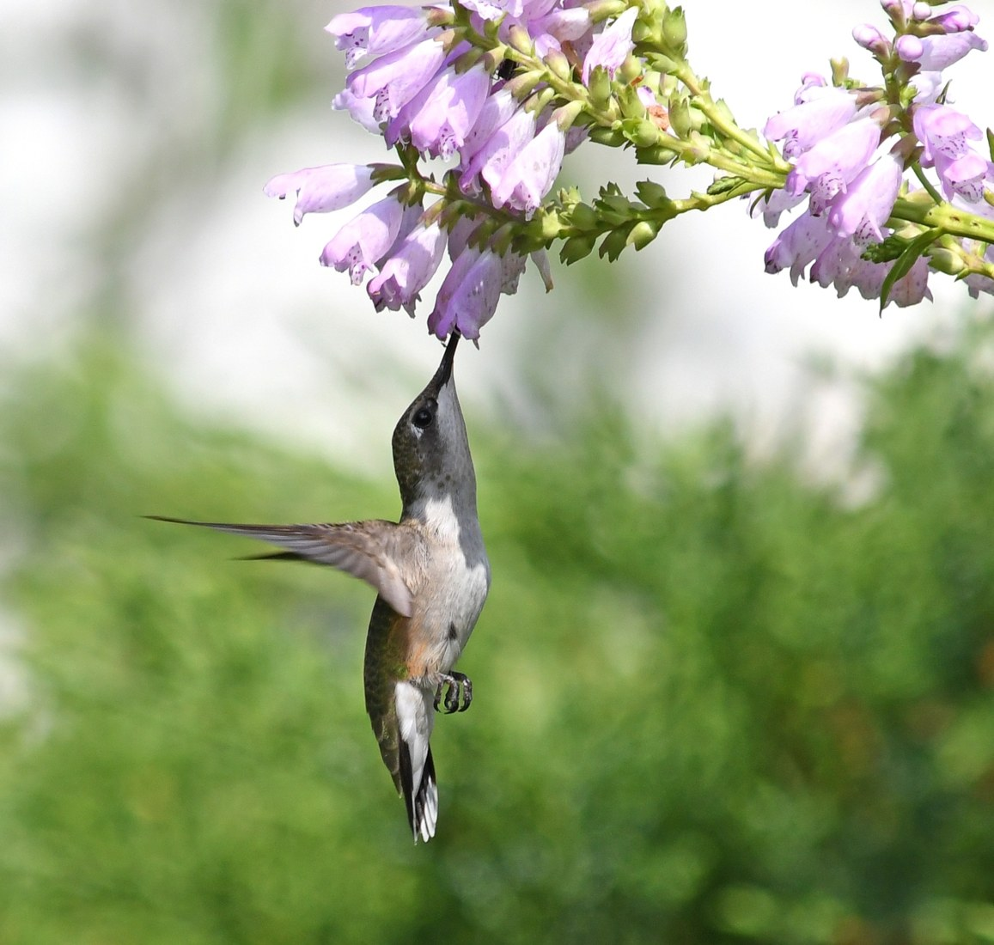
A hummingbird reaches into the tubular flowers of obedient plant. Jim Hudgins/USFWS. Public domain.
Photograph: Jim Hudgins/USFWS · Original source · Public domain. Resized proportionally.

Flowers are only part of the food supply
Keep vegetation that supports small arthropods. A garden stripped of insects cannot supply the bird’s complete diet. Avoid routine broad insecticide spraying around feeding and nesting areas. Feeders can supplement habitat, but they cannot supply the animal food available in a living garden. [Life]

A practical Lafayette layout
Use a sunny, well-drained patch for wild bergamot and a partly shaded edge for columbine. Reserve an existing moist pocket for cardinal flower or jewelweed. Keep perching branches nearby and arrange flowering groups so one bird has difficulty guarding every food source. This layout is a site-design recommendation based on the plant and bird requirements above.
For a small yard, begin with two flowering periods and expand after one season of observation. Buy propagated plants; leave wild plants and their habitats intact. These plantings are for wildlife observation, not an edible garden. Cardinal flower is toxic if eaten. [Lob]

Feeder placement and maintenance
Hang an optional feeder in shade with safe access for cleaning, beyond a cat’s reach and away from hazardous glass. Use the recipe and cleaning schedule in the Animal sheet. Choose a feeder only if someone can maintain it consistently. [Feed, Bird]
[Aud] Audubon species and migration account
[Col] NC State Extension eastern columbine
[Mon] NC State Extension wild bergamot
[Lob] NC State Extension cardinal flower
[Jew] NC State Extension spotted jewelweed
[Feed] Smithsonian nectar recipe and feeder care
[Bird] Cornell Lab species overview
Daniel Schwen photograph — CC BY-SA 4.0. License
Jim Hudgins/USFWS photograph — Public domain.

Related Information Sheets
Animal sheet | Climate sheet | Ecology sheet
Added September 22, 2026 · All Information Sheets

Sharing and reuse
© 2026 James Taylor · Plant Education Project. The original human-authored text in this Information Sheet is licensed under Creative Commons Attribution–NonCommercial 4.0 International (CC BY-NC 4.0).
You may share and adapt this text for noncommercial purposes. Credit the author and Plant Education Project, link to the source and license, and identify any changes. These permissions cannot be withdrawn from users who comply with the license, including for copies already released.
Photographs, illustrations, logos, quotations, and other third-party material are excluded from this text license and retain their individual rights and permissions. Separately published articles and book manuscripts are not licensed by this notice.

Sharing and image credits
Original Information Sheet text is licensed under Creative Commons Attribution–NonCommercial 4.0 International (CC BY-NC 4.0). Credit James Taylor and the Plant Education Project, link to the source and license, and identify changes. Photographs and other third-party material retain the rights and permissions stated with each image.

