Pavement Ant
Combined Information Sheets

Pavement Ant
Online Information Sheet: planteducationproject.com/animals/pavement-ant/
🌿 Animal Information Sheet
Tetramorium immigrans
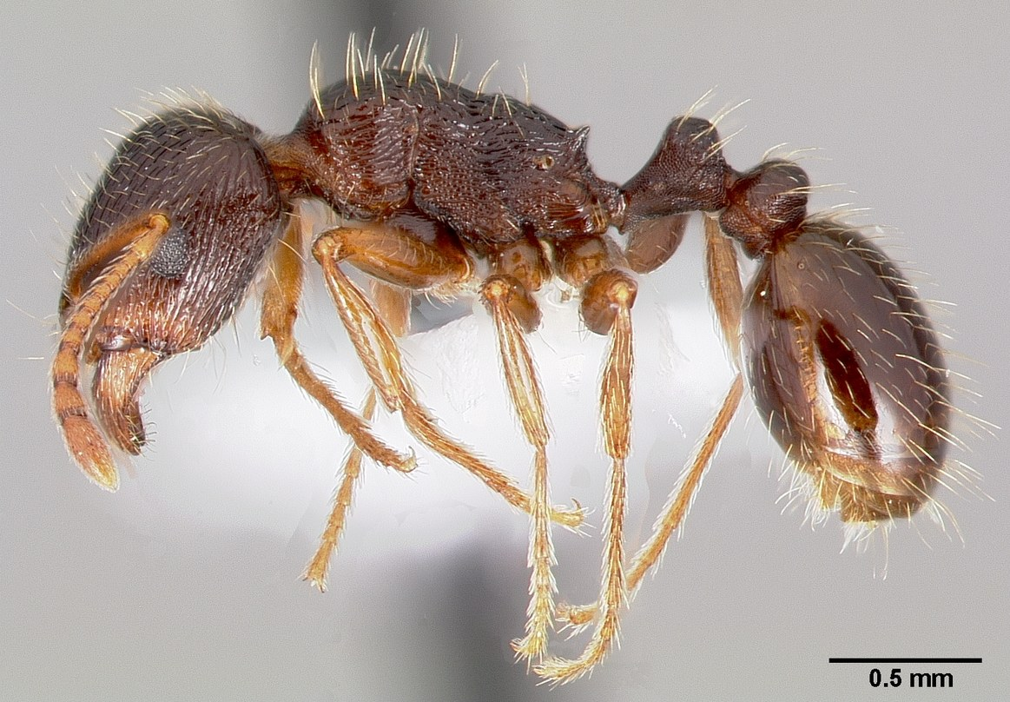
AntWeb worker profile showing two waist nodes and small spines.
Photograph: April Nobile · Original source · CC BY 4.0. Resized proportionally.
The familiar small ant beneath sidewalks and paving stones. Its success in disturbed ground makes it easy to observe, but the older name Tetramorium caespitum can conceal important differences among species.

At a Glance
Field | Information
Scientific name | Tetramorium immigrans
Worker length | About 2.5 to 4 mm
Native status | Introduced to North America from Eurasia
Practical significance | Widespread introduced urban ant; local ecological effects vary

Identification
Workers have two waist nodes, a pair of small rear spines on the middle body, and grooves on the head and thorax. Color is usually dark brown to black. A hand lens helps; these features are difficult to confirm in a distant phone photograph. [ID]
Odorous house ants lack the two conspicuous waist nodes. Do not label an ant as a fire ant because it forms a mound or gathers in a dense group. Closely related Tetramorium species may require expert examination.

Food and foraging
An omnivorous scavenger that collects sugary foods, insect material, and other small food particles. Workers can recruit nestmates quickly to a concentrated food source. [ID]

Life cycle and seasonal timing
A mated queen usually founds a colony independently. Mature colonies normally have one reproductive queen. Workers rear eggs, larvae, and pupae in underground chambers. Rival neighboring colonies may engage in conspicuous contests.
In the Northern Hemisphere, mating flights are commonly reported from late May through July, often near sunrise on still days. Local weather changes the timing. [ID, Pavement]
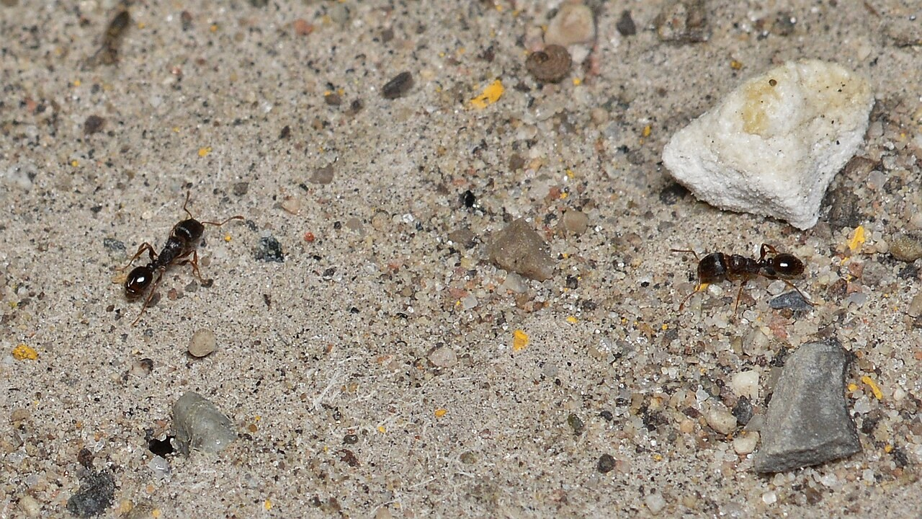
Tetramorium immigrans male.jpg • Jacy Lucier • CC BY-SA 4.0
Photograph: Jacy Lucier · Original source · CC BY-SA 4.0. Resized proportionally.
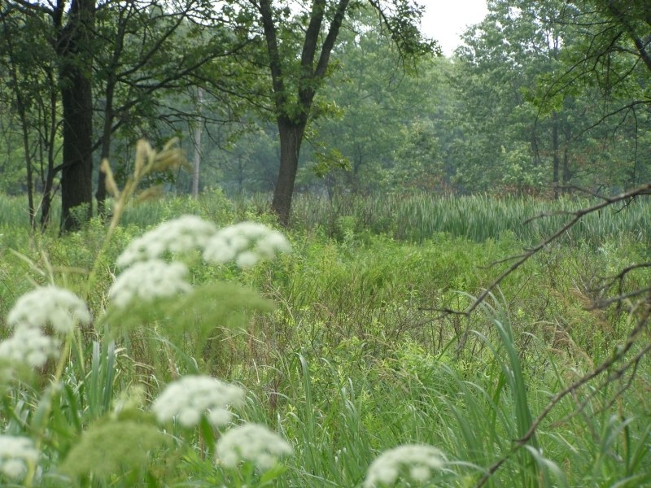
Immigrant Pavement Ants (Tetramorium immigrans) - Guelph, Ontario 2020-07-26.jpg • Ryan Hodnett • CC BY-SA 4.0
Photograph: Ryan Hodnett · Original source · CC BY-SA 4.0. Resized proportionally.

Environment and local occurrence
Soil beneath or beside sidewalks, driveways, stones, and other cover, especially in open disturbed places. Excavated soil at cracks can reveal entrances, although the nest extends beyond what is visible.
Morris records the older pavement-ant name Tetramorium caespitum in Wayne County. That historical record alone is not a verified modern Tippecanoe record of T. immigrans. [IN]

Living with this ant
Tolerate outdoor colonies when they are not causing a practical problem. Indoors, remove food residues and seal entry routes. If needed, choose a labeled bait and follow progress over time rather than judging success by dead workers alone. [UC]
Observe without handling or deliberately disturbing the nest. Before using a pesticide, confirm the ant and follow the current label for the site and application. Protect food, children, pets, and nearby water.

Related Information Sheets
Added September 22, 2026 · All Information Sheets

Sharing and reuse
© 2026 James Taylor · Plant Education Project. The original human-authored text in this Information Sheet is licensed under Creative Commons Attribution–NonCommercial 4.0 International (CC BY-NC 4.0).
You may share and adapt this text for noncommercial purposes. Credit the author and Plant Education Project, link to the source and license, and identify any changes. These permissions cannot be withdrawn from users who comply with the license, including for copies already released.
Photographs, illustrations, logos, quotations, and other third-party material are excluded from this text license and retain their individual rights and permissions. Separately published articles and book manuscripts are not licensed by this notice.

Pavement Ant — Climate
Online Information Sheet: planteducationproject.com/animals/pavement-ant/climate/
🌿 Climate Information Sheet
Tetramorium immigrans
Indiana provides a seasonal outdoor setting, with freezing winters and warm summers. The table describes Lafayette weather; it is not a nest-temperature range or a laboratory tolerance limit for this ant.

Lafayette climate at a glance
Month | Mean °F | Mean °C | Precip in | Precip mm
Jan | 25.8 | -3.4 | 2.19 | 56
Feb | 29.7 | -1.3 | 1.78 | 45
Mar | 40.0 | 4.4 | 2.73 | 69
Apr | 51.1 | 10.6 | 3.84 | 98
May | 61.6 | 16.4 | 4.04 | 103
Jun | 70.7 | 21.5 | 4.56 | 116
Jul | 73.6 | 23.1 | 4.08 | 104
Aug | 72.2 | 22.3 | 3.12 | 79
Sep | 65.5 | 18.6 | 2.59 | 66
Oct | 53.7 | 12.1 | 2.91 | 74
Nov | 41.3 | 5.2 | 2.87 | 73
Dec | 31.0 | -0.6 | 2.29 | 58

Seasonal activity
Outdoor activity responds to seasonal warming, while colonies beside heated buildings may become active unusually early. Winter indoor swarms should be investigated rather than treated as normal outdoor timing.
In the Northern Hemisphere, mating flights are commonly reported from late May through July, often near sunrise on still days. Local weather changes the timing. [ID, Pavement]

The nest has its own climate
Concrete can be much warmer than shaded soil. Compare shaded and sunny entrances at matched times, and record surface temperature separately from the weather-station air temperature.
Sun, cover, soil depth, and indoor heating can shift exposure within a few steps. No single temperature or humidity target should be inferred from this regional climate table.

Weather extremes and future change
NOAA’s 2022 Indiana assessment projects warmer conditions and increased risks from heavy precipitation, while greater evaporation can intensify drought. These are regional projections; they do not predict the abundance of an individual ant species. [Climate]
Observation suggestion: record the first spring workers and each swarm with the date, time, recent rain, and location. Compare several years before attributing a change to climate rather than food availability, habitat change, or observation effort.

References

Related Information Sheets
Added September 22, 2026 · All Information Sheets

Sharing and reuse
© 2026 James Taylor · Plant Education Project. The original human-authored text in this Information Sheet is licensed under Creative Commons Attribution–NonCommercial 4.0 International (CC BY-NC 4.0).
You may share and adapt this text for noncommercial purposes. Credit the author and Plant Education Project, link to the source and license, and identify any changes. These permissions cannot be withdrawn from users who comply with the license, including for copies already released.
Photographs, illustrations, logos, quotations, and other third-party material are excluded from this text license and retain their individual rights and permissions. Separately published articles and book manuscripts are not licensed by this notice.

Pavement Ant — Ecology
Online Information Sheet: planteducationproject.com/animals/pavement-ant/ecology/
🌿 Ecology Information Sheet
Tetramorium immigrans
Follow this ant’s feeding, nesting, and relationships with plants and other animals to understand its role in the local community.
Pavement ants photographed in Guelph, Ontario. An introduced-range example.
Photograph: Ryan Hodnett · Original source · CC BY-SA 4.0. Resized proportionally.

Food web role
This introduced species is particularly successful in cities. The 2022 review describes substantial knowledge gaps and generally modest documented impacts compared with several more damaging invasive ants. Introduced status and a measured local impact are different findings. [Pavement]

Relationships with plants
The main garden issue is usually location, not direct feeding damage to living plants. An ant carrying a seed may be moving, consuming, or discarding it; watch the outcome before calling the event seed dispersal.
When ants visit a plant, distinguish feeding on plant tissue, gathering nectar or honeydew, hunting, and simple passage. Seeing ants on a flower does not establish effective pollination. [UC]

Colony and community
A mated queen usually founds a colony independently. Mature colonies normally have one reproductive queen. Workers rear eggs, larvae, and pupae in underground chambers. Rival neighboring colonies may engage in conspicuous contests.
Widespread introduced urban ant; local ecological effects vary. Morris records the older pavement-ant name Tetramorium caespitum in Wayne County. That historical record alone is not a verified modern Tippecanoe record of T. immigrans. [IN]

A question to investigate
How do trail traffic and the number of active entrances differ between sunny and shaded pavement edges?
Observe for five minutes on at least three occasions. Record what workers carry or contact, note the weather, and include a nearby comparison area. Visible traffic is not a measure of total colony size.

Management implication
Tolerate outdoor colonies when they are not causing a practical problem. Indoors, remove food residues and seal entry routes. If needed, choose a labeled bait and follow progress over time rather than judging success by dead workers alone.
Retain the observation record after any action. Compare the original problem, plant condition, and ant traffic rather than using the disappearance of every ant as the goal. [UC]

Useful terms
Honeydew is sugary excretion from sap-feeding insects. Brood means eggs, larvae, and pupae. A mutualism benefits both partners.

Related Information Sheets
Added September 22, 2026 · All Information Sheets

Sharing and reuse
© 2026 James Taylor · Plant Education Project. The original human-authored text in this Information Sheet is licensed under Creative Commons Attribution–NonCommercial 4.0 International (CC BY-NC 4.0).
You may share and adapt this text for noncommercial purposes. Credit the author and Plant Education Project, link to the source and license, and identify any changes. These permissions cannot be withdrawn from users who comply with the license, including for copies already released.
Photographs, illustrations, logos, quotations, and other third-party material are excluded from this text license and retain their individual rights and permissions. Separately published articles and book manuscripts are not licensed by this notice.

Pavement Ant — Environment
Online Information Sheet: planteducationproject.com/animals/pavement-ant/environment/
🌿 Environment Information Sheet
Tetramorium immigrans
The nest environment explains where this ant can live and how it reaches food. Compare soil, shelter, moisture, and nearby vegetation before treating an entire landscape as one habitat.
Immigrant Pavement Ants (Tetramorium immigrans) - Guelph, Ontario 2020-07-26.jpg • Ryan Hodnett • CC BY-SA 4.0
Photograph: Ryan Hodnett · Original source · CC BY-SA 4.0. Resized proportionally.
Hoosier Prairie P7150009.jpg • Chris Light, National Park Service • Public domain
Photograph: Chris Light, National Park Service · Original source · Public domain. Resized proportionally.

Habitat and shelter
Soil beneath or beside sidewalks, driveways, stones, and other cover, especially in open disturbed places. Excavated soil at cracks can reveal entrances, although the nest extends beyond what is visible. [ID]

Water and the nesting substrate
Paving changes the delivery of rain and the rate of surface heating. Cracks concentrate runoff, while nearby soil may remain dry. A single dry-looking surface does not describe the deeper nest.

Food routes and vegetation
An omnivorous scavenger that collects sugary foods, insect material, and other small food particles. Workers can recruit nestmates quickly to a concentrated food source.
The main garden issue is usually location, not direct feeding damage to living plants. An ant carrying a seed may be moving, consuming, or discarding it; watch the outcome before calling the event seed dispersal. [ID, UC]

Comparison with Lafayette
Concrete can be much warmer than shaded soil. Compare shaded and sunny entrances at matched times, and record surface temperature separately from the weather-station air temperature.
Morris records the older pavement-ant name Tetramorium caespitum in Wayne County. That historical record alone is not a verified modern Tippecanoe record of T. immigrans. [IN]

Manage the setting
Observe pavement edges, soil joints, and nearby vegetation without lifting heavy slabs. Record entrances separately; several entrances may belong to one colony.
Keep a record of the actual conflict: indoor food contamination, structural nesting, a blocked path, or no practical problem. An outdoor ant population does not by itself call for control. [PU]

A simple habitat observation
Choose two nearby places with contrasting cover. Observe each for five minutes at a similar time of day. Record shade, substrate, wetness, visible entrances, and the number of workers crossing a fixed line. Repeat on several days; a trail count measures visible traffic, not colony size.

Related Information Sheets
Added September 22, 2026 · All Information Sheets

Sharing and reuse
© 2026 James Taylor · Plant Education Project. The original human-authored text in this Information Sheet is licensed under Creative Commons Attribution–NonCommercial 4.0 International (CC BY-NC 4.0).
You may share and adapt this text for noncommercial purposes. Credit the author and Plant Education Project, link to the source and license, and identify any changes. These permissions cannot be withdrawn from users who comply with the license, including for copies already released.
Photographs, illustrations, logos, quotations, and other third-party material are excluded from this text license and retain their individual rights and permissions. Separately published articles and book manuscripts are not licensed by this notice.

Sharing and image credits
Original Information Sheet text is licensed under Creative Commons Attribution–NonCommercial 4.0 International (CC BY-NC 4.0). Credit James Taylor and the Plant Education Project, link to the source and license, and identify changes. Photographs and other third-party material retain the rights and permissions stated with each image.

