Odorous House Ant
Combined Information Sheets

Odorous House Ant
Online Information Sheet: planteducationproject.com/animals/odorous-house-ant/
🌿 Animal Information Sheet
Tapinoma sessile
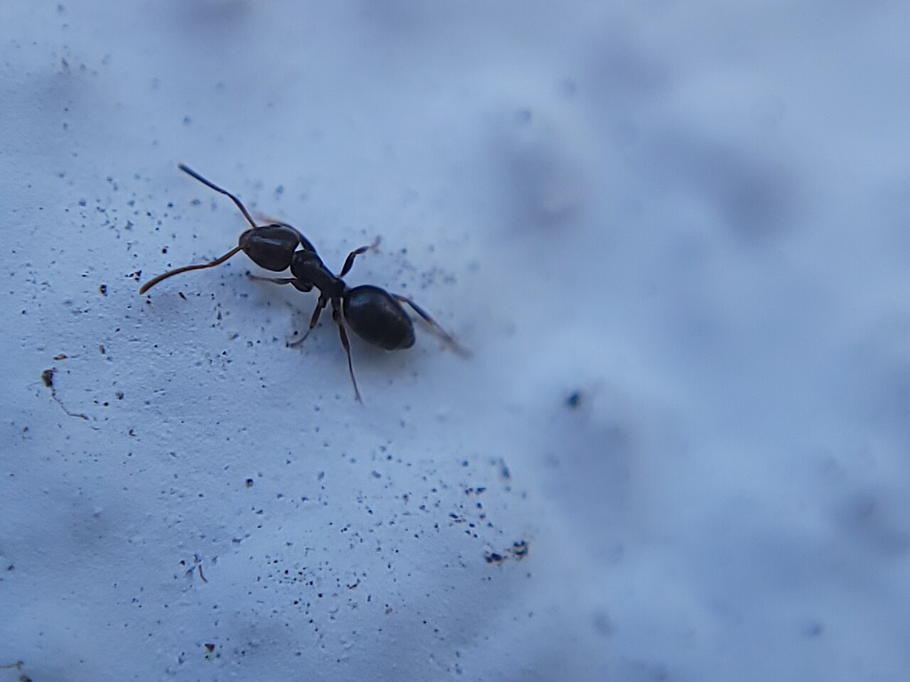
Worker photographed alive. Species identification follows the source record.
Photograph: Theo Summer · Original source · CC BY 4.0. Resized proportionally.
A small native scavenger that follows food trails through gardens and sometimes kitchens. Identify the ant and locate what attracts it before deciding whether control is needed.

At a Glance
Field | Information
Scientific name | Tapinoma sessile
Worker length | About 2 to 3 mm
Native status | Native to North America
Practical significance | Native ant that can become a persistent household nuisance

Identification
Workers are brown to nearly black. The tiny waist node is largely concealed by the abdomen. Viewed from the side, the middle body is uneven rather than smoothly arched. Odor can support identification, but a photograph, size estimate, and close view of the waist are more useful than deliberately crushing an ant. [ID]
Pavement ants have two visible waist nodes and fine grooves on the head. Small Lasius ants have a more evident single node. “Sugar ant” is a feeding nickname, not a reliable species name.

Food and foraging
Collects sugary liquids, especially honeydew, and takes insect food. Check leaf undersides and tender shoots when workers repeatedly climb a plant. [ID]
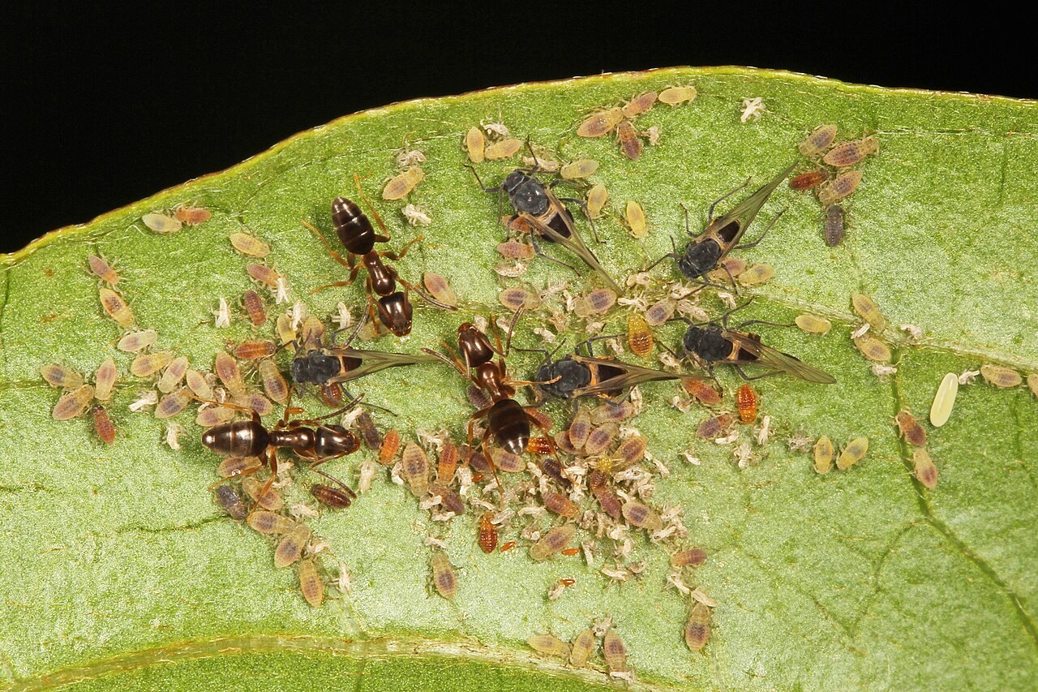
Odorous house ants with aphids in Virginia. This illustrates an observed association.
Photograph: Judy Gallagher · Original source · CC BY 2.0. Resized proportionally.

Life cycle and seasonal timing
Eggs develop through legless larvae and pupae into adults. Wingless female workers forage and care for the brood. Queens reproduce; winged males and young queens can appear during the warm season.
Winged forms are often reported in early to midsummer; June and July are a regional guide, not a fixed Indiana schedule. [ID]
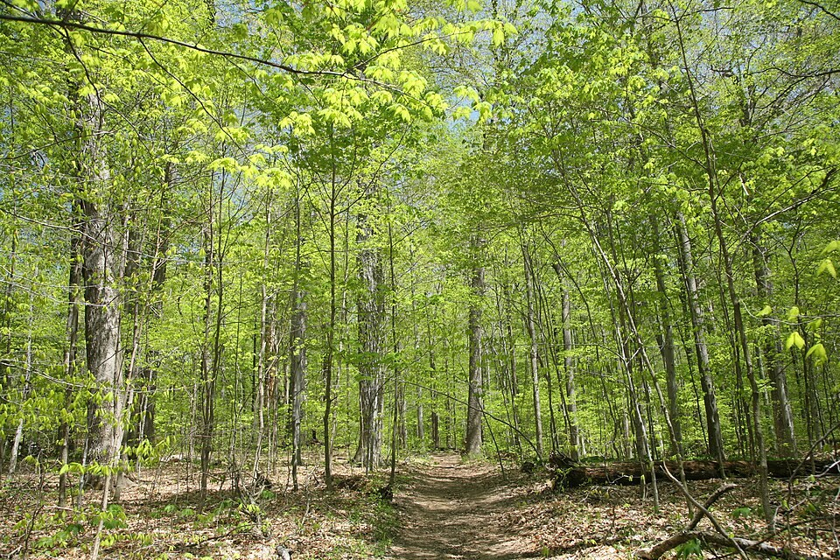
Turkey Run SP, IN 2.jpg • Daniel Schwen • CC BY-SA 4.0
Photograph: Daniel Schwen · Original source · CC BY-SA 4.0. Resized proportionally.
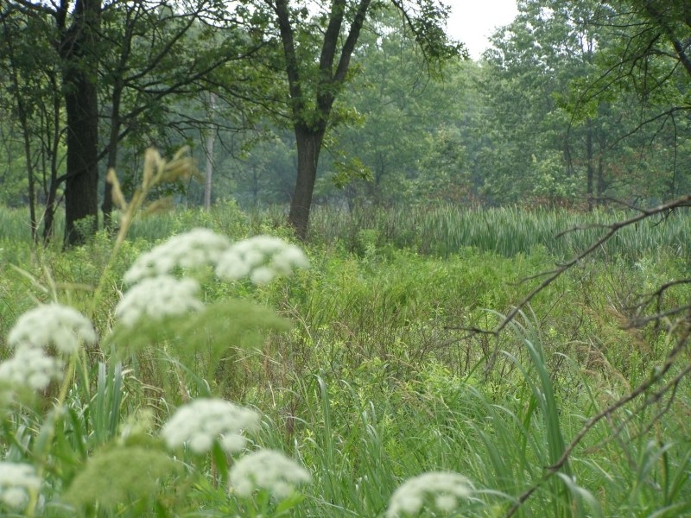
Hoosier Prairie P7150009.jpg • Chris Light, National Park Service • Public domain
Photograph: Chris Light, National Park Service · Original source · Public domain. Resized proportionally.

Environment and local occurrence
Soil beneath stones, boards, mulch, and other cover; woodland edges and disturbed ground. Colonies can also occupy sheltered spaces in buildings, especially near moisture.
Morris lists Tippecanoe County for Tapinoma sessile. This is a historical occurrence, not a current abundance estimate. [IN]

Living with this ant
Clean up spills, seal food, correct leaks, and close entry gaps. For persistent indoor colonies, use a labeled ant bait appropriate to the site or obtain professional help. Keep sprays away from an active baiting program. [UC]
Observe without handling or deliberately disturbing the nest. Before using a pesticide, confirm the ant and follow the current label for the site and application. Protect food, children, pets, and nearby water.

Related Information Sheets
Added September 22, 2026 · All Information Sheets

Sharing and reuse
© 2026 James Taylor · Plant Education Project. The original human-authored text in this Information Sheet is licensed under Creative Commons Attribution–NonCommercial 4.0 International (CC BY-NC 4.0).
You may share and adapt this text for noncommercial purposes. Credit the author and Plant Education Project, link to the source and license, and identify any changes. These permissions cannot be withdrawn from users who comply with the license, including for copies already released.
Photographs, illustrations, logos, quotations, and other third-party material are excluded from this text license and retain their individual rights and permissions. Separately published articles and book manuscripts are not licensed by this notice.

Odorous House Ant — Climate
Online Information Sheet: planteducationproject.com/animals/odorous-house-ant/climate/
🌿 Climate Information Sheet
Tapinoma sessile
Indiana provides a seasonal outdoor setting, with freezing winters and warm summers. The table describes Lafayette weather; it is not a nest-temperature range or a laboratory tolerance limit for this ant.

Lafayette climate at a glance
Month | Mean °F | Mean °C | Precip in | Precip mm
Jan | 25.8 | -3.4 | 2.19 | 56
Feb | 29.7 | -1.3 | 1.78 | 45
Mar | 40.0 | 4.4 | 2.73 | 69
Apr | 51.1 | 10.6 | 3.84 | 98
May | 61.6 | 16.4 | 4.04 | 103
Jun | 70.7 | 21.5 | 4.56 | 116
Jul | 73.6 | 23.1 | 4.08 | 104
Aug | 72.2 | 22.3 | 3.12 | 79
Sep | 65.5 | 18.6 | 2.59 | 66
Oct | 53.7 | 12.1 | 2.91 | 74
Nov | 41.3 | 5.2 | 2.87 | 73
Dec | 31.0 | -0.6 | 2.29 | 58

Seasonal activity
For outdoor observations, compare spring warming with summer food availability. Heated structures can support activity when outdoor trails are quiet.
Winged forms are often reported in early to midsummer; June and July are a regional guide, not a fixed Indiana schedule. [ID]

The nest has its own climate
A shaded mulch bed and a sunlit wall may support different activity at the same air temperature. Record the surface, shade, and moisture condition beside the trail.
Sun, cover, soil depth, and indoor heating can shift exposure within a few steps. No single temperature or humidity target should be inferred from this regional climate table.

Weather extremes and future change
NOAA’s 2022 Indiana assessment projects warmer conditions and increased risks from heavy precipitation, while greater evaporation can intensify drought. These are regional projections; they do not predict the abundance of an individual ant species. [Climate]
Observation suggestion: record the first spring workers and each swarm with the date, time, recent rain, and location. Compare several years before attributing a change to climate rather than food availability, habitat change, or observation effort.

References

Related Information Sheets
Added September 22, 2026 · All Information Sheets

Sharing and reuse
© 2026 James Taylor · Plant Education Project. The original human-authored text in this Information Sheet is licensed under Creative Commons Attribution–NonCommercial 4.0 International (CC BY-NC 4.0).
You may share and adapt this text for noncommercial purposes. Credit the author and Plant Education Project, link to the source and license, and identify any changes. These permissions cannot be withdrawn from users who comply with the license, including for copies already released.
Photographs, illustrations, logos, quotations, and other third-party material are excluded from this text license and retain their individual rights and permissions. Separately published articles and book manuscripts are not licensed by this notice.

Odorous House Ant — Ecology
Online Information Sheet: planteducationproject.com/animals/odorous-house-ant/ecology/
🌿 Ecology Information Sheet
Tapinoma sessile
Follow this ant’s feeding, nesting, and relationships with plants and other animals to understand its role in the local community.
Odorous house ants with aphids in Virginia. This illustrates an observed association.
Photograph: Judy Gallagher · Original source · CC BY 2.0. Resized proportionally.

Food web role
This species links sugary plant-derived resources, other insects, and predators of ants. Foraging ants redistribute food within the colony, while their activity changes where small food remains accumulate. [ID]

Relationships with plants
Workers taking honeydew may defend sap-feeding insects. Their presence on a leaf is a reason to inspect the plant; it does not establish that the ants caused leaf injury.
When ants visit a plant, distinguish feeding on plant tissue, gathering nectar or honeydew, hunting, and simple passage. Seeing ants on a flower does not establish effective pollination. [UC]

Colony and community
Eggs develop through legless larvae and pupae into adults. Wingless female workers forage and care for the brood. Queens reproduce; winged males and young queens can appear during the warm season.
Native ant that can become a persistent household nuisance. Morris lists Tippecanoe County for Tapinoma sessile. This is a historical occurrence, not a current abundance estimate. [IN]

A question to investigate
Do trail counts increase on plants with visible aphids compared with nearby plants without them?
Observe for five minutes on at least three occasions. Record what workers carry or contact, note the weather, and include a nearby comparison area. Visible traffic is not a measure of total colony size.

Management implication
Clean up spills, seal food, correct leaks, and close entry gaps. For persistent indoor colonies, use a labeled ant bait appropriate to the site or obtain professional help. Keep sprays away from an active baiting program.
Retain the observation record after any action. Compare the original problem, plant condition, and ant traffic rather than using the disappearance of every ant as the goal. [UC]

Useful terms
Honeydew is sugary excretion from sap-feeding insects. Brood means eggs, larvae, and pupae. A mutualism benefits both partners.

Related Information Sheets
Added September 22, 2026 · All Information Sheets

Sharing and reuse
© 2026 James Taylor · Plant Education Project. The original human-authored text in this Information Sheet is licensed under Creative Commons Attribution–NonCommercial 4.0 International (CC BY-NC 4.0).
You may share and adapt this text for noncommercial purposes. Credit the author and Plant Education Project, link to the source and license, and identify any changes. These permissions cannot be withdrawn from users who comply with the license, including for copies already released.
Photographs, illustrations, logos, quotations, and other third-party material are excluded from this text license and retain their individual rights and permissions. Separately published articles and book manuscripts are not licensed by this notice.

Odorous House Ant — Environment
Online Information Sheet: planteducationproject.com/animals/odorous-house-ant/environment/
🌿 Environment Information Sheet
Tapinoma sessile
The nest environment explains where this ant can live and how it reaches food. Compare soil, shelter, moisture, and nearby vegetation before treating an entire landscape as one habitat.
Turkey Run SP, IN 2.jpg • Daniel Schwen • CC BY-SA 4.0
Photograph: Daniel Schwen · Original source · CC BY-SA 4.0. Resized proportionally.
Hoosier Prairie P7150009.jpg • Chris Light, National Park Service • Public domain
Photograph: Chris Light, National Park Service · Original source · Public domain. Resized proportionally.

Habitat and shelter
Soil beneath stones, boards, mulch, and other cover; woodland edges and disturbed ground. Colonies can also occupy sheltered spaces in buildings, especially near moisture. [ID]

Water and the nesting substrate
Small covered spaces retain moisture differently from exposed soil. A leaking fitting, damp mulch against a wall, or watered container can bring shelter and food routes close to a building.

Food routes and vegetation
Collects sugary liquids, especially honeydew, and takes insect food. Check leaf undersides and tender shoots when workers repeatedly climb a plant.
Workers taking honeydew may defend sap-feeding insects. Their presence on a leaf is a reason to inspect the plant; it does not establish that the ants caused leaf injury. [ID, UC]

Comparison with Lafayette
A shaded mulch bed and a sunlit wall may support different activity at the same air temperature. Record the surface, shade, and moisture condition beside the trail.
Morris lists Tippecanoe County for Tapinoma sessile. This is a historical occurrence, not a current abundance estimate. [IN]

Manage the setting
Trace trails in both directions and mark entry points. Keep landscape cover away from structural openings while retaining litter and dead wood in suitable garden areas farther from the building.
Keep a record of the actual conflict: indoor food contamination, structural nesting, a blocked path, or no practical problem. An outdoor ant population does not by itself call for control. [PU]

A simple habitat observation
Choose two nearby places with contrasting cover. Observe each for five minutes at a similar time of day. Record shade, substrate, wetness, visible entrances, and the number of workers crossing a fixed line. Repeat on several days; a trail count measures visible traffic, not colony size.

Related Information Sheets
Added September 22, 2026 · All Information Sheets

Sharing and reuse
© 2026 James Taylor · Plant Education Project. The original human-authored text in this Information Sheet is licensed under Creative Commons Attribution–NonCommercial 4.0 International (CC BY-NC 4.0).
You may share and adapt this text for noncommercial purposes. Credit the author and Plant Education Project, link to the source and license, and identify any changes. These permissions cannot be withdrawn from users who comply with the license, including for copies already released.
Photographs, illustrations, logos, quotations, and other third-party material are excluded from this text license and retain their individual rights and permissions. Separately published articles and book manuscripts are not licensed by this notice.

Sharing and image credits
Original Information Sheet text is licensed under Creative Commons Attribution–NonCommercial 4.0 International (CC BY-NC 4.0). Credit James Taylor and the Plant Education Project, link to the source and license, and identify changes. Photographs and other third-party material retain the rights and permissions stated with each image.

