Larger Citronella Ant
Combined Information Sheets

Larger Citronella Ant
Online Information Sheet: planteducationproject.com/animals/larger-citronella-ant/
🌿 Animal Information Sheet
Lasius interjectus
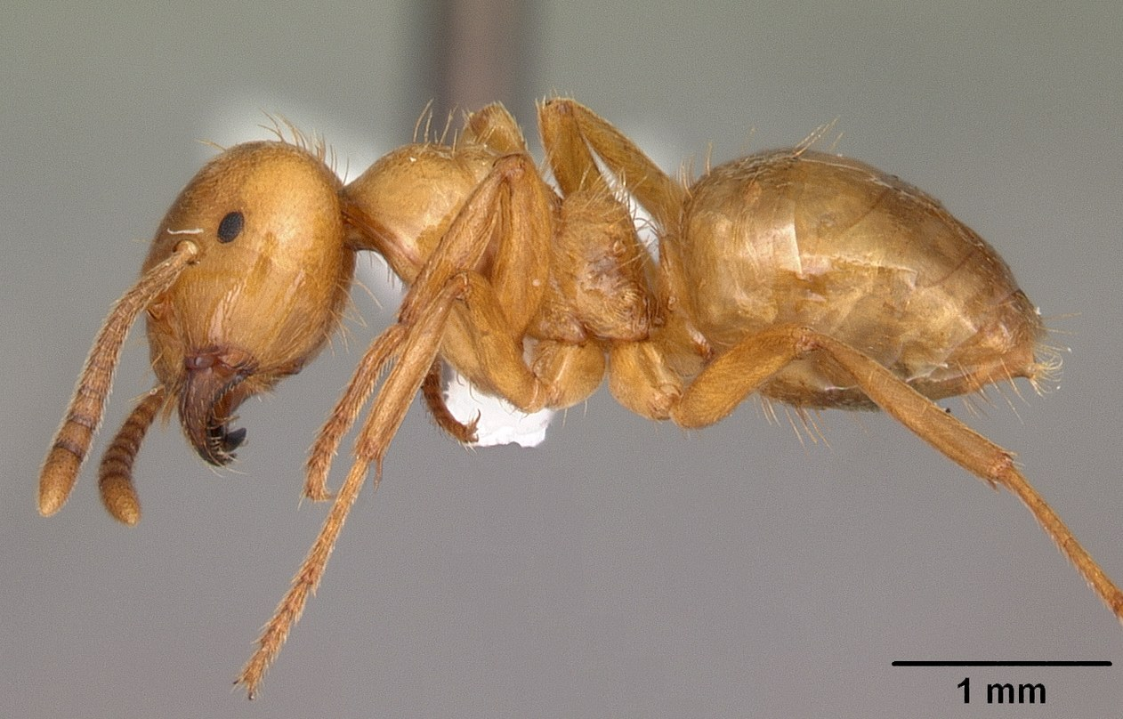
AntWeb worker profile of Lasius interjectus showing the yellow body and single node.
Photograph: April Nobile · Original source · CC BY 4.0. Resized proportionally.
A yellow ant that spends much of its life belowground. A sudden indoor swarm can look alarming, but these ants are not wood-eating termites and ordinarily do not attack stored food.

At a Glance
Field | Information
Scientific name | Lasius interjectus
Worker length | Workers about 4 to 4.5 mm
Native status | Native to North America
Practical significance | Usually an inconspicuous soil ant; swarms can be a nuisance

Identification
Workers are yellow to yellowish brown, with small eyes, a single waist node, and 12-segmented antennae. Disturbed ants can release a lemonlike odor. Winged reproductives are darker and larger than workers. [ID]
Lasius claviger, the smaller citronella ant, looks similar. Color and smell alone do not securely distinguish the two. Termites lack the narrow ant waist and elbowed worker or queen antennae.

Food and foraging
Associated mainly with honeydew from root-feeding aphids and mealybugs. The food relationship is largely hidden belowground rather than on exposed foliage. [ID]
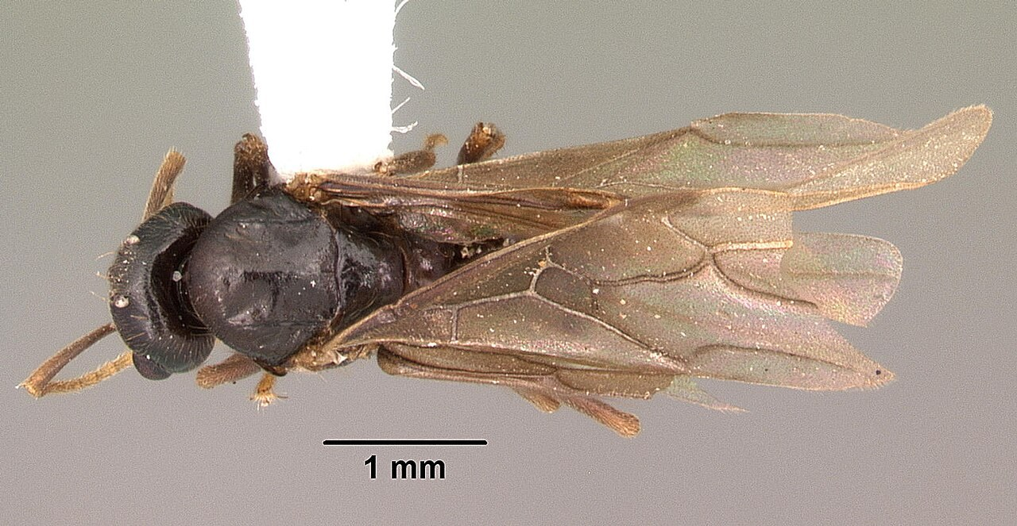
Winged reproductive specimen of Lasius interjectus viewed from above.
Photograph: April Nobile · Original source · CC BY 4.0. Resized proportionally.

Life cycle and seasonal timing
Brood develops underground, and seasonal winged reproductives disperse from established nests. The concealed biology of colonies is less well documented than the dramatic swarming events that bring them to attention.
Swarms are especially noticeable in mid to late summer. Colonies beneath heated structures can produce unusual early, late, or indoor swarms. [ID, Citronella]
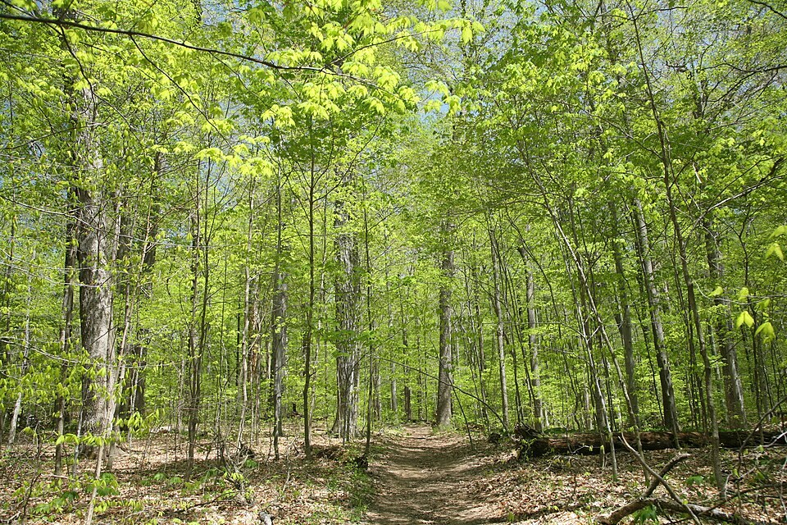
Turkey Run SP, IN 2.jpg • Daniel Schwen • CC BY-SA 4.0
Photograph: Daniel Schwen · Original source · CC BY-SA 4.0. Resized proportionally.
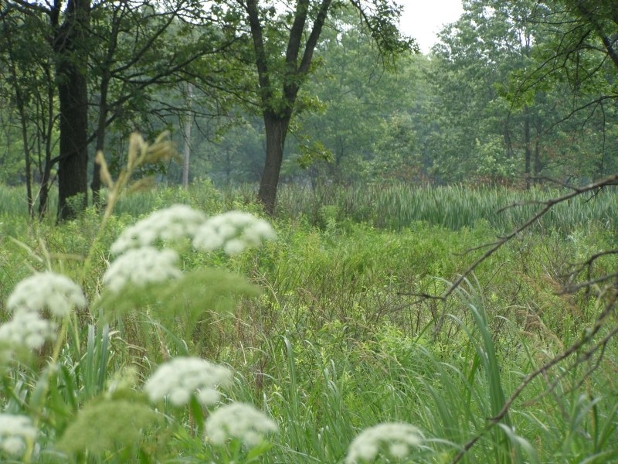
Hoosier Prairie P7150009.jpg • Chris Light, National Park Service • Public domain
Photograph: Chris Light, National Park Service · Original source · Public domain. Resized proportionally.

Environment and local occurrence
Soil beneath stones, logs, slabs, and other cover; open woods, lawns, gardens, and sites beside foundations. Nest entrances may be associated with small piles of excavated soil.
Morris lists Tippecanoe County for Lasius interjectus and describes it as common in damp situations. The county record is historical. [IN]

Living with this ant
Vacuum nuisance swarmers and identify them. Seal accessible entry cracks after assessing the source. Recurrent indoor swarms may justify professional investigation; routine food baits may attract little interest. [UC]
Observe without handling or deliberately disturbing the nest. Before using a pesticide, confirm the ant and follow the current label for the site and application. Protect food, children, pets, and nearby water.

Related Information Sheets
Added September 22, 2026 · All Information Sheets

Sharing and reuse
© 2026 James Taylor · Plant Education Project. The original human-authored text in this Information Sheet is licensed under Creative Commons Attribution–NonCommercial 4.0 International (CC BY-NC 4.0).
You may share and adapt this text for noncommercial purposes. Credit the author and Plant Education Project, link to the source and license, and identify any changes. These permissions cannot be withdrawn from users who comply with the license, including for copies already released.
Photographs, illustrations, logos, quotations, and other third-party material are excluded from this text license and retain their individual rights and permissions. Separately published articles and book manuscripts are not licensed by this notice.

Larger Citronella Ant — Climate
Online Information Sheet: planteducationproject.com/animals/larger-citronella-ant/climate/
🌿 Climate Information Sheet
Lasius interjectus
Indiana provides a seasonal outdoor setting, with freezing winters and warm summers. The table describes Lafayette weather; it is not a nest-temperature range or a laboratory tolerance limit for this ant.

Lafayette climate at a glance
Month | Mean °F | Mean °C | Precip in | Precip mm
Jan | 25.8 | -3.4 | 2.19 | 56
Feb | 29.7 | -1.3 | 1.78 | 45
Mar | 40.0 | 4.4 | 2.73 | 69
Apr | 51.1 | 10.6 | 3.84 | 98
May | 61.6 | 16.4 | 4.04 | 103
Jun | 70.7 | 21.5 | 4.56 | 116
Jul | 73.6 | 23.1 | 4.08 | 104
Aug | 72.2 | 22.3 | 3.12 | 79
Sep | 65.5 | 18.6 | 2.59 | 66
Oct | 53.7 | 12.1 | 2.91 | 74
Nov | 41.3 | 5.2 | 2.87 | 73
Dec | 31.0 | -0.6 | 2.29 | 58

Seasonal activity
Visible swarms are brief windows into an otherwise hidden colony. Their absence during a routine walk is not evidence that citronella ants are absent from the area.
Swarms are especially noticeable in mid to late summer. Colonies beneath heated structures can produce unusual early, late, or indoor swarms. [ID, Citronella]

The nest has its own climate
A heated slab can keep adjacent soil warmer than nearby open ground. Record whether a swarm is inside, beside a foundation, or in unheated outdoor soil.
Sun, cover, soil depth, and indoor heating can shift exposure within a few steps. No single temperature or humidity target should be inferred from this regional climate table.

Weather extremes and future change
NOAA’s 2022 Indiana assessment projects warmer conditions and increased risks from heavy precipitation, while greater evaporation can intensify drought. These are regional projections; they do not predict the abundance of an individual ant species. [Climate]
Observation suggestion: record the first spring workers and each swarm with the date, time, recent rain, and location. Compare several years before attributing a change to climate rather than food availability, habitat change, or observation effort.

References

Related Information Sheets
Added September 22, 2026 · All Information Sheets

Sharing and reuse
© 2026 James Taylor · Plant Education Project. The original human-authored text in this Information Sheet is licensed under Creative Commons Attribution–NonCommercial 4.0 International (CC BY-NC 4.0).
You may share and adapt this text for noncommercial purposes. Credit the author and Plant Education Project, link to the source and license, and identify any changes. These permissions cannot be withdrawn from users who comply with the license, including for copies already released.
Photographs, illustrations, logos, quotations, and other third-party material are excluded from this text license and retain their individual rights and permissions. Separately published articles and book manuscripts are not licensed by this notice.

Larger Citronella Ant — Ecology
Online Information Sheet: planteducationproject.com/animals/larger-citronella-ant/ecology/
🌿 Ecology Information Sheet
Lasius interjectus
Follow this ant’s feeding, nesting, and relationships with plants and other animals to understand its role in the local community.
AntWeb worker profile of Lasius interjectus showing the yellow body and single node.
Photograph: April Nobile · Original source · CC BY 4.0. Resized proportionally.

Food web role
These ants provide a useful example of belowground mutualism: sugar from plant-feeding insects supports the ant colony. The ecological consequences depend on the partner insects and their abundance, not simply the presence of a swarm. [Citronella]

Relationships with plants
Root-feeding insects supply honeydew, connecting the ants with the belowground plant community. Finding citronella ants alone does not diagnose damaging root-aphid or root-mealybug populations.
When ants visit a plant, distinguish feeding on plant tissue, gathering nectar or honeydew, hunting, and simple passage. Seeing ants on a flower does not establish effective pollination. [UC]

Colony and community
Brood develops underground, and seasonal winged reproductives disperse from established nests. The concealed biology of colonies is less well documented than the dramatic swarming events that bring them to attention.
Usually an inconspicuous soil ant; swarms can be a nuisance. Morris lists Tippecanoe County for Lasius interjectus and describes it as common in damp situations. The county record is historical. [IN]

A question to investigate
Do repeated swarms emerge from the same soil-connected opening, and are they associated with a warm structure?
Observe for five minutes on at least three occasions. Record what workers carry or contact, note the weather, and include a nearby comparison area. Visible traffic is not a measure of total colony size.

Management implication
Vacuum nuisance swarmers and identify them. Seal accessible entry cracks after assessing the source. Recurrent indoor swarms may justify professional investigation; routine food baits may attract little interest.
Retain the observation record after any action. Compare the original problem, plant condition, and ant traffic rather than using the disappearance of every ant as the goal. [UC]

Useful terms
Honeydew is sugary excretion from sap-feeding insects. Brood means eggs, larvae, and pupae. A mutualism benefits both partners.

Related Information Sheets
Added September 22, 2026 · All Information Sheets

Sharing and reuse
© 2026 James Taylor · Plant Education Project. The original human-authored text in this Information Sheet is licensed under Creative Commons Attribution–NonCommercial 4.0 International (CC BY-NC 4.0).
You may share and adapt this text for noncommercial purposes. Credit the author and Plant Education Project, link to the source and license, and identify any changes. These permissions cannot be withdrawn from users who comply with the license, including for copies already released.
Photographs, illustrations, logos, quotations, and other third-party material are excluded from this text license and retain their individual rights and permissions. Separately published articles and book manuscripts are not licensed by this notice.

Larger Citronella Ant — Environment
Online Information Sheet: planteducationproject.com/animals/larger-citronella-ant/environment/
🌿 Environment Information Sheet
Lasius interjectus
The nest environment explains where this ant can live and how it reaches food. Compare soil, shelter, moisture, and nearby vegetation before treating an entire landscape as one habitat.
Turkey Run SP, IN 2.jpg • Daniel Schwen • CC BY-SA 4.0
Photograph: Daniel Schwen · Original source · CC BY-SA 4.0. Resized proportionally.
Hoosier Prairie P7150009.jpg • Chris Light, National Park Service • Public domain
Photograph: Chris Light, National Park Service · Original source · Public domain. Resized proportionally.

Habitat and shelter
Soil beneath stones, logs, slabs, and other cover; open woods, lawns, gardens, and sites beside foundations. Nest entrances may be associated with small piles of excavated soil. [ID]

Water and the nesting substrate
Belowground shelter and access to living roots are central features. An intact soil profile can contain a colony even when no workers are visible at the surface.

Food routes and vegetation
Associated mainly with honeydew from root-feeding aphids and mealybugs. The food relationship is largely hidden belowground rather than on exposed foliage.
Root-feeding insects supply honeydew, connecting the ants with the belowground plant community. Finding citronella ants alone does not diagnose damaging root-aphid or root-mealybug populations. [ID, Citronella]

Comparison with Lafayette
A heated slab can keep adjacent soil warmer than nearby open ground. Record whether a swarm is inside, beside a foundation, or in unheated outdoor soil.
Morris lists Tippecanoe County for Lasius interjectus and describes it as common in damp situations. The county record is historical. [IN]

Manage the setting
Examine where swarmers emerge and whether an opening connects to soil beneath a slab. Avoid dismantling healthy garden soil merely to look for root-associated insects.
Keep a record of the actual conflict: indoor food contamination, structural nesting, a blocked path, or no practical problem. An outdoor ant population does not by itself call for control. [PU]

A simple habitat observation
Choose two nearby places with contrasting cover. Observe each for five minutes at a similar time of day. Record shade, substrate, wetness, visible entrances, and the number of workers crossing a fixed line. Repeat on several days; a trail count measures visible traffic, not colony size.

Related Information Sheets
Added September 22, 2026 · All Information Sheets

Sharing and reuse
© 2026 James Taylor · Plant Education Project. The original human-authored text in this Information Sheet is licensed under Creative Commons Attribution–NonCommercial 4.0 International (CC BY-NC 4.0).
You may share and adapt this text for noncommercial purposes. Credit the author and Plant Education Project, link to the source and license, and identify any changes. These permissions cannot be withdrawn from users who comply with the license, including for copies already released.
Photographs, illustrations, logos, quotations, and other third-party material are excluded from this text license and retain their individual rights and permissions. Separately published articles and book manuscripts are not licensed by this notice.

Sharing and image credits
Original Information Sheet text is licensed under Creative Commons Attribution–NonCommercial 4.0 International (CC BY-NC 4.0). Credit James Taylor and the Plant Education Project, link to the source and license, and identify changes. Photographs and other third-party material retain the rights and permissions stated with each image.

