Field Ants
Combined Information Sheets

Field Ants
Online Information Sheet: planteducationproject.com/animals/field-ants/
🌿 Animal Information Sheet
Formica species
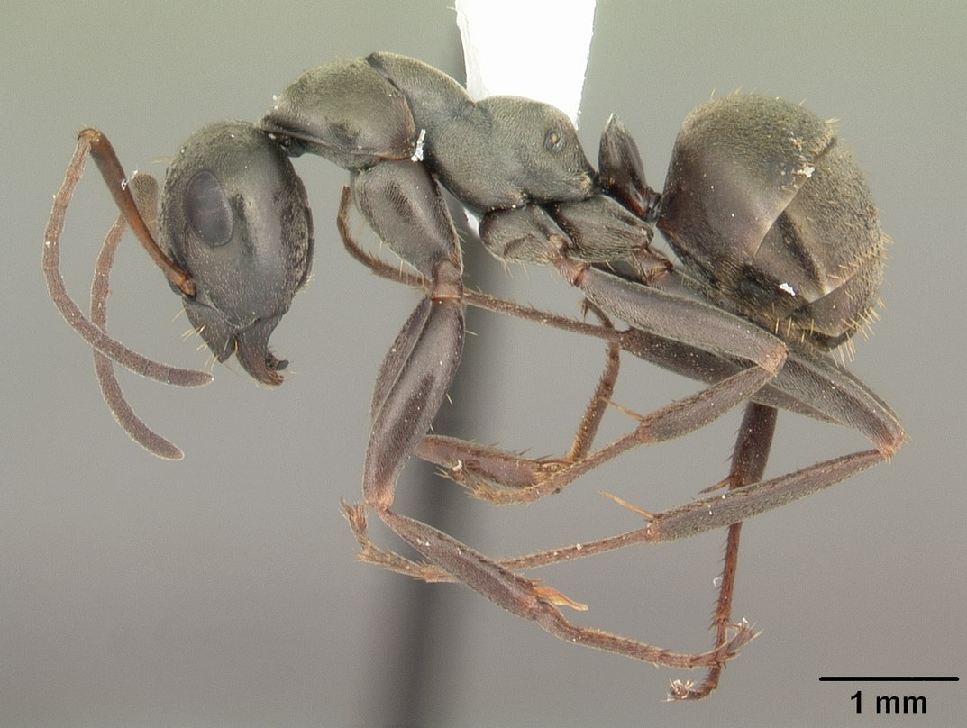
AntWeb worker profile of Formica subsericea, a representative field ant.
Photograph: April Nobile · Original source · CC BY 4.0. Resized proportionally.
Fast-moving ants of soil, grassland, woodland edges, and other habitats. Some build obvious mounds, while others have modest entrances. Formica subsericea is the photographic example in this set.

At a Glance
Field | Information
Scientific name | Formica species
Worker length | Many local workers are about 3 to 7 mm; species vary
Native status | Numerous Indiana species are native
Practical significance | A diverse genus group; assess each species separately

Identification
Workers have one waist node and typically an uneven middle-body profile. Many have visible simple eyes on the top of the head. Black, reddish, and mixed colors all occur. A mound and body color do not establish the species. [ID]
Carpenter ants usually have a smoother, evenly rounded upper profile. A red-and-black field ant is not automatically a fire ant. Some Formica species require a specialist and a series of worker specimens for identification.

Food and foraging
Common resources include insect prey, dead insects, and honeydew. Feeding observations are more informative than assuming that every large mound represents plant damage. [ID]
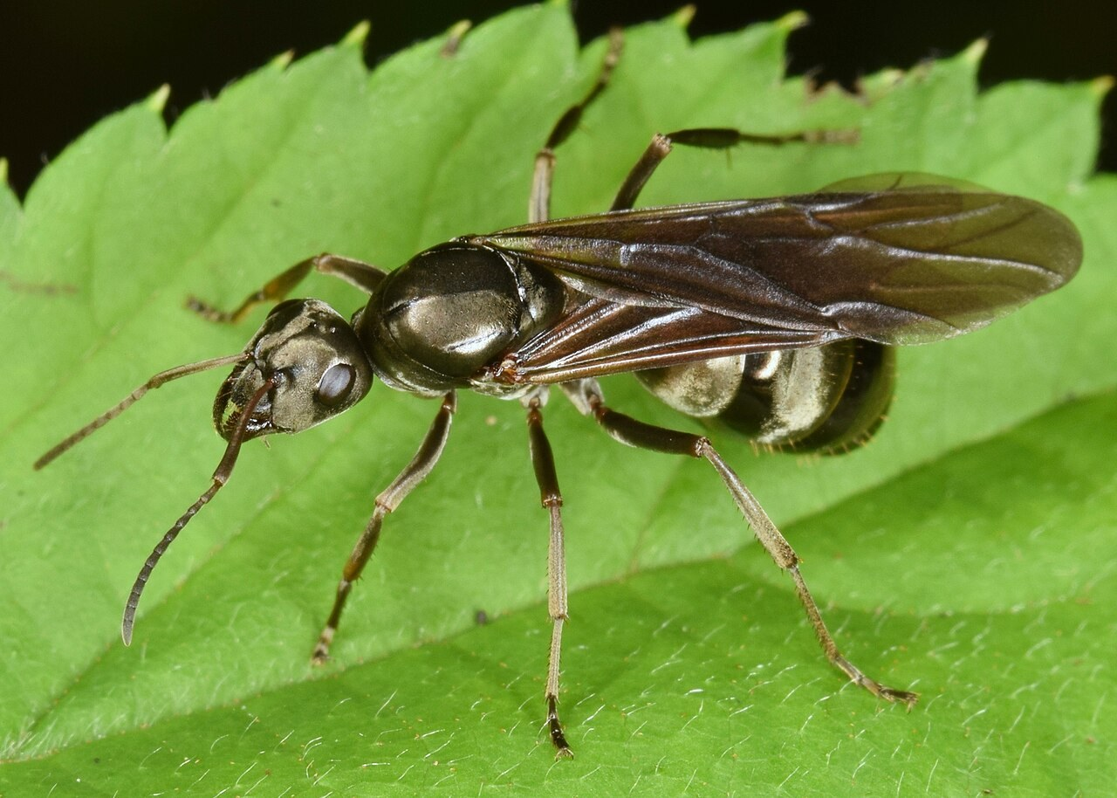
Winged Formica subsericea from the credited source record.
Photograph: Christina Butler from Georgia, United States · Original source · CC BY 2.0. Resized proportionally.

Life cycle and seasonal timing
Workers rear brood in soil nests. Winged reproductives occur seasonally, but nesting systems and colony-founding strategies vary markedly among species. Some Formica have specialized social relationships with other ants.
Many Midwestern field-ant swarms occur during summer and early autumn. This broad group has no single dependable flight month. [ID]
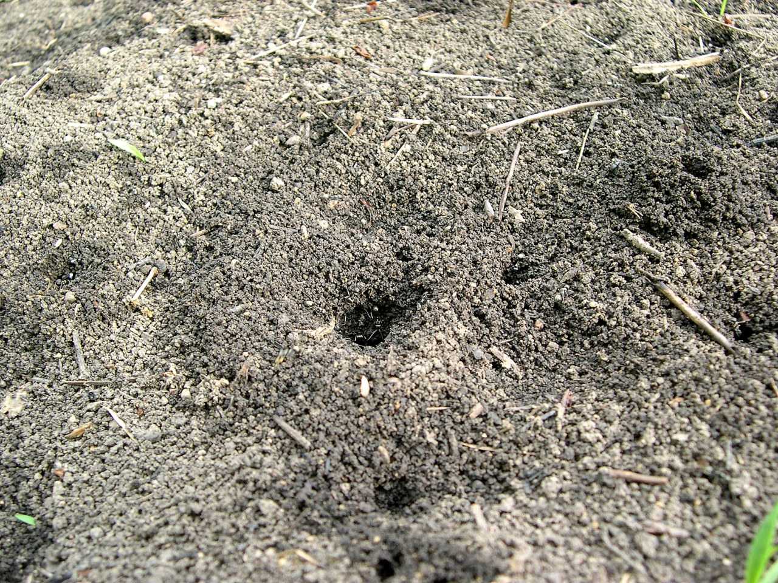
Black Ant (Formica subsericea) mound - Flickr - Jay Sturner.jpg • Jay Sturner from USA • CC BY 2.0
Photograph: Jay Sturner from USA · Original source · CC BY 2.0. Resized proportionally.
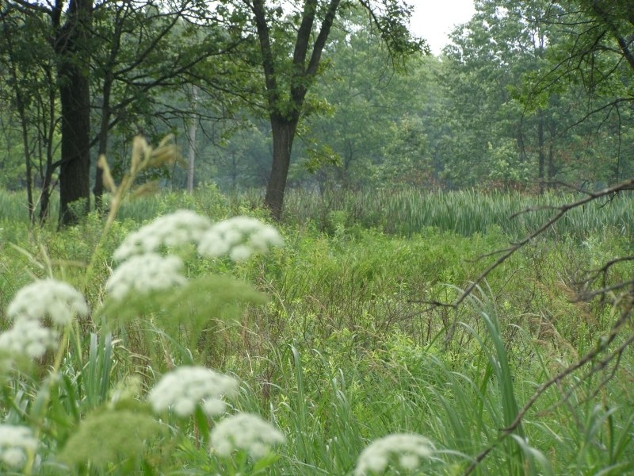
Hoosier Prairie P7150009.jpg • Chris Light, National Park Service • Public domain
Photograph: Chris Light, National Park Service · Original source · Public domain. Resized proportionally.

Environment and local occurrence
Open soil, lawns, prairies, woodland margins, and other settings depending on species. Some build soil or thatch mounds; others nest beneath objects with less visible surface structure.
Morris lists Tippecanoe County for the historical Formica fusca subsericea combination. Other Formica species need their own records. [IN]

Living with this ant
Usually tolerate outdoor nests. If a mound interferes with a path or mowing, first consider adjusting the route or managed area. Confirm the ant before selecting a targeted response. [UC]
Observe without handling or deliberately disturbing the nest. Before using a pesticide, confirm the ant and follow the current label for the site and application. Protect food, children, pets, and nearby water.

Related Information Sheets
Added September 22, 2026 · All Information Sheets

Sharing and reuse
© 2026 James Taylor · Plant Education Project. The original human-authored text in this Information Sheet is licensed under Creative Commons Attribution–NonCommercial 4.0 International (CC BY-NC 4.0).
You may share and adapt this text for noncommercial purposes. Credit the author and Plant Education Project, link to the source and license, and identify any changes. These permissions cannot be withdrawn from users who comply with the license, including for copies already released.
Photographs, illustrations, logos, quotations, and other third-party material are excluded from this text license and retain their individual rights and permissions. Separately published articles and book manuscripts are not licensed by this notice.

Field Ants — Climate
Online Information Sheet: planteducationproject.com/animals/field-ants/climate/
🌿 Climate Information Sheet
Formica species
Indiana provides a seasonal outdoor setting, with freezing winters and warm summers. The table describes Lafayette weather; it is not a nest-temperature range or a laboratory tolerance limit for this ant.

Lafayette climate at a glance
Month | Mean °F | Mean °C | Precip in | Precip mm
Jan | 25.8 | -3.4 | 2.19 | 56
Feb | 29.7 | -1.3 | 1.78 | 45
Mar | 40.0 | 4.4 | 2.73 | 69
Apr | 51.1 | 10.6 | 3.84 | 98
May | 61.6 | 16.4 | 4.04 | 103
Jun | 70.7 | 21.5 | 4.56 | 116
Jul | 73.6 | 23.1 | 4.08 | 104
Aug | 72.2 | 22.3 | 3.12 | 79
Sep | 65.5 | 18.6 | 2.59 | 66
Oct | 53.7 | 12.1 | 2.91 | 74
Nov | 41.3 | 5.2 | 2.87 | 73
Dec | 31.0 | -0.6 | 2.29 | 58

Seasonal activity
Record the first surface activity, major foraging periods, and winged-ant appearances separately. These are different biological events and need not respond identically to weather.
Many Midwestern field-ant swarms occur during summer and early autumn. This broad group has no single dependable flight month. [ID]

The nest has its own climate
Sun exposure can change a mound temperature rapidly. A warm mound top does not describe all chambers below it. Use nonintrusive surface readings and make that limitation explicit.
Sun, cover, soil depth, and indoor heating can shift exposure within a few steps. No single temperature or humidity target should be inferred from this regional climate table.

Weather extremes and future change
NOAA’s 2022 Indiana assessment projects warmer conditions and increased risks from heavy precipitation, while greater evaporation can intensify drought. These are regional projections; they do not predict the abundance of an individual ant species. [Climate]
Observation suggestion: record the first spring workers and each swarm with the date, time, recent rain, and location. Compare several years before attributing a change to climate rather than food availability, habitat change, or observation effort.

References

Related Information Sheets
Added September 22, 2026 · All Information Sheets

Sharing and reuse
© 2026 James Taylor · Plant Education Project. The original human-authored text in this Information Sheet is licensed under Creative Commons Attribution–NonCommercial 4.0 International (CC BY-NC 4.0).
You may share and adapt this text for noncommercial purposes. Credit the author and Plant Education Project, link to the source and license, and identify any changes. These permissions cannot be withdrawn from users who comply with the license, including for copies already released.
Photographs, illustrations, logos, quotations, and other third-party material are excluded from this text license and retain their individual rights and permissions. Separately published articles and book manuscripts are not licensed by this notice.

Field Ants — Ecology
Online Information Sheet: planteducationproject.com/animals/field-ants/ecology/
🌿 Ecology Information Sheet
Formica species
Follow this ant’s feeding, nesting, and relationships with plants and other animals to understand its role in the local community.
Nest mound attributed to Formica subsericea by photographer Jay Sturner.
Photograph: Jay Sturner from USA · Original source · CC BY 2.0. Resized proportionally.

Food web role
Formica ants can be influential predators and scavengers. They also interact with sap-feeding insects and compete with other ants. Their diversity makes species-level identification especially valuable for ecological interpretation. [ID]

Relationships with plants
Some species attend honeydew-producing insects. Certain mound-building species can suppress nearby vegetation; this should not be generalized to every field ant or blamed for every bare patch.
When ants visit a plant, distinguish feeding on plant tissue, gathering nectar or honeydew, hunting, and simple passage. Seeing ants on a flower does not establish effective pollination. [UC]

Colony and community
Workers rear brood in soil nests. Winged reproductives occur seasonally, but nesting systems and colony-founding strategies vary markedly among species. Some Formica have specialized social relationships with other ants.
A diverse genus group; assess each species separately. Morris lists Tippecanoe County for the historical Formica fusca subsericea combination. Other Formica species need their own records. [IN]

A question to investigate
Does the vegetation pattern around a mound remain consistent through the season, and is there direct evidence of ant activity affecting it?
Observe for five minutes on at least three occasions. Record what workers carry or contact, note the weather, and include a nearby comparison area. Visible traffic is not a measure of total colony size.

Management implication
Usually tolerate outdoor nests. If a mound interferes with a path or mowing, first consider adjusting the route or managed area. Confirm the ant before selecting a targeted response.
Retain the observation record after any action. Compare the original problem, plant condition, and ant traffic rather than using the disappearance of every ant as the goal. [UC]

Useful terms
Honeydew is sugary excretion from sap-feeding insects. Brood means eggs, larvae, and pupae. A mutualism benefits both partners.

Related Information Sheets
Added September 22, 2026 · All Information Sheets

Sharing and reuse
© 2026 James Taylor · Plant Education Project. The original human-authored text in this Information Sheet is licensed under Creative Commons Attribution–NonCommercial 4.0 International (CC BY-NC 4.0).
You may share and adapt this text for noncommercial purposes. Credit the author and Plant Education Project, link to the source and license, and identify any changes. These permissions cannot be withdrawn from users who comply with the license, including for copies already released.
Photographs, illustrations, logos, quotations, and other third-party material are excluded from this text license and retain their individual rights and permissions. Separately published articles and book manuscripts are not licensed by this notice.

Field Ants — Environment
Online Information Sheet: planteducationproject.com/animals/field-ants/environment/
🌿 Environment Information Sheet
Formica species
The nest environment explains where this ant can live and how it reaches food. Compare soil, shelter, moisture, and nearby vegetation before treating an entire landscape as one habitat.
Black Ant (Formica subsericea) mound - Flickr - Jay Sturner.jpg • Jay Sturner from USA • CC BY 2.0
Photograph: Jay Sturner from USA · Original source · CC BY 2.0. Resized proportionally.
Hoosier Prairie P7150009.jpg • Chris Light, National Park Service • Public domain
Photograph: Chris Light, National Park Service · Original source · Public domain. Resized proportionally.

Habitat and shelter
Open soil, lawns, prairies, woodland margins, and other settings depending on species. Some build soil or thatch mounds; others nest beneath objects with less visible surface structure. [ID]

Water and the nesting substrate
Mound exposure, vegetation cover, and soil drainage affect local conditions. A large mound is a constructed nest environment, not simply a pile of unwanted soil.

Food routes and vegetation
Common resources include insect prey, dead insects, and honeydew. Feeding observations are more informative than assuming that every large mound represents plant damage.
Some species attend honeydew-producing insects. Certain mound-building species can suppress nearby vegetation; this should not be generalized to every field ant or blamed for every bare patch. [ID, UC]

Comparison with Lafayette
Sun exposure can change a mound temperature rapidly. A warm mound top does not describe all chambers below it. Use nonintrusive surface readings and make that limitation explicit.
Morris lists Tippecanoe County for the historical Formica fusca subsericea combination. Other Formica species need their own records. [IN]

Manage the setting
Describe the mound material, height, cover, and surrounding vegetation. Avoid opening the nest. For large habitat projects, retain a range of undisturbed ground conditions and consult species-level evidence.
Keep a record of the actual conflict: indoor food contamination, structural nesting, a blocked path, or no practical problem. An outdoor ant population does not by itself call for control. [PU]

A simple habitat observation
Choose two nearby places with contrasting cover. Observe each for five minutes at a similar time of day. Record shade, substrate, wetness, visible entrances, and the number of workers crossing a fixed line. Repeat on several days; a trail count measures visible traffic, not colony size.

Related Information Sheets
Added September 22, 2026 · All Information Sheets

Sharing and reuse
© 2026 James Taylor · Plant Education Project. The original human-authored text in this Information Sheet is licensed under Creative Commons Attribution–NonCommercial 4.0 International (CC BY-NC 4.0).
You may share and adapt this text for noncommercial purposes. Credit the author and Plant Education Project, link to the source and license, and identify any changes. These permissions cannot be withdrawn from users who comply with the license, including for copies already released.
Photographs, illustrations, logos, quotations, and other third-party material are excluded from this text license and retain their individual rights and permissions. Separately published articles and book manuscripts are not licensed by this notice.

Sharing and image credits
Original Information Sheet text is licensed under Creative Commons Attribution–NonCommercial 4.0 International (CC BY-NC 4.0). Credit James Taylor and the Plant Education Project, link to the source and license, and identify changes. Photographs and other third-party material retain the rights and permissions stated with each image.

