Cornfield Ant
Combined Information Sheets

Cornfield Ant
Online Information Sheet: planteducationproject.com/animals/cornfield-ant/
🌿 Animal Information Sheet
Lasius americanus
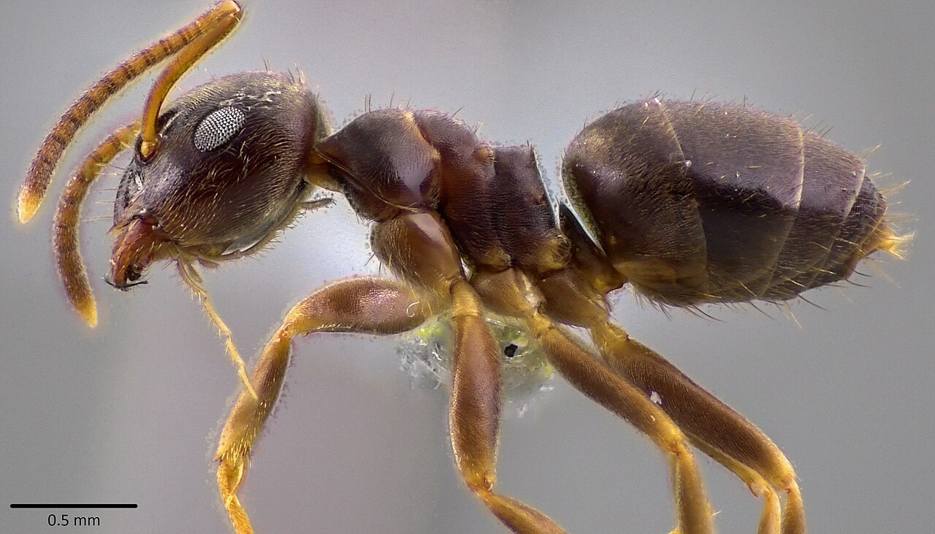
Worker profile of Lasius americanus from the credited source record.
Photograph: Emmett Collins-Sussman · Original source · CC BY 4.0. Resized proportionally.
A small brown native ant also called the woodland fuzzy ant. “Cornfield ant” is used for several Lasius ants, so keep the scientific name with photographs and records.

At a Glance
Field | Information
Scientific name | Lasius americanus
Worker length | About 2.5 to 4 mm
Native status | Native to North America
Practical significance | Native soil and woodland ant; usually a minor nuisance

Identification
Workers are brown, often with paler legs, with one waist node and an uneven middle-body profile. Species identification among small Lasius ants depends on details such as hair distribution and body proportions that usually require magnification. [ID]
Lasius neoniger is also called the cornfield or turfgrass ant. Older North American records labeled Lasius alienus may concern L. americanus; do not transfer every old locality or behavior record automatically.

Food and foraging
Collects honeydew and small insect food. Trails to plants can reveal sap-feeding insects, while much colony activity remains beneath cover or in soil. [ID]
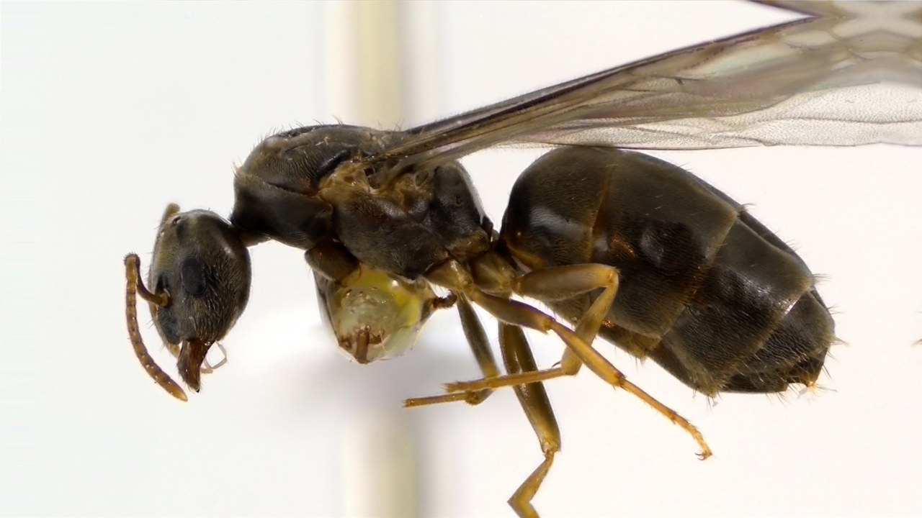
Winged queen of Lasius americanus. Queens are larger and more heavily built than workers.
Photograph: Emmett Collins-Sussman · Original source · CC BY 4.0. Resized proportionally.

Life cycle and seasonal timing
Colonies develop through egg, larval, pupal, and adult stages. Winged males and young queens disperse seasonally. The size and behavior of a queen should not be compared directly with the worker identification characters.
Regional guides place Lasius americanus mating swarms mainly in summer into early autumn. Confirm the species before attributing a September swarm to this ant rather than L. neoniger. [ID]
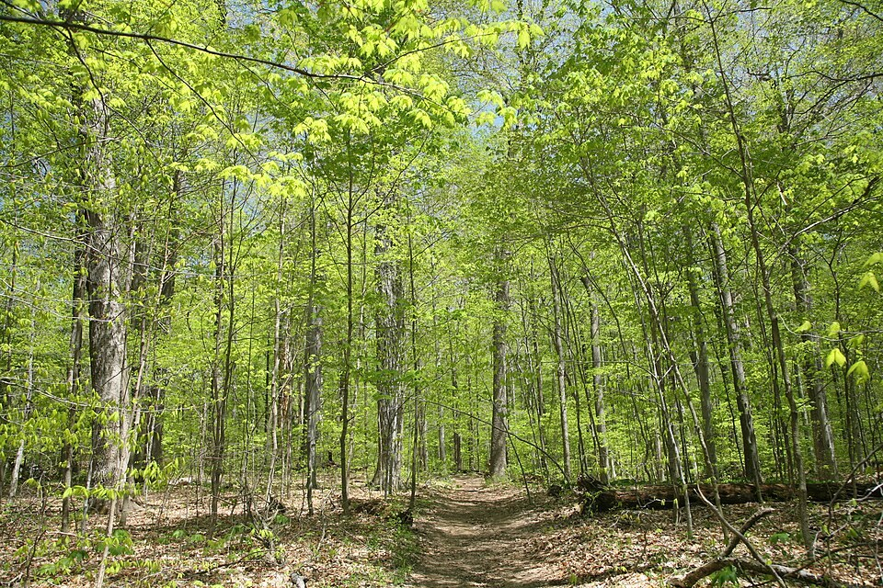
Turkey Run SP, IN 2.jpg • Daniel Schwen • CC BY-SA 4.0
Photograph: Daniel Schwen · Original source · CC BY-SA 4.0. Resized proportionally.
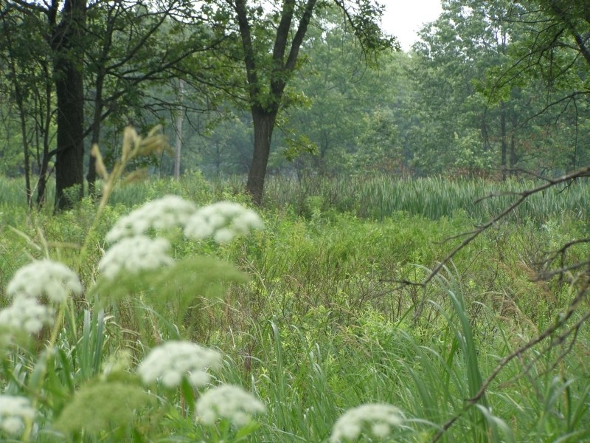
Hoosier Prairie P7150009.jpg • Chris Light, National Park Service • Public domain
Photograph: Chris Light, National Park Service · Original source · Public domain. Resized proportionally.

Environment and local occurrence
Soil and sheltered spaces beneath stones or decaying wood in woodlands, edges, and some modified landscapes. A small crater in a lawn can suggest a soil-nesting ant but is not species diagnostic.
Historical Indiana Lasius records use older names with changing species boundaries. A current specimen identification is needed before assigning a historical locality confidently to L. americanus. [IN]

Living with this ant
Usually tolerate outdoor nests. For occasional indoor foragers, correct food and water attractions and seal access. Obtain a close identification before deciding that a recurring problem is this species. [UC]
Observe without handling or deliberately disturbing the nest. Before using a pesticide, confirm the ant and follow the current label for the site and application. Protect food, children, pets, and nearby water.

Related Information Sheets
Added September 22, 2026 · All Information Sheets

Sharing and reuse
© 2026 James Taylor · Plant Education Project. The original human-authored text in this Information Sheet is licensed under Creative Commons Attribution–NonCommercial 4.0 International (CC BY-NC 4.0).
You may share and adapt this text for noncommercial purposes. Credit the author and Plant Education Project, link to the source and license, and identify any changes. These permissions cannot be withdrawn from users who comply with the license, including for copies already released.
Photographs, illustrations, logos, quotations, and other third-party material are excluded from this text license and retain their individual rights and permissions. Separately published articles and book manuscripts are not licensed by this notice.

Cornfield Ant — Climate
Online Information Sheet: planteducationproject.com/animals/cornfield-ant/climate/
🌿 Climate Information Sheet
Lasius americanus
Indiana provides a seasonal outdoor setting, with freezing winters and warm summers. The table describes Lafayette weather; it is not a nest-temperature range or a laboratory tolerance limit for this ant.

Lafayette climate at a glance
Month | Mean °F | Mean °C | Precip in | Precip mm
Jan | 25.8 | -3.4 | 2.19 | 56
Feb | 29.7 | -1.3 | 1.78 | 45
Mar | 40.0 | 4.4 | 2.73 | 69
Apr | 51.1 | 10.6 | 3.84 | 98
May | 61.6 | 16.4 | 4.04 | 103
Jun | 70.7 | 21.5 | 4.56 | 116
Jul | 73.6 | 23.1 | 4.08 | 104
Aug | 72.2 | 22.3 | 3.12 | 79
Sep | 65.5 | 18.6 | 2.59 | 66
Oct | 53.7 | 12.1 | 2.91 | 74
Nov | 41.3 | 5.2 | 2.87 | 73
Dec | 31.0 | -0.6 | 2.29 | 58

Seasonal activity
Warm-season surface activity is easiest to detect, but colony persistence should be assessed across repeated visits. A single quiet visit in cool weather is weak evidence that a nest disappeared.
Regional guides place Lasius americanus mating swarms mainly in summer into early autumn. Confirm the species before attributing a September swarm to this ant rather than L. neoniger. [ID]

The nest has its own climate
Compare litter depth, overhead shade, and the cover object at each site. Do not assign the outdoor climate of a forest floor from measurements taken on a nearby sunlit sidewalk.
Sun, cover, soil depth, and indoor heating can shift exposure within a few steps. No single temperature or humidity target should be inferred from this regional climate table.

Weather extremes and future change
NOAA’s 2022 Indiana assessment projects warmer conditions and increased risks from heavy precipitation, while greater evaporation can intensify drought. These are regional projections; they do not predict the abundance of an individual ant species. [Climate]
Observation suggestion: record the first spring workers and each swarm with the date, time, recent rain, and location. Compare several years before attributing a change to climate rather than food availability, habitat change, or observation effort.

References

Related Information Sheets
Added September 22, 2026 · All Information Sheets

Sharing and reuse
© 2026 James Taylor · Plant Education Project. The original human-authored text in this Information Sheet is licensed under Creative Commons Attribution–NonCommercial 4.0 International (CC BY-NC 4.0).
You may share and adapt this text for noncommercial purposes. Credit the author and Plant Education Project, link to the source and license, and identify any changes. These permissions cannot be withdrawn from users who comply with the license, including for copies already released.
Photographs, illustrations, logos, quotations, and other third-party material are excluded from this text license and retain their individual rights and permissions. Separately published articles and book manuscripts are not licensed by this notice.

Cornfield Ant — Ecology
Online Information Sheet: planteducationproject.com/animals/cornfield-ant/ecology/
🌿 Ecology Information Sheet
Lasius americanus
Follow this ant’s feeding, nesting, and relationships with plants and other animals to understand its role in the local community.
Worker profile of Lasius americanus from the credited source record.
Photograph: Emmett Collins-Sussman · Original source · CC BY 4.0. Resized proportionally.

Food web role
This ant belongs to a larger community of small soil and woodland ants. Nest excavation and food transport connect belowground shelters with aboveground resources. Its ecological role cannot be inferred from the word cornfield alone. [ID]

Relationships with plants
Honeydew connects the ants with sap-feeding insects. Watch whether workers contact aphids, carry insect prey, or merely pass over a leaf; those observations imply different ecological roles.
When ants visit a plant, distinguish feeding on plant tissue, gathering nectar or honeydew, hunting, and simple passage. Seeing ants on a flower does not establish effective pollination. [UC]

Colony and community
Colonies develop through egg, larval, pupal, and adult stages. Winged males and young queens disperse seasonally. The size and behavior of a queen should not be compared directly with the worker identification characters.
Native soil and woodland ant; usually a minor nuisance. Historical Indiana Lasius records use older names with changing species boundaries. A current specimen identification is needed before assigning a historical locality confidently to L. americanus. [IN]

A question to investigate
Are verified Lasius americanus records more frequent beneath woody cover than in adjacent open turf on the same observation route?
Observe for five minutes on at least three occasions. Record what workers carry or contact, note the weather, and include a nearby comparison area. Visible traffic is not a measure of total colony size.

Management implication
Usually tolerate outdoor nests. For occasional indoor foragers, correct food and water attractions and seal access. Obtain a close identification before deciding that a recurring problem is this species.
Retain the observation record after any action. Compare the original problem, plant condition, and ant traffic rather than using the disappearance of every ant as the goal. [UC]

Useful terms
Honeydew is sugary excretion from sap-feeding insects. Brood means eggs, larvae, and pupae. A mutualism benefits both partners.

Related Information Sheets
Added September 22, 2026 · All Information Sheets

Sharing and reuse
© 2026 James Taylor · Plant Education Project. The original human-authored text in this Information Sheet is licensed under Creative Commons Attribution–NonCommercial 4.0 International (CC BY-NC 4.0).
You may share and adapt this text for noncommercial purposes. Credit the author and Plant Education Project, link to the source and license, and identify any changes. These permissions cannot be withdrawn from users who comply with the license, including for copies already released.
Photographs, illustrations, logos, quotations, and other third-party material are excluded from this text license and retain their individual rights and permissions. Separately published articles and book manuscripts are not licensed by this notice.

Cornfield Ant — Environment
Online Information Sheet: planteducationproject.com/animals/cornfield-ant/environment/
🌿 Environment Information Sheet
Lasius americanus
The nest environment explains where this ant can live and how it reaches food. Compare soil, shelter, moisture, and nearby vegetation before treating an entire landscape as one habitat.
Turkey Run SP, IN 2.jpg • Daniel Schwen • CC BY-SA 4.0
Photograph: Daniel Schwen · Original source · CC BY-SA 4.0. Resized proportionally.
Hoosier Prairie P7150009.jpg • Chris Light, National Park Service • Public domain
Photograph: Chris Light, National Park Service · Original source · Public domain. Resized proportionally.

Habitat and shelter
Soil and sheltered spaces beneath stones or decaying wood in woodlands, edges, and some modified landscapes. A small crater in a lawn can suggest a soil-nesting ant but is not species diagnostic. [ID]

Water and the nesting substrate
Cover objects and litter create small moist refuges. Their underside conditions can differ greatly from the top of the surrounding lawn, particularly after several rain-free days.

Food routes and vegetation
Collects honeydew and small insect food. Trails to plants can reveal sap-feeding insects, while much colony activity remains beneath cover or in soil.
Honeydew connects the ants with sap-feeding insects. Watch whether workers contact aphids, carry insect prey, or merely pass over a leaf; those observations imply different ecological roles. [ID, UC]

Comparison with Lafayette
Compare litter depth, overhead shade, and the cover object at each site. Do not assign the outdoor climate of a forest floor from measurements taken on a nearby sunlit sidewalk.
Historical Indiana Lasius records use older names with changing species boundaries. A current specimen identification is needed before assigning a historical locality confidently to L. americanus. [IN]

Manage the setting
Record whether an observation came from closed woodland, a wooded edge, or open turf. This habitat distinction helps interpret records that otherwise share the common name cornfield ant.
Keep a record of the actual conflict: indoor food contamination, structural nesting, a blocked path, or no practical problem. An outdoor ant population does not by itself call for control. [PU]

A simple habitat observation
Choose two nearby places with contrasting cover. Observe each for five minutes at a similar time of day. Record shade, substrate, wetness, visible entrances, and the number of workers crossing a fixed line. Repeat on several days; a trail count measures visible traffic, not colony size.

Related Information Sheets
Added September 22, 2026 · All Information Sheets

Sharing and reuse
© 2026 James Taylor · Plant Education Project. The original human-authored text in this Information Sheet is licensed under Creative Commons Attribution–NonCommercial 4.0 International (CC BY-NC 4.0).
You may share and adapt this text for noncommercial purposes. Credit the author and Plant Education Project, link to the source and license, and identify any changes. These permissions cannot be withdrawn from users who comply with the license, including for copies already released.
Photographs, illustrations, logos, quotations, and other third-party material are excluded from this text license and retain their individual rights and permissions. Separately published articles and book manuscripts are not licensed by this notice.

Sharing and image credits
Original Information Sheet text is licensed under Creative Commons Attribution–NonCommercial 4.0 International (CC BY-NC 4.0). Credit James Taylor and the Plant Education Project, link to the source and license, and identify changes. Photographs and other third-party material retain the rights and permissions stated with each image.

