Black Carpenter Ant
Combined Information Sheets

Black Carpenter Ant
Online Information Sheet: planteducationproject.com/animals/black-carpenter-ant/
🌿 Animal Information Sheet
Camponotus pennsylvanicus
A large native ant that excavates wood for shelter. It eats other foods, not wood. Around a house, finding the nest and correcting moisture matter more than killing a few roaming workers.

At a Glance
Field | Information
Scientific name | Camponotus pennsylvanicus
Worker length | Workers commonly about 6 to 13 mm
Native status | Native to eastern and central North America
Practical significance | Native woodland ant; established nests can damage building wood

Identification
Workers are black and vary considerably in size within one colony. The upper outline of the middle body is smoothly rounded when seen from the side, and the waist has one node. Coarse wood fragments near an opening can indicate excavation but do not establish the species by themselves. [ID]
Field ants can be similar in size and color but usually have a less evenly arched middle body. Termites have a broad waist and straight, beaded antennae; winged termites have two similarly sized wing pairs.

Food and foraging
Collects honeydew and other sugary liquids and eats live or dead insects. Foraging workers may travel from a tree nest into a house without nesting inside. [ID]
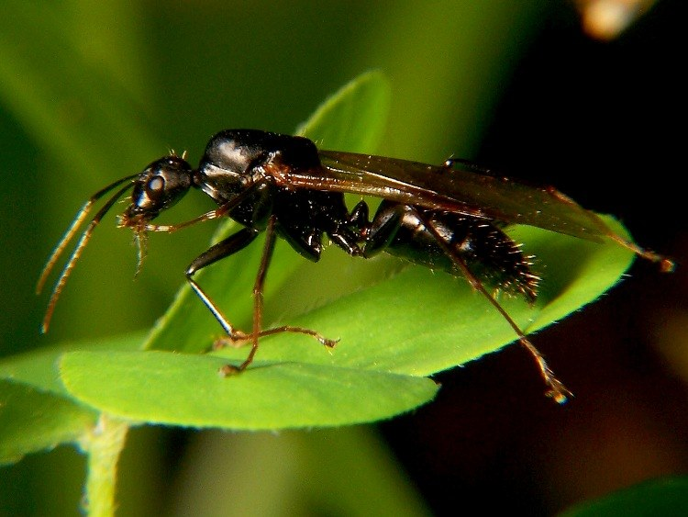
Winged male black carpenter ant. Males have a different build from workers.
Photograph: xpda · Original source · CC BY-SA 4.0. Resized proportionally.

Life cycle and seasonal timing
Colonies include differently sized female workers, a queen, brood, and seasonal winged reproductives. A colony may use a main nest and additional satellite nests. Their moisture conditions and occupants can differ.
Winged reproductives are often noticed in spring and early summer. Repeated winter or very early indoor activity warrants a search for a sheltered nest. [ID, Carpenter]
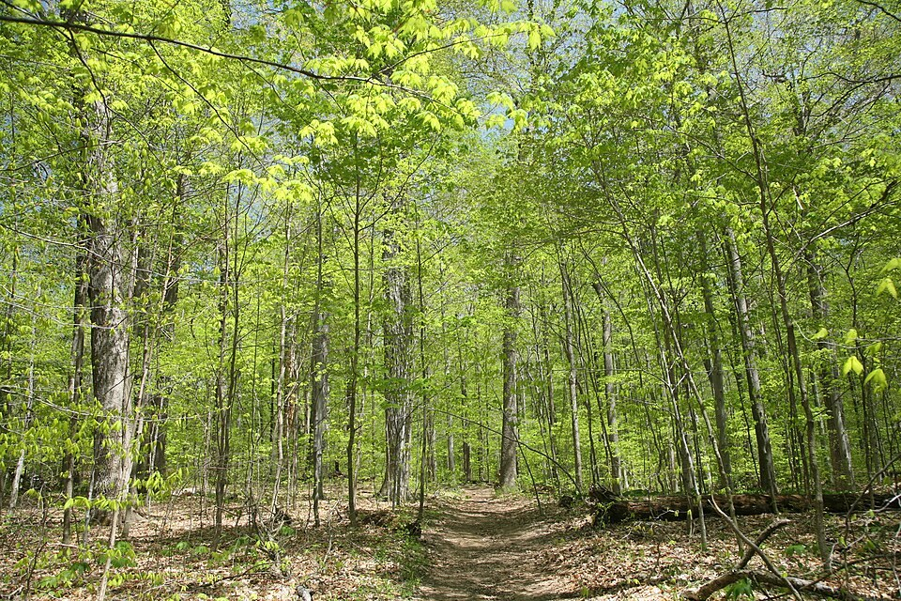
Carpenter ant drone wiki.jpg • Bruce Marlin • CC BY-SA 2.5
Photograph: Bruce Marlin · Original source · CC BY-SA 2.5. Resized proportionally.
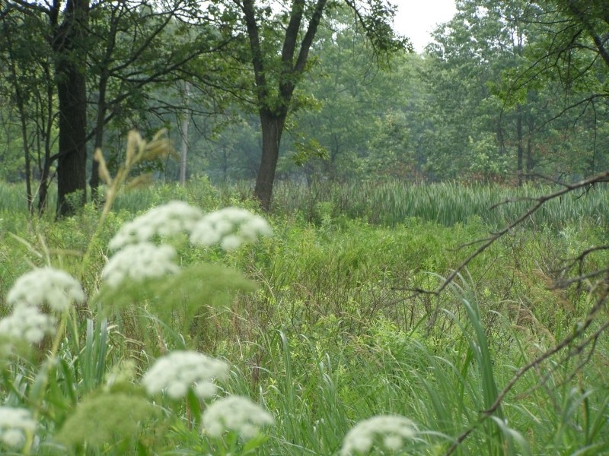
Turkey Run SP, IN 2.jpg • Daniel Schwen • CC BY-SA 4.0
Photograph: Daniel Schwen · Original source · CC BY-SA 4.0. Resized proportionally.

Environment and local occurrence
Hollow or decaying trees, stumps, logs, and sometimes structural timbers. Damp wood often supports the main nest; satellite nests may occupy drier spaces.
Morris lists Tippecanoe County under an older Camponotus pennsylvanicus combination. The record supports historical local occurrence, not a current nest location. [IN]

Living with this ant
Document activity and wood debris, repair water problems, and seek professional assessment when a building nest is suspected. Treating visible foragers alone can leave the main nest and satellites intact. [UC]
Observe without handling or deliberately disturbing the nest. Before using a pesticide, confirm the ant and follow the current label for the site and application. Protect food, children, pets, and nearby water.

Related Information Sheets
Added September 22, 2026 · All Information Sheets

Sharing and reuse
© 2026 James Taylor · Plant Education Project. The original human-authored text in this Information Sheet is licensed under Creative Commons Attribution–NonCommercial 4.0 International (CC BY-NC 4.0).
You may share and adapt this text for noncommercial purposes. Credit the author and Plant Education Project, link to the source and license, and identify any changes. These permissions cannot be withdrawn from users who comply with the license, including for copies already released.
Photographs, illustrations, logos, quotations, and other third-party material are excluded from this text license and retain their individual rights and permissions. Separately published articles and book manuscripts are not licensed by this notice.

Black Carpenter Ant — Climate
Online Information Sheet: planteducationproject.com/animals/black-carpenter-ant/climate/
🌿 Climate Information Sheet
Camponotus pennsylvanicus
Indiana provides a seasonal outdoor setting, with freezing winters and warm summers. The table describes Lafayette weather; it is not a nest-temperature range or a laboratory tolerance limit for this ant.

Lafayette climate at a glance
Month | Mean °F | Mean °C | Precip in | Precip mm
Jan | 25.8 | -3.4 | 2.19 | 56
Feb | 29.7 | -1.3 | 1.78 | 45
Mar | 40.0 | 4.4 | 2.73 | 69
Apr | 51.1 | 10.6 | 3.84 | 98
May | 61.6 | 16.4 | 4.04 | 103
Jun | 70.7 | 21.5 | 4.56 | 116
Jul | 73.6 | 23.1 | 4.08 | 104
Aug | 72.2 | 22.3 | 3.12 | 79
Sep | 65.5 | 18.6 | 2.59 | 66
Oct | 53.7 | 12.1 | 2.91 | 74
Nov | 41.3 | 5.2 | 2.87 | 73
Dec | 31.0 | -0.6 | 2.29 | 58

Seasonal activity
Look for outdoor foraging in the warm season, especially toward evening. Compare sheltered wood with exposed air conditions when evaluating unusual winter activity.
Winged reproductives are often noticed in spring and early summer. Repeated winter or very early indoor activity warrants a search for a sheltered nest. [ID, Carpenter]

The nest has its own climate
A hollow tree, damp sill, and insulated wall can have very different temperature and moisture regimes. An airport minimum temperature does not equal the temperature in any of those nests.
Sun, cover, soil depth, and indoor heating can shift exposure within a few steps. No single temperature or humidity target should be inferred from this regional climate table.

Weather extremes and future change
NOAA’s 2022 Indiana assessment projects warmer conditions and increased risks from heavy precipitation, while greater evaporation can intensify drought. These are regional projections; they do not predict the abundance of an individual ant species. [Climate]
Observation suggestion: record the first spring workers and each swarm with the date, time, recent rain, and location. Compare several years before attributing a change to climate rather than food availability, habitat change, or observation effort.

References

Related Information Sheets
Added September 22, 2026 · All Information Sheets

Sharing and reuse
© 2026 James Taylor · Plant Education Project. The original human-authored text in this Information Sheet is licensed under Creative Commons Attribution–NonCommercial 4.0 International (CC BY-NC 4.0).
You may share and adapt this text for noncommercial purposes. Credit the author and Plant Education Project, link to the source and license, and identify any changes. These permissions cannot be withdrawn from users who comply with the license, including for copies already released.
Photographs, illustrations, logos, quotations, and other third-party material are excluded from this text license and retain their individual rights and permissions. Separately published articles and book manuscripts are not licensed by this notice.

Black Carpenter Ant — Ecology
Online Information Sheet: planteducationproject.com/animals/black-carpenter-ant/ecology/
🌿 Ecology Information Sheet
Camponotus pennsylvanicus
Follow this ant’s feeding, nesting, and relationships with plants and other animals to understand its role in the local community.
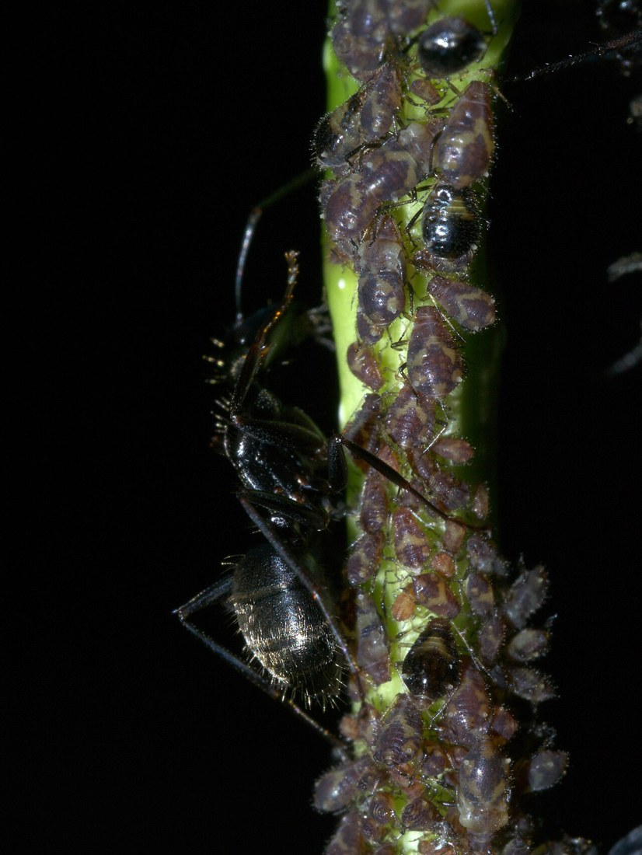
Black carpenter ant with aphids in Oklahoma. Identification follows the photographer record.
Photograph: xpda · Original source · CC BY-SA 4.0. Resized proportionally.

Food web role
Carpenter ants contribute to woodland food webs as predators and scavengers and as food for other animals. Their galleries modify dead or softened wood, but they do not digest cellulose in the way wood-feeding termites do. [Carpenter]

Relationships with plants
Workers on trunks may be hunting insects or collecting honeydew. Their presence on a living tree is not proof that the tree is dying; nesting in damaged wood and foraging on foliage are different observations.
When ants visit a plant, distinguish feeding on plant tissue, gathering nectar or honeydew, hunting, and simple passage. Seeing ants on a flower does not establish effective pollination. [UC]

Colony and community
Colonies include differently sized female workers, a queen, brood, and seasonal winged reproductives. A colony may use a main nest and additional satellite nests. Their moisture conditions and occupants can differ.
Native woodland ant; established nests can damage building wood. Morris lists Tippecanoe County under an older Camponotus pennsylvanicus combination. The record supports historical local occurrence, not a current nest location. [IN]

A question to investigate
Are workers merely crossing the trunk, collecting food on foliage, or entering a specific cavity?
Observe for five minutes on at least three occasions. Record what workers carry or contact, note the weather, and include a nearby comparison area. Visible traffic is not a measure of total colony size.

Management implication
Document activity and wood debris, repair water problems, and seek professional assessment when a building nest is suspected. Treating visible foragers alone can leave the main nest and satellites intact.
Retain the observation record after any action. Compare the original problem, plant condition, and ant traffic rather than using the disappearance of every ant as the goal. [UC]

Useful terms
Honeydew is sugary excretion from sap-feeding insects. Brood means eggs, larvae, and pupae. A mutualism benefits both partners.

Related Information Sheets
Added September 22, 2026 · All Information Sheets

Sharing and reuse
© 2026 James Taylor · Plant Education Project. The original human-authored text in this Information Sheet is licensed under Creative Commons Attribution–NonCommercial 4.0 International (CC BY-NC 4.0).
You may share and adapt this text for noncommercial purposes. Credit the author and Plant Education Project, link to the source and license, and identify any changes. These permissions cannot be withdrawn from users who comply with the license, including for copies already released.
Photographs, illustrations, logos, quotations, and other third-party material are excluded from this text license and retain their individual rights and permissions. Separately published articles and book manuscripts are not licensed by this notice.

Black Carpenter Ant — Environment
Online Information Sheet: planteducationproject.com/animals/black-carpenter-ant/environment/
🌿 Environment Information Sheet
Camponotus pennsylvanicus
The nest environment explains where this ant can live and how it reaches food. Compare soil, shelter, moisture, and nearby vegetation before treating an entire landscape as one habitat.
Turkey Run SP, IN 2.jpg • Daniel Schwen • CC BY-SA 4.0
Photograph: Daniel Schwen · Original source · CC BY-SA 4.0. Resized proportionally.
Hoosier Prairie P7150009.jpg • Chris Light, National Park Service • Public domain
Photograph: Chris Light, National Park Service · Original source · Public domain. Resized proportionally.

Habitat and shelter
Hollow or decaying trees, stumps, logs, and sometimes structural timbers. Damp wood often supports the main nest; satellite nests may occupy drier spaces. [ID]

Water and the nesting substrate
Water leakage and wood decay make building material easier to excavate. Examine the water source as well as the insect evidence; new sawdust does not identify the original cause of deterioration.

Food routes and vegetation
Collects honeydew and other sugary liquids and eats live or dead insects. Foraging workers may travel from a tree nest into a house without nesting inside.
Workers on trunks may be hunting insects or collecting honeydew. Their presence on a living tree is not proof that the tree is dying; nesting in damaged wood and foraging on foliage are different observations. [ID, UC]

Comparison with Lafayette
A hollow tree, damp sill, and insulated wall can have very different temperature and moisture regimes. An airport minimum temperature does not equal the temperature in any of those nests.
Morris lists Tippecanoe County under an older Camponotus pennsylvanicus combination. The record supports historical local occurrence, not a current nest location. [IN]

Manage the setting
Retain safe dead wood in suitable natural areas, but keep stored firewood and damp debris away from the building. Inspect window frames, roof leaks, plumbing areas, and wood in contact with soil.
Keep a record of the actual conflict: indoor food contamination, structural nesting, a blocked path, or no practical problem. An outdoor ant population does not by itself call for control. [PU]

A simple habitat observation
Choose two nearby places with contrasting cover. Observe each for five minutes at a similar time of day. Record shade, substrate, wetness, visible entrances, and the number of workers crossing a fixed line. Repeat on several days; a trail count measures visible traffic, not colony size.

Related Information Sheets
Added September 22, 2026 · All Information Sheets

Sharing and reuse
© 2026 James Taylor · Plant Education Project. The original human-authored text in this Information Sheet is licensed under Creative Commons Attribution–NonCommercial 4.0 International (CC BY-NC 4.0).
You may share and adapt this text for noncommercial purposes. Credit the author and Plant Education Project, link to the source and license, and identify any changes. These permissions cannot be withdrawn from users who comply with the license, including for copies already released.
Photographs, illustrations, logos, quotations, and other third-party material are excluded from this text license and retain their individual rights and permissions. Separately published articles and book manuscripts are not licensed by this notice.

Sharing and image credits
Original Information Sheet text is licensed under Creative Commons Attribution–NonCommercial 4.0 International (CC BY-NC 4.0). Credit James Taylor and the Plant Education Project, link to the source and license, and identify changes. Photographs and other third-party material retain the rights and permissions stated with each image.

