Acrobat Ants
Combined Information Sheets

Acrobat Ants
Online Information Sheet: planteducationproject.com/animals/acrobat-ants/
🌿 Animal Information Sheet
Crematogaster species
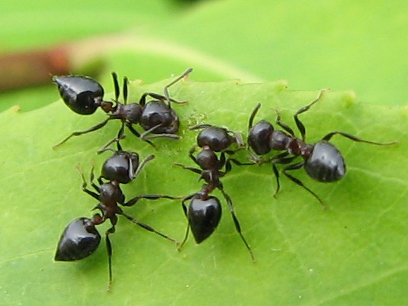
Crematogaster cerasi workers in Ontario. The pointed heart-shaped abdomen is visible.
Photograph: Jacy Lucier · Original source · CC BY-SA 4.0. Resized proportionally.
Small ants named for their habit of raising the abdomen when disturbed. Indiana has several species; the photographs show Crematogaster cerasi as an example, not every member of the genus.

At a Glance
Field | Information
Scientific name | Crematogaster species
Worker length | Many local workers are about 2.5 to 4 mm
Native status | Several Indiana members are native; status is species dependent
Practical significance | A genus group, not one species

Identification
Look for a distinctly heart-shaped abdomen from above, two waist nodes, and attachment of the waist toward the upper surface of the abdomen. The raised-abdomen posture is useful when observed naturally. Color alone is unreliable. [ID]
Small carpenter ants lack the heart-shaped abdomen and have one waist node. A genus-level identification does not determine which Crematogaster species is present or establish its full range.

Food and foraging
Foragers take insect food and sugary liquids, including honeydew. Trails can run along bark and branches as well as along building edges. [ID]
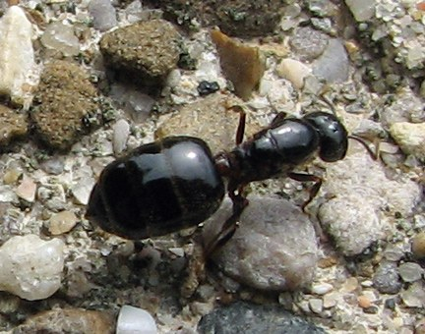
Crematogaster cerasi queen. A representative species, not a genus-wide size standard.
Photograph: Jacy Lucier · Original source · CC BY-SA 4.0. Resized proportionally.

Life cycle and seasonal timing
Colonies contain workers, brood, and reproductive ants. Winged males and queens appear seasonally. Colony-founding biology differs among species, so a single nest size or reproductive schedule should not be applied to the entire group.
Midwestern guides often report mating swarms in summer through early autumn. Species identification and local observations are needed for a more precise calendar. [ID]
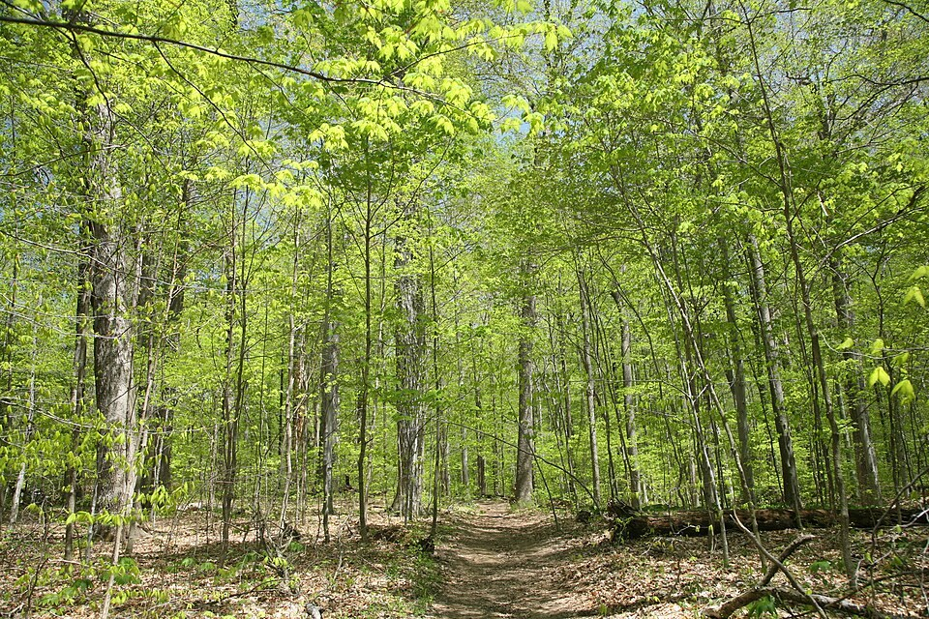
Turkey Run SP, IN 2.jpg • Daniel Schwen • CC BY-SA 4.0
Photograph: Daniel Schwen · Original source · CC BY-SA 4.0. Resized proportionally.
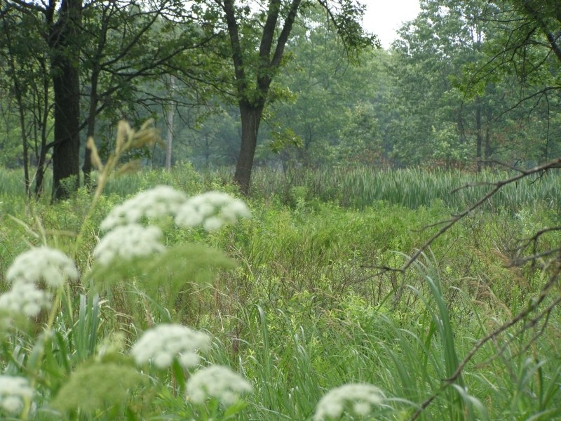
Hoosier Prairie P7150009.jpg • Chris Light, National Park Service • Public domain
Photograph: Chris Light, National Park Service · Original source · Public domain. Resized proportionally.

Environment and local occurrence
Many local species occupy dead branches, stumps, logs, and other sheltered woody spaces. Some nest under stones or use previously damaged building wood and wall voids.
Morris lists Tippecanoe County for Crematogaster lineolata and the historical cerasi form. These support historical group occurrence; the photos are not local voucher specimens. [IN]

Living with this ant
Preserve harmless outdoor colonies. Indoors, identify the nest location and correct damaged or damp wood. Persistent activity in inaccessible framing may require a pest professional. [UC]
Observe without handling or deliberately disturbing the nest. Before using a pesticide, confirm the ant and follow the current label for the site and application. Protect food, children, pets, and nearby water.

Related Information Sheets
Added September 22, 2026 · All Information Sheets

Sharing and reuse
© 2026 James Taylor · Plant Education Project. The original human-authored text in this Information Sheet is licensed under Creative Commons Attribution–NonCommercial 4.0 International (CC BY-NC 4.0).
You may share and adapt this text for noncommercial purposes. Credit the author and Plant Education Project, link to the source and license, and identify any changes. These permissions cannot be withdrawn from users who comply with the license, including for copies already released.
Photographs, illustrations, logos, quotations, and other third-party material are excluded from this text license and retain their individual rights and permissions. Separately published articles and book manuscripts are not licensed by this notice.

Acrobat Ants — Climate
Online Information Sheet: planteducationproject.com/animals/acrobat-ants/climate/
🌿 Climate Information Sheet
Crematogaster species
Indiana provides a seasonal outdoor setting, with freezing winters and warm summers. The table describes Lafayette weather; it is not a nest-temperature range or a laboratory tolerance limit for this ant.

Lafayette climate at a glance
Month | Mean °F | Mean °C | Precip in | Precip mm
Jan | 25.8 | -3.4 | 2.19 | 56
Feb | 29.7 | -1.3 | 1.78 | 45
Mar | 40.0 | 4.4 | 2.73 | 69
Apr | 51.1 | 10.6 | 3.84 | 98
May | 61.6 | 16.4 | 4.04 | 103
Jun | 70.7 | 21.5 | 4.56 | 116
Jul | 73.6 | 23.1 | 4.08 | 104
Aug | 72.2 | 22.3 | 3.12 | 79
Sep | 65.5 | 18.6 | 2.59 | 66
Oct | 53.7 | 12.1 | 2.91 | 74
Nov | 41.3 | 5.2 | 2.87 | 73
Dec | 31.0 | -0.6 | 2.29 | 58

Seasonal activity
Outdoor activity and reproductive flights generally occur during the warmer part of the year. Timing varies among species and between sheltered wood and exposed ground.
Midwestern guides often report mating swarms in summer through early autumn. Species identification and local observations are needed for a more precise calendar. [ID]

The nest has its own climate
A sunlit dead branch warms and dries differently from a shaded log. Record the actual nesting substrate instead of treating all woody sites as one environment.
Sun, cover, soil depth, and indoor heating can shift exposure within a few steps. No single temperature or humidity target should be inferred from this regional climate table.

Weather extremes and future change
NOAA’s 2022 Indiana assessment projects warmer conditions and increased risks from heavy precipitation, while greater evaporation can intensify drought. These are regional projections; they do not predict the abundance of an individual ant species. [Climate]
Observation suggestion: record the first spring workers and each swarm with the date, time, recent rain, and location. Compare several years before attributing a change to climate rather than food availability, habitat change, or observation effort.

References

Related Information Sheets
Added September 22, 2026 · All Information Sheets

Sharing and reuse
© 2026 James Taylor · Plant Education Project. The original human-authored text in this Information Sheet is licensed under Creative Commons Attribution–NonCommercial 4.0 International (CC BY-NC 4.0).
You may share and adapt this text for noncommercial purposes. Credit the author and Plant Education Project, link to the source and license, and identify any changes. These permissions cannot be withdrawn from users who comply with the license, including for copies already released.
Photographs, illustrations, logos, quotations, and other third-party material are excluded from this text license and retain their individual rights and permissions. Separately published articles and book manuscripts are not licensed by this notice.

Acrobat Ants — Ecology
Online Information Sheet: planteducationproject.com/animals/acrobat-ants/ecology/
🌿 Ecology Information Sheet
Crematogaster species
Follow this ant’s feeding, nesting, and relationships with plants and other animals to understand its role in the local community.
Crematogaster cerasi workers in Ontario. The pointed heart-shaped abdomen is visible.
Photograph: Jacy Lucier · Original source · CC BY-SA 4.0. Resized proportionally.

Food web role
Acrobat ants can connect canopy resources with the ground and woody cavities. Predation, scavenging, and collection of sugary liquids each contribute to their food supply. The balance varies with species and site. [ID]

Relationships with plants
Workers often visit honeydew-producing insects. Directly observe the interaction before saying that the ants protect a pest. Nesting in a dead branch does not establish that the ants killed the branch.
When ants visit a plant, distinguish feeding on plant tissue, gathering nectar or honeydew, hunting, and simple passage. Seeing ants on a flower does not establish effective pollination. [UC]

Colony and community
Colonies contain workers, brood, and reproductive ants. Winged males and queens appear seasonally. Colony-founding biology differs among species, so a single nest size or reproductive schedule should not be applied to the entire group.
A genus group, not one species. Morris lists Tippecanoe County for Crematogaster lineolata and the historical cerasi form. These support historical group occurrence; the photos are not local voucher specimens. [IN]

A question to investigate
Do workers arriving at a branch collect honeydew, carry prey, or enter a woody cavity?
Observe for five minutes on at least three occasions. Record what workers carry or contact, note the weather, and include a nearby comparison area. Visible traffic is not a measure of total colony size.

Management implication
Preserve harmless outdoor colonies. Indoors, identify the nest location and correct damaged or damp wood. Persistent activity in inaccessible framing may require a pest professional.
Retain the observation record after any action. Compare the original problem, plant condition, and ant traffic rather than using the disappearance of every ant as the goal. [UC]

Useful terms
Honeydew is sugary excretion from sap-feeding insects. Brood means eggs, larvae, and pupae. A mutualism benefits both partners.

Related Information Sheets
Added September 22, 2026 · All Information Sheets

Sharing and reuse
© 2026 James Taylor · Plant Education Project. The original human-authored text in this Information Sheet is licensed under Creative Commons Attribution–NonCommercial 4.0 International (CC BY-NC 4.0).
You may share and adapt this text for noncommercial purposes. Credit the author and Plant Education Project, link to the source and license, and identify any changes. These permissions cannot be withdrawn from users who comply with the license, including for copies already released.
Photographs, illustrations, logos, quotations, and other third-party material are excluded from this text license and retain their individual rights and permissions. Separately published articles and book manuscripts are not licensed by this notice.

Acrobat Ants — Environment
Online Information Sheet: planteducationproject.com/animals/acrobat-ants/environment/
🌿 Environment Information Sheet
Crematogaster species
The nest environment explains where this ant can live and how it reaches food. Compare soil, shelter, moisture, and nearby vegetation before treating an entire landscape as one habitat.
Turkey Run SP, IN 2.jpg • Daniel Schwen • CC BY-SA 4.0
Photograph: Daniel Schwen · Original source · CC BY-SA 4.0. Resized proportionally.
Hoosier Prairie P7150009.jpg • Chris Light, National Park Service • Public domain
Photograph: Chris Light, National Park Service · Original source · Public domain. Resized proportionally.

Habitat and shelter
Many local species occupy dead branches, stumps, logs, and other sheltered woody spaces. Some nest under stones or use previously damaged building wood and wall voids. [ID]

Water and the nesting substrate
The combination of shelter, wood condition, and access to food matters. Indoor activity near damp framing is a reason to inspect the moisture problem as well as identify the insects.

Food routes and vegetation
Foragers take insect food and sugary liquids, including honeydew. Trails can run along bark and branches as well as along building edges.
Workers often visit honeydew-producing insects. Directly observe the interaction before saying that the ants protect a pest. Nesting in a dead branch does not establish that the ants killed the branch. [ID, UC]

Comparison with Lafayette
A sunlit dead branch warms and dries differently from a shaded log. Record the actual nesting substrate instead of treating all woody sites as one environment.
Morris lists Tippecanoe County for Crematogaster lineolata and the historical cerasi form. These support historical group occurrence; the photos are not local voucher specimens. [IN]

Manage the setting
Inspect trails on trunks and branches without removing bark or breaking occupied wood. Keep branches from providing direct access to rooflines where indoor activity is a problem.
Keep a record of the actual conflict: indoor food contamination, structural nesting, a blocked path, or no practical problem. An outdoor ant population does not by itself call for control. [PU]

A simple habitat observation
Choose two nearby places with contrasting cover. Observe each for five minutes at a similar time of day. Record shade, substrate, wetness, visible entrances, and the number of workers crossing a fixed line. Repeat on several days; a trail count measures visible traffic, not colony size.

Related Information Sheets
Added September 22, 2026 · All Information Sheets

Sharing and reuse
© 2026 James Taylor · Plant Education Project. The original human-authored text in this Information Sheet is licensed under Creative Commons Attribution–NonCommercial 4.0 International (CC BY-NC 4.0).
You may share and adapt this text for noncommercial purposes. Credit the author and Plant Education Project, link to the source and license, and identify any changes. These permissions cannot be withdrawn from users who comply with the license, including for copies already released.
Photographs, illustrations, logos, quotations, and other third-party material are excluded from this text license and retain their individual rights and permissions. Separately published articles and book manuscripts are not licensed by this notice.

Sharing and image credits
Original Information Sheet text is licensed under Creative Commons Attribution–NonCommercial 4.0 International (CC BY-NC 4.0). Credit James Taylor and the Plant Education Project, link to the source and license, and identify changes. Photographs and other third-party material retain the rights and permissions stated with each image.

