Siberian Iris
Iris sibirica L. | Iridaceae | Herbaceous perennial
A long-lived, clump-forming iris for sunny gardens with dependable moisture. The species is native to Europe and temperate Asia; it is not native to Indiana or North America. Plants sold as “Siberian iris” may be hybrids, so confirm the label when species-level identity matters.

At a glance
Mature size | Usually about 2–3 ft (60–90 cm) tall; clumps commonly spread about 2–3 ft. Cultivars vary.
Flowers | Usually blue to violet-purple, with contrasting yellow and white markings; cultivars include white and other colors. Late spring to early summer; timing varies with climate.
Light | Full sun for best flowering; tolerates partial shade, though shade can reduce bloom and make foliage flop.
Water | Evenly moist soil during spring growth and flowering. Established plants tolerate some dry periods but flower and look best with steady moisture.
Soil | Moist, fertile, humus-rich, slightly acidic to neutral soil. Adaptable to clay and wet garden soils; avoid prolonged drying.
Hardiness | Generally grown in USDA zones 3–8; cultivar and local conditions matter.
Garden uses | Perennial border, rain garden, pond or stream edge, and cut flowers. Keep it out of unmanaged natural areas.
Wildlife | Flowers are visited by pollinating insects. Do not treat it as a host plant for Indiana native specialist wildlife.

Identification
Narrow, upright, sword-shaped blue-green leaves arise in dense fans from a fibrous rhizome system. Slender flowering stems rise above the foliage and carry several beardless flowers. Unlike bearded iris, the petals lack the fuzzy “beard.” The familiar garden group includes named cultivars and hybrids, often involving Iris sibirica and related species; flower color alone cannot confirm the species.

Growing and care
Plant in spring or early fall. Set bare-root rhizomes shallowly, with the crown near the soil surface, and water well. Container-grown plants should be set at the same depth they were growing. Space plants roughly 18–24 in (45–60 cm) apart, adjusting for cultivar size. Keep soil consistently moist while plants establish and through active spring growth. A light organic mulch helps conserve moisture, but keep it from piling over the crown.
Remove spent flower stems if seed production is not wanted; leave healthy foliage until it yellows naturally so the plant can replenish its rhizomes. Divide crowded clumps when flowering declines, often every 3–5 years. Lift and divide after bloom or in early fall, keeping several healthy fans with each division. Wear gloves when handling sap; sensitive people may develop skin irritation.

Soil mix
Garden bed: use the existing native soil when it retains moisture but drains reasonably; incorporate finished compost through the planting area if soil is poor. No routine container recipe is needed for an in-ground perennial. For a container, use 2 parts quality peat-free or peat-based potting mix, 1 part finished compost, and 1 part perlite or fine pine bark; choose a large pot with drainage holes and keep the mix evenly moist. This is a practical horticultural mix, not a species-specific tested formula.

Native status
Tippecanoe County, Indiana | Not native; cultivated ornamental.
Indiana | Not native. Do not describe it as an Indiana native plant.
Midwest | Not native to the Midwest.
Continental United States | Not native to the contiguous United States; Kew reports naturalization in North America.
Alaska | Not native.
Hawaii | Not native.

Kew describes the species’ native range as Central Europe to Mongolia, extending across parts of central and eastern Europe and temperate Asia. The exact range differs among taxonomic databases and horticultural plants may be hybrids. Indiana’s invasive-plant assessment list was consulted; this sheet does not characterize Siberian iris as a listed Indiana invasive. Prevent garden waste and seed from entering wetlands or other natural areas.

Ecology and cautions
Siberian iris favors open, moist habitats in its native range, including wet meadows and stream margins. In gardens, flowers provide a short seasonal resource for flower-visiting insects. It can form expanding clumps by rhizomes. It is not the yellow flag iris (Iris pseudacorus), a different species regulated as an aquatic invasive in Indiana. Iris rhizomes and sap can irritate or harm if ingested; keep children and pets from chewing the plant. The ASPCA lists iris as toxic to dogs, cats, and horses, with rhizomes containing the greatest concentration of toxic compounds.

Propagation
The most reliable garden method is division of an established clump. Seed propagation is possible but slower, and seedlings may not resemble named cultivars. Do not collect seed or plants from wild populations.

Photographic views
Garden close view: flowering Siberian iris in a cultivated planting. Habitat view: Siberian iris growing in a wet meadow beside a stream. These generated illustrative images are not documentary photographs of a verified location or wild population.

References
- Royal Botanic Gardens, Kew. Plants of the World Online: Iris sibirica L. — https://powo.science.kew.org/taxon/urn:lsid:ipni.org:names:439087-1/general-information
- North Carolina Extension Gardener Plant Toolbox: Iris sibirica — https://plants.ces.ncsu.edu/plants/iris-sibirica/
- Missouri Botanical Garden Plant Finder: Iris “Rill” (Siberian iris group; horticultural culture and hybrid-group note) — https://www.missouribotanicalgarden.org/PlantFinder/PlantFinderDetails.aspx?ht=3&isprofile=0&taxonid=270460
- Purdue University, Indiana Invasive Species Council: Official Invasive Plant List — https://ag.purdue.edu/department/entm/iisc/invasive-plants.html
- Indiana Department of Natural Resources: Aquatic Invasive Species—Plants — https://secure.in.gov/dnr/rules-and-regulations/invasive-species/aquatic-invasive-species-plants/
- ASPCA Animal Poison Control: Iris — https://www.aspca.org/pet-care/aspca-poison-control/toxic-and-non-toxic-plants/iris
Plant Education Project | Information Sheet | Research checked 12 October 2026
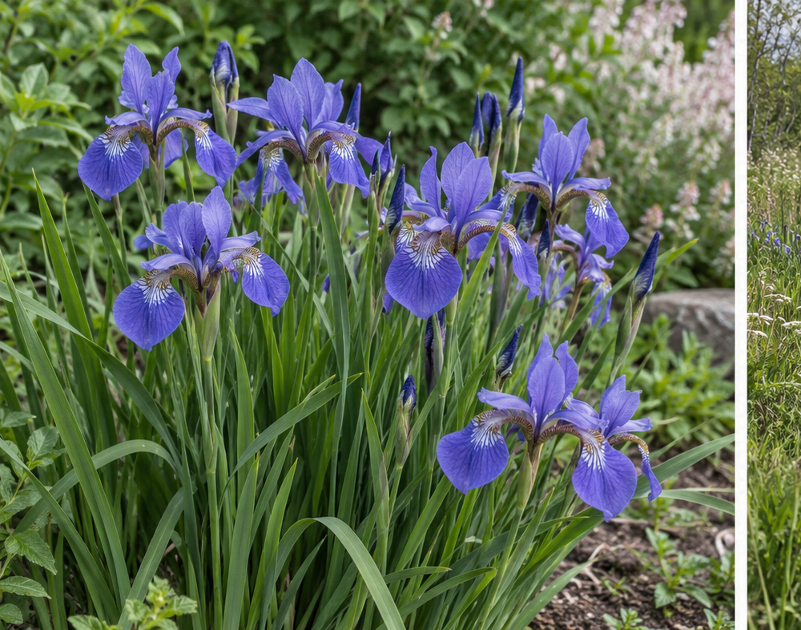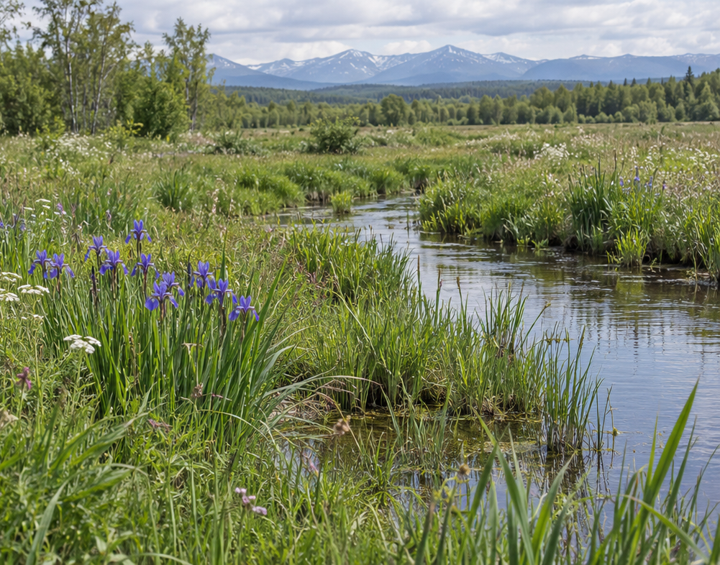
Left: garden close view. Right: illustrative Eurasian wet-meadow habitat. AI-generated visual; not a verified field record.

