SIBERIAN IRIS
Iris sibirica L. | Iridaceae | Herbaceous perennial
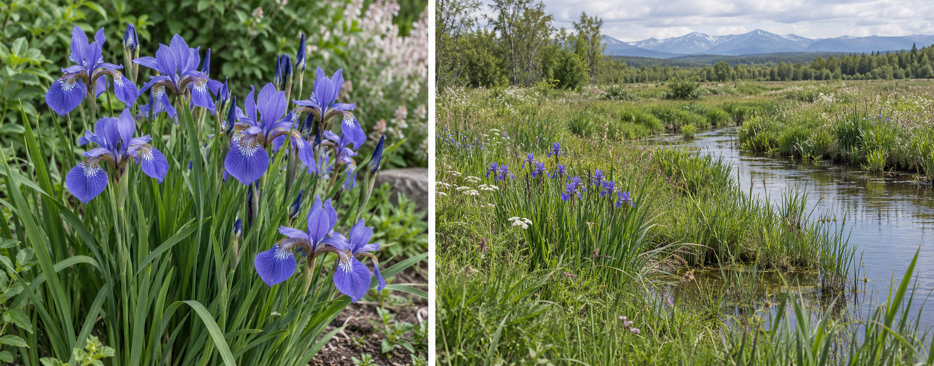
SUN • MOIST SOIL • LATE SPRING BLOOM
Light | Full sun for best bloom; partial shade tolerated.
Water | Keep evenly moist during spring growth; established plants tolerate some dry spells.
Size | Usually 2–3 ft tall; clumps about 2–3 ft wide. Cultivars vary.
Care | Divide crowded clumps every 3–5 years or when flowering declines. Leave foliage until it yellows.
Native status | Not native to Indiana, the Midwest, or North America; native to Europe and temperate Asia.
Safety | Iris is toxic to dogs, cats, and horses, especially rhizomes. Avoid ingestion; sap may irritate skin.
Soil mix | Garden bed: moisture-retentive soil amended with finished compost if needed. Container: 2 parts potting mix + 1 part compost + 1 part perlite or fine bark; keep moist.
Plant Education Project | Information Sheet companion | Research checked 12 October 2026

