Japanese Zelkova Information Package
  - Zelkova serrata | Keyaki | Elm family
Plant Education Project • W. Lafayette, Indiana • Reviewed 2026-09-23
Japanese zelkova needs room to become a large tree. This package connects identification, climate, native habitat, ecology, and growing practice so you can judge its fit before planting.
To understand the care of a plant, understand its native climate and environment.

1 Plant Information Sheet
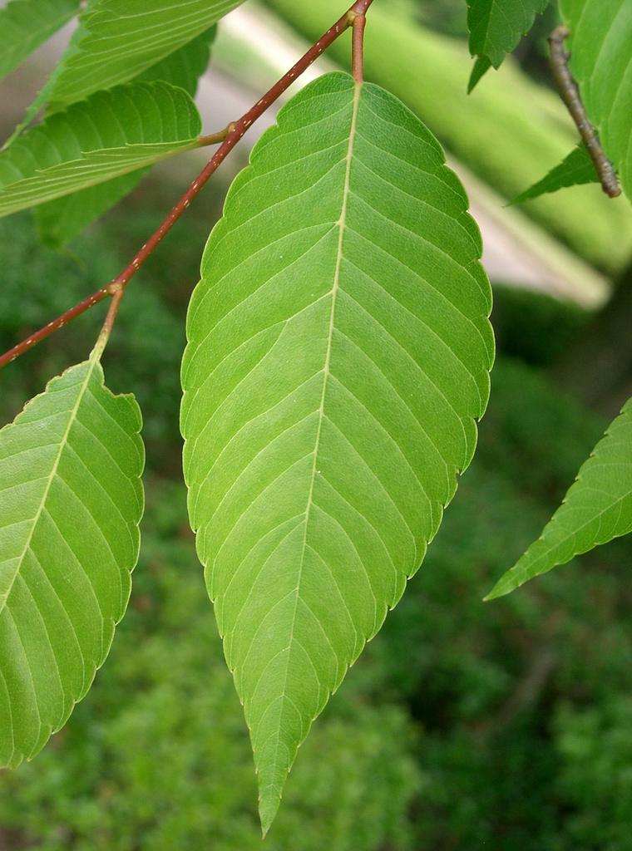
Japanese zelkova foliage. The side veins end at the toothed leaf margin. KENPEI, via NC State Extension, CC BY-SA 3.0. Uncropped; scaled for display.

At a glance
Feature | Guidance
Scientific name | Zelkova serrata (Thunb.) Makino [1]
Plant type | Deciduous shade tree; Ulmaceae [2]
Mature size | Typically 50–80 ft tall; crown may become similarly broad. Check the plant label. [2, 3]
Light and water | Full sun; moist soil with good drainage. Some drought tolerance after establishment. [2]
Cold hardiness | USDA zones 5–8 [2, 3]
Native to the United States | No [1]
Native to W. Lafayette | No; native to eastern Asia [1]
Invasive status | Local ecological status not established. Not on Indiana’s 44-species Terrestrial Plant Rule list; escape concerns exist elsewhere. [4, 5]
Self seeding | Yes, possible; local frequency is unmeasured. [5]
Edibility | Grow as an ornamental. No edible part is recommended in this package.
County occurrence | No verified Tippecanoe County wild record is claimed.
Main siting caution | Allow for a broad crown and roots; avoid overhead utilities and cramped planting spaces.

Identification
Look for alternate, simple leaves with toothed edges and veins running toward the teeth. The crown is often vase shaped. Older bark develops a mottled appearance as patches flake away; autumn leaves can turn yellow, orange, or reddish purple. [2, 3]
Use the scientific name when buying. Other zelkovas and true elms require their own profiles; a shared common name does not establish identity.
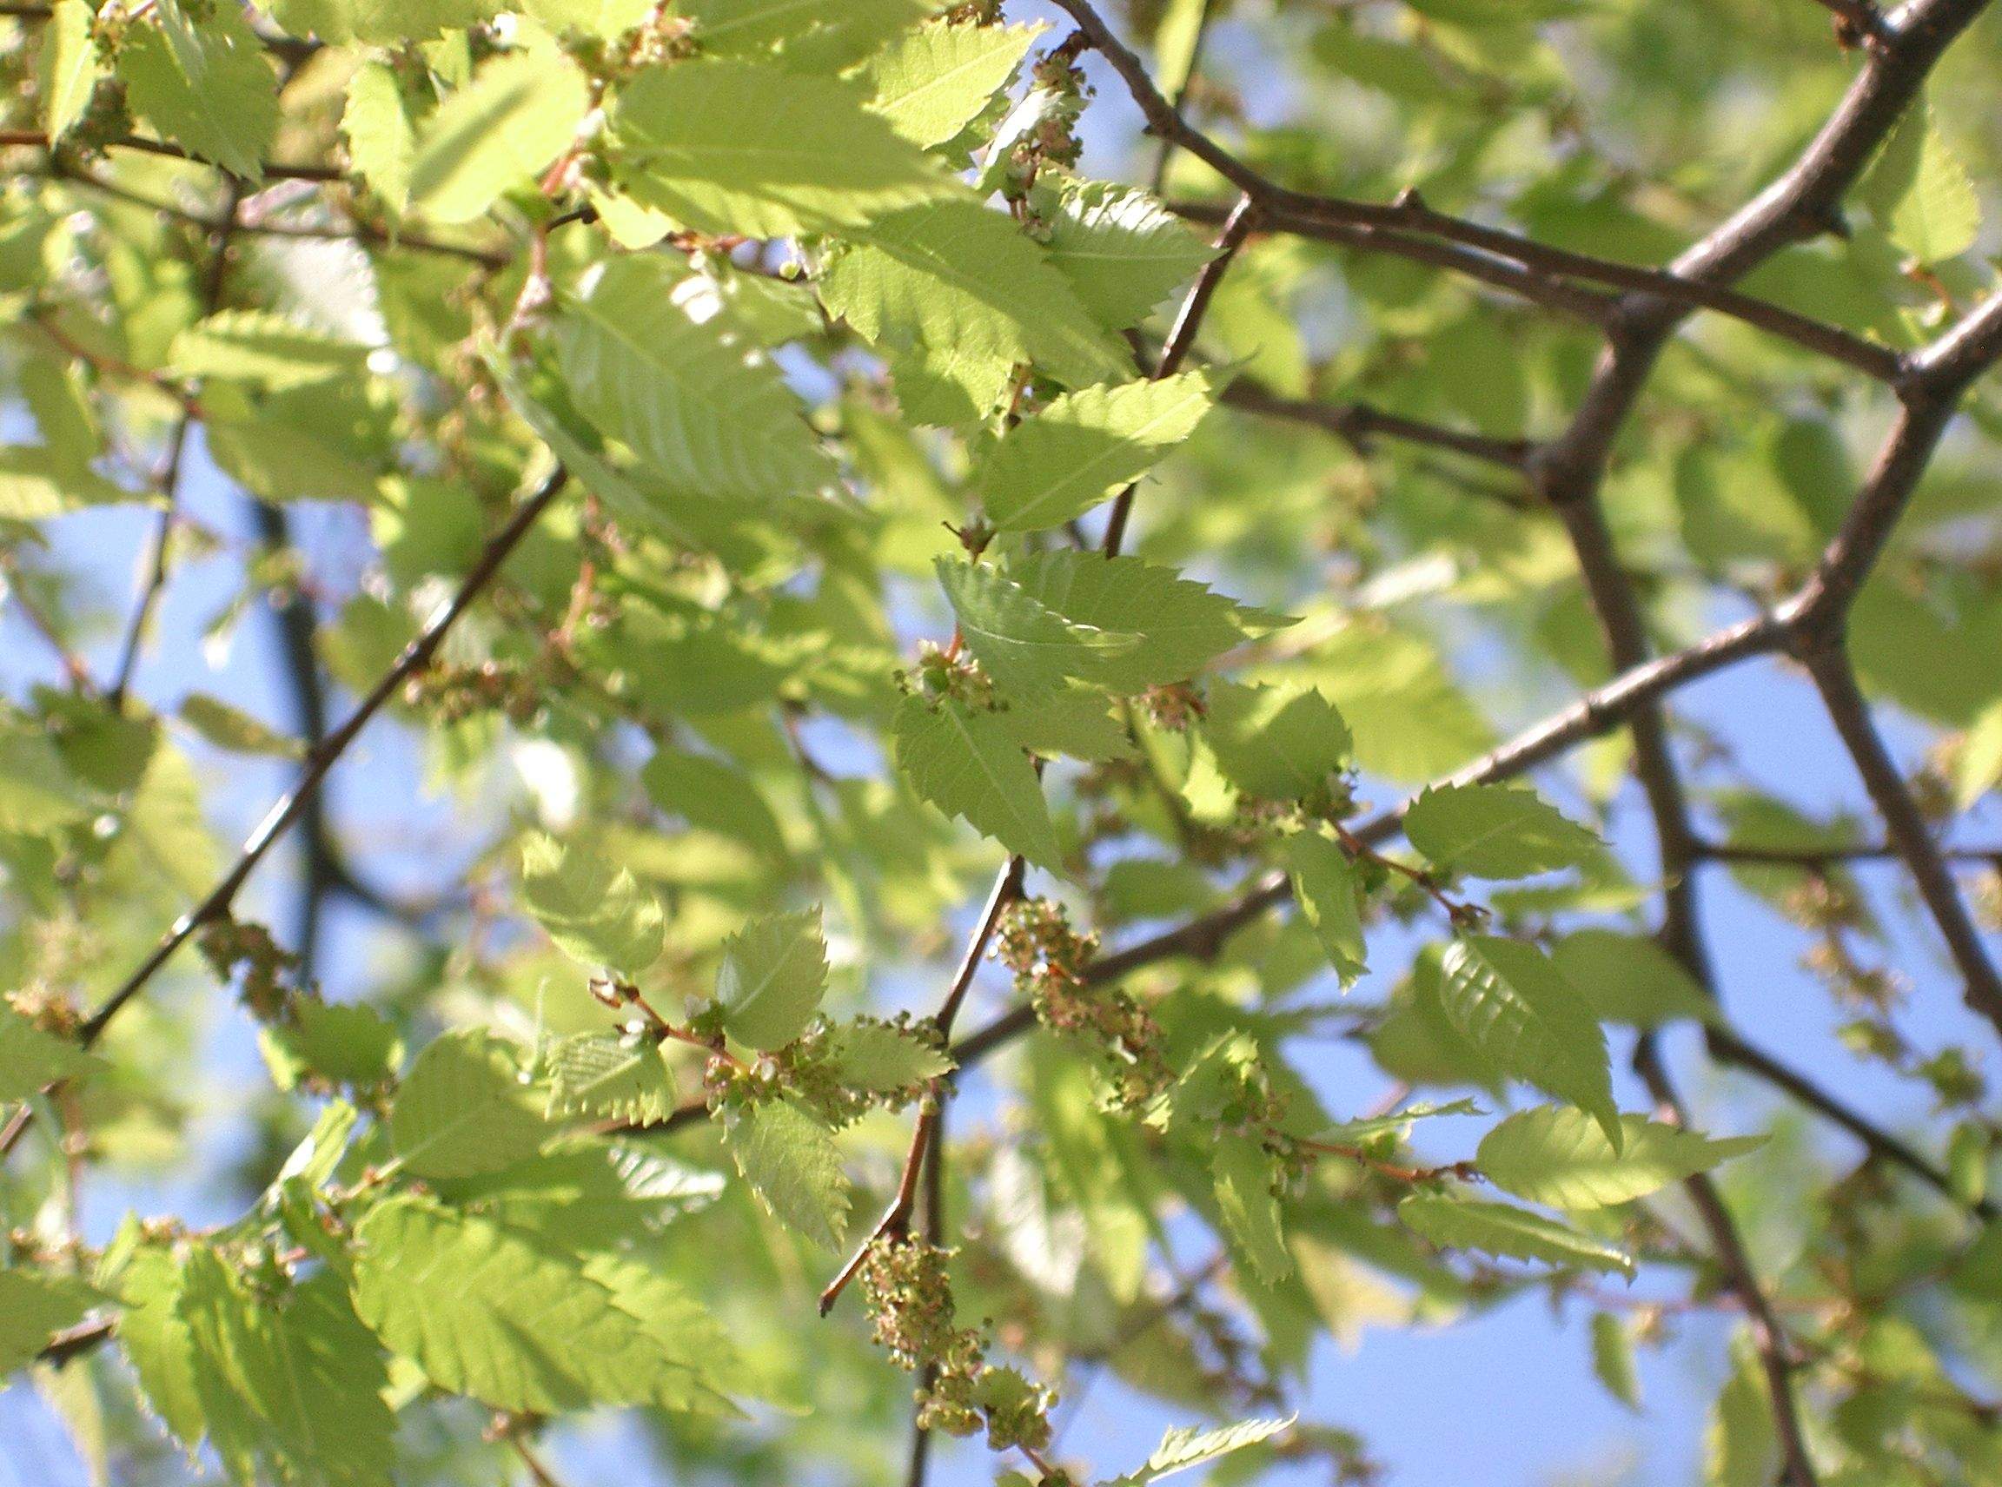
Small spring flowers and expanding leaves, Osaka, Japan. KENPEI, Wikimedia Commons, CC BY-SA 3.0. Uncropped; scaled for display.

Flowering and fruit
The small green flowers appear in spring and are easily overlooked. Small fruits called drupes follow. Flowering is not the tree’s main ornamental feature; foliage, branching form, and bark provide most of its visual interest. Local dates vary with the season. [2, 3]

2 Climate Information Sheet
Winter tolerance is only one part of suitability. A tree within its listed hardiness range can still struggle with saturated roots, drought, or a poorly chosen site.

Native range and seasons
Kew accepts this species and places its native range in eastern Asia, including Japan, Korea, parts of China, Taiwan, and the Kuril Islands. The range spans different elevations and climates, so one rainfall figure cannot describe every native population. [1, 6]
As a deciduous tree, zelkova grows leaves during its active season and loses them for winter. Apply this seasonal rhythm to outdoor landscape care. A small bonsai container needs a separate winter protection plan; the hardiness of a tree rooted in the ground does not describe an exposed pot.

Applying the hardiness rating locally
Zones 5–8 are the published cultivation range. Check the precise planting address on the USDA map. USDA zones describe average annual extreme minimum winter temperatures, not record lows or an assurance of survival. Heat, soil moisture, wind, and exposure also matter. [2, 3, 7]
Feature | Guidance
Spring | Check drainage after rain; watch new leaves after late cold spells.
Summer | Check moisture in the root ball as well as the surrounding soil before watering.
Autumn | Record leaf color and seedling appearance; continue moisture checks during dry weather.
Winter | Observe branch structure from the ground and inspect for storm damage when safe.

This seasonal checklist is a practical monitoring plan for W. Lafayette, not a prediction of exact flowering or watering dates. Morton Arboretum flags ice damage as a concern, reinforcing the value of sound branch structure. [3]

3 Environment Information Sheet
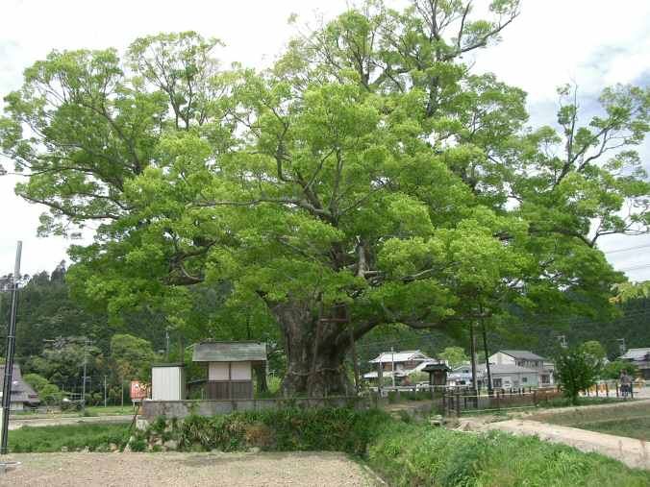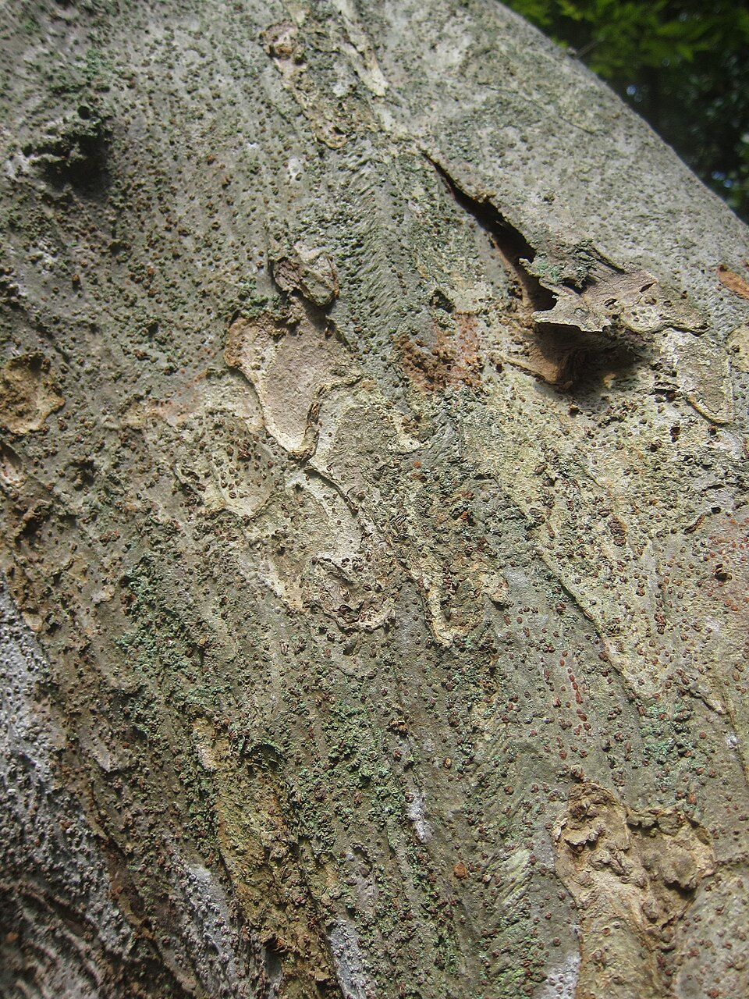
Left: Noma Keyaki, Osaka, Japan, by Miya, CC BY-SA 4.0. Right: mature bark in Enoshima, Japan, by Geographer, CC BY-SA 3.0. These show trees within the native range, not a verified wild forest stand. Uncropped; scaled for display.

Environment and native habitat
Native settings include moist woods, hillsides, and stream margins. The National Arboretum in Canberra describes populations on alluvial soils beside streams in lowland and mountain settings. Alluvial soil is material deposited by flowing water. This setting combines water supply with variation in drainage and elevation. [6, 8]
A specific example is the Kuimaru Pass protected zelkova forest in Fukushima, Japan. The Forestry Agency describes old zelkovas concentrated on the lower slopes, with oak forest higher up. The protected stand conserves genetic resources and relies on natural regeneration. [9]
See the Kuimaru Pass forest photographs for documented natural habitat.

Translate habitat into a planting site
Choose a generous soil area that holds useful moisture but drains. Morton Arboretum advises against wet sites. Streamside origin does not mean that a compacted, permanently waterlogged planting hole is suitable. [3, 6]
Before planting, measure the available canopy space, identify utilities, and examine drainage after a soaking rain. Do not rely on pruning to keep a naturally large tree permanently small. For a landscape tree, use the site’s soil as backfill; a special potting recipe belongs to container culture. [10]

4 Ecology Information Sheet

A shade tree and a habitat choice
A zelkova can supply shade and physical structure in a developed landscape. Those functions do not establish how well it supports Indiana’s specialist insects. Local food webs depend on particular plant relationships; being in the elm family is not proof that zelkova replaces every ecological role of a native elm. [11]
For a wildlife-focused planting, compare it with trees native to the planting location and suited to the soil. Confirm county records before labeling an alternative native to Tippecanoe County. Evaluate documented food-web relationships alongside shade and appearance.

Self seeding and responsible planting
Natural Land Institute reports self sowing and emerging invasion concerns, including increased seed production when different planted selections cross-pollinate. Indiana’s published 44-species rule does not list zelkova. These are different kinds of evidence: absence from that list does not establish ecological harmlessness. [4, 5]
Practical response: inspect beds and nearby woodland edges for seedlings, confirm their identity, and remove unwanted recruits while small. Avoid introducing this species into restoration sites intended to support native vegetation.

Conservation at home and abroad
A species may deserve protection in its native forests while requiring caution where introduced. The Japanese protected forest illustrates why preserving old trees, regeneration, and local genetic diversity matters. A planted ornamental elsewhere does not replace that forest community. [9]

A simple observation project
Mark a tree and record leaf emergence, flowering, fall color, and seedling recruitment through a year. Photograph any insects using it and distinguish feeding from resting. These observations can inform future sheets without turning an isolated sighting into a general claim.

5 Growing and Propagation Information Sheet

Establish the tree correctly
Locate the root flare before setting planting depth. Keep it at or slightly above the surrounding finished grade, correct circling roots, and backfill with the soil removed from the hole. Water thoroughly after planting. [10]
Spread 2–3 in of mulch over the planting area while leaving a clear gap around the trunk. Check moisture rather than watering on an unchanging calendar. Newly planted roots need attention even when an established tree of the same species tolerates drought. Avoid fertilizer during the first growing season. [10]

Build sound branches while young
Have crowded or competing major stems assessed early. University of Utah notes that branches can cluster at one point and recommends structural pruning while trees are young. Use a qualified arborist for large limbs or work near utilities. Dutch elm disease resistance does not mean immunity to every pest or disease. [2, 12]

Seed germination and light
Light is not an absolute germination requirement. Ishii’s 1979 study tested 0, 7, 15, 30, and 60 days of prechilling. Longer treatment improved germination and shortened the time to emergence. Diffuse light and alternating temperatures helped less-chilled seeds, but that advantage disappeared after 60 days of prechilling. [13]
Practical starting point: obtain fresh, correctly identified seed with a supplier’s storage and moist-chilling instructions. Treat roughly 60 days of moist chilling as a research-supported starting point, not a universal guarantee. Sow in a draining seed medium and keep it evenly moist. Avoid using a “must have light” label for this species. [13]
Keep a seed-lot record with source, collection date, chilling dates, sowing date, and number germinated. Seedlings vary; seed propagation does not guarantee the named parent’s form or autumn color.

When growth looks wrong
Feature | Guidance
Wilting or brown margins | Check moisture both inside and outside the original root ball before changing irrigation.
Persistent wet soil | Reassess drainage and planting depth; extra fertilizer does not correct lack of root aeration.
Crown dieback or bark cracks | Seek an assessment. NC State reports these symptoms in stressed urban plantings. [2]
Crowded branch junctions | Ask an arborist to plan structural pruning while corrective cuts remain small. [12]

References
Source numbers identify the supporting accounts. Planting and observation steps are practical adaptations for home landscapes. Links reviewed 2026-09-23.
[1] Kew Science. Plants of the World Online — accepted name and native range
[2] NC State Extension. Zelkova serrata — identification and cultivation
[3] The Morton Arboretum. Japanese zelkova — size, soil, hardiness, and ice damage
[4] Indiana DNR. Terrestrial Plant Rule — published 44-species list
[5] Alan Branhagen, Natural Land Institute. What Is the Big Deal About Invasive Plants — 2025 observations and concerns
[6] National Arboretum Canberra. Forest 84 — Japanese zelkova native habitat
[7] USDA Agricultural Research Service. How to Use the Maps — hardiness ratings and their limits
[8] Oklahoma State University Extension. Oklahoma Proven — Japanese zelkova habitat profile
[9] Japan Forestry Agency, Kanto Regional Forest Office. Kuimaru Pass zelkova genetic-resource conservation forest
[10] John E. Woodmansee, Purdue Extension. Arbor Day — Planting a Tree Correctly, 2024
[11] NC State Extension. Extension Gardener Handbook — Native Plants
[12] University of Utah. Tree Tour — Japanese zelkova and branch structure
[13] Yukio Ishii, 1979. Effect of light and temperature on the germination of Zelkowa serrata seeds with various prechilling times. Journal of the Japanese Forestry Society 61:362–366. DOI 10.11519/jjfs1953.61.10_362. English abstract via National Diet Library.

Photograph credits
All four photographs are reproduced uncropped and scaled for display. The two environment photographs show native-range trees; neither is presented as a documented wild stand. Full natural-habitat photographs are linked in the Environment sheet.
Foliage — KENPEI, via NC State Extension • CC BY-SA 3.0
Flowers — KENPEI, Zelkova serrata5.jpg • CC BY-SA 3.0
Noma Keyaki — Miya • CC BY-SA 4.0
Bark in Enoshima — Geographer • CC BY-SA 3.0

Plant Education Project

planteducationproject.com
QR destination is the project home page.
Sharing and reuse
© 2026 James Taylor · Plant Education Project. The original human-authored text in these Information Sheets is licensed under Creative Commons Attribution–NonCommercial 4.0 International (CC BY-NC 4.0).
https://creativecommons.org/licenses/by-nc/4.0/
You may share and adapt this text for noncommercial purposes. Credit the author and Plant Education Project, link to the source and license, and identify any changes. These permissions cannot be withdrawn from users who comply with the license, including for copies already released.
Photographs, illustrations, logos, quotations, and other third-party material are excluded from this text license and retain their individual rights and permissions. Separately published articles and book manuscripts are not licensed by this notice.

