Hens and Chicks Information Package
  - Sempervivum tectorum L.
Five connected Information Sheets for identification, climate, environment, ecology, and growing. Use this package to understand the plant and make practical growing decisions in Lafayette, Indiana.
Version 1.0 • Reviewed 2026-09-23
A hardy houseleek needs strong light and drainage. Begin with a reliable identification; the common name also applies to plants with different winter requirements.
Open the complete package online

Package contents
1 Plant
2 Climate
3 Environment
4 Ecology
5 Growing and Propagation

1 Plant
Grow this hardy houseleek outdoors in sun and a root zone that drains freely. This five-part package explains its identity, native setting, ecological relationships, and practical care in Lafayette, Indiana.
Online Plant sheet
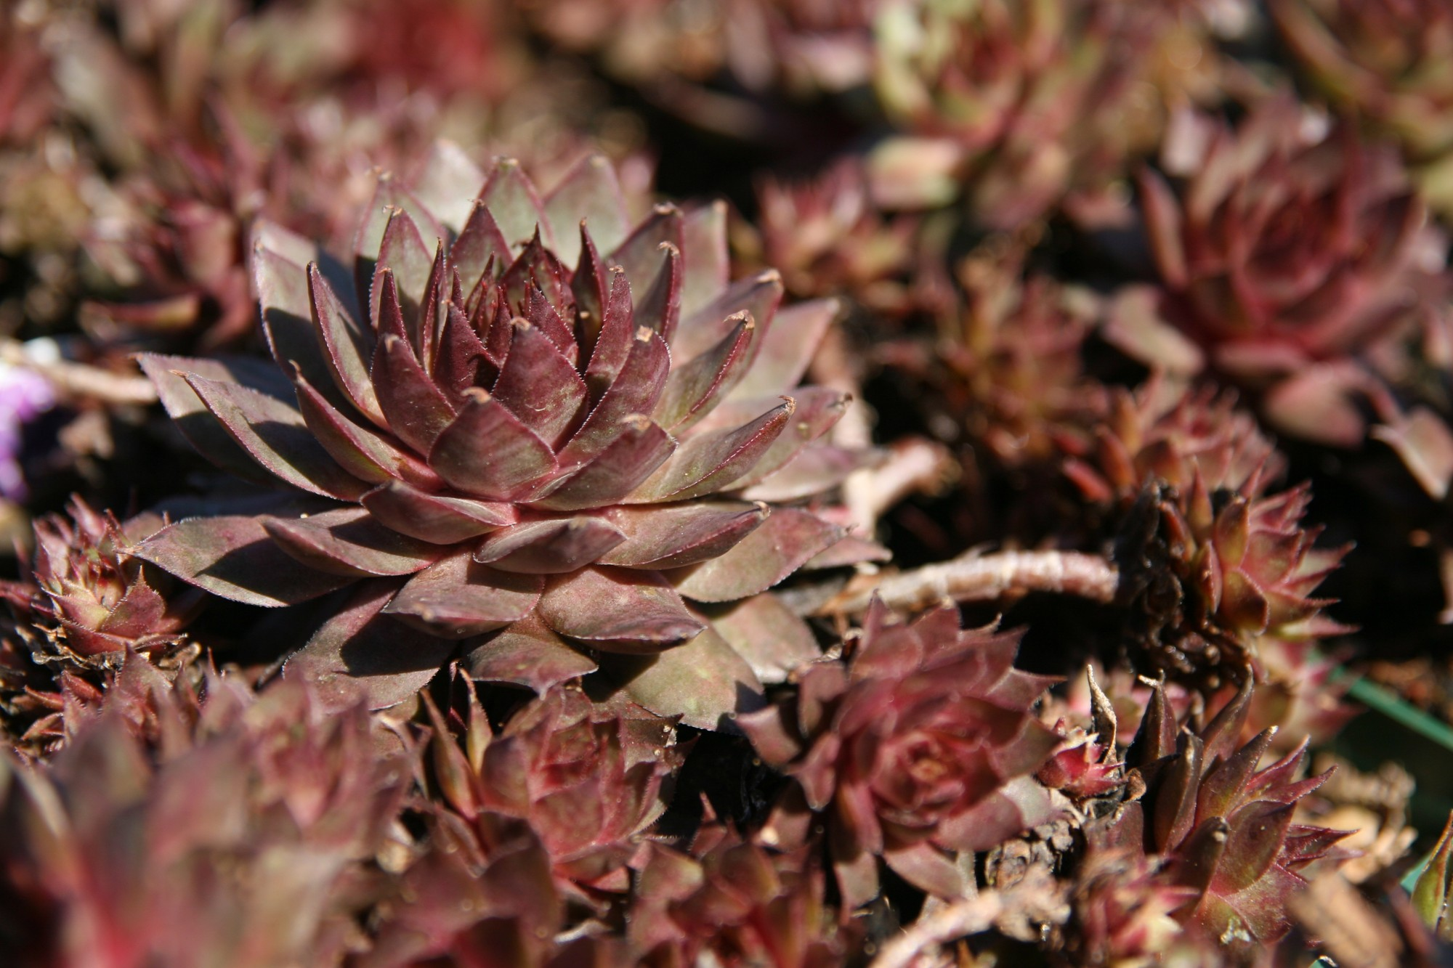
Sempervivum tectorum ‘Red Beauty’, a cultivated selection photographed at a Maryland nursery. Photograph: David J. Stang, Wikimedia Commons, CC BY-SA 4.0. Uncropped; resized for display.

At a glance
Feature | Guidance
Plant type | Hardy evergreen succulent
Light | Sun; light shade in extreme heat
Water | Dry between established-plant waterings
Mature size | Rosette about 4 in; stalk to 12 in
Growing setting | Outdoors preferred for hardy plants
Native to United States | No
Native to Lafayette area | No
Indiana invasive status | Not verified in this review
Self-seeding | Possible; local frequency unmeasured
Edibility | Not recommended as food
Principal caution | Sap may irritate skin; pet safety unverified
County occurrence | Tippecanoe wild record not verified

Identification and life cycle
Sempervivum tectorum L. belongs to the stonecrop family, Crassulaceae. Fleshy, pointed leaves form a low rosette; daughter rosettes develop on short connecting stems called stolons. Roots establish beneath the rosettes and offsets. A fixed root-depth figure is not established here.
Typical rosettes reach about 4 in (10 cm) across and foliage about 4 in high. Flower stalks can reach 12 in (30 cm); a colony may spread 6–18 in (15–45 cm). Size and leaf color vary among selections. A rosette may persist for years before flowering; the colony continues through its offsets.
Sources: Missouri Botanical Garden — species size, flowering and hardiness; NC State Extension — Sempervivum genus and sap caution.

Names and look alikes
This is a species profile, not a confirmed cultivar identification for every plant sold as Hens & Chicks. Retain a nursery label when available. The portrait shows the named cultivar Red Beauty as an example of rosette form.
Echeveria also has species called hens and chicks. Confirm the scientific name before applying outdoor winter advice. Color alone cannot establish a cultivar. Sempervivum arachnoideum and hybrids may have conspicuous cobweb-like hairs.
Sources: ASPCA — a common-name trap: its Hens and Chickens record is Echeveria elegans; NC State Extension — Sempervivum genus and sap caution.

Basic care
Choose strong light, an open drainage outlet, and modest fertility. Let an established plant’s root zone dry between thorough waterings. Check the soil before adding water after rain. Gradually increase sun exposure when moving a shaded plant outdoors.
Use the Growing and Propagation sheet for the mix recipe, new-offset care, seasonal calendar, and diagnosis guide.
Sources: NC State Extension — Sempervivum tectorum.
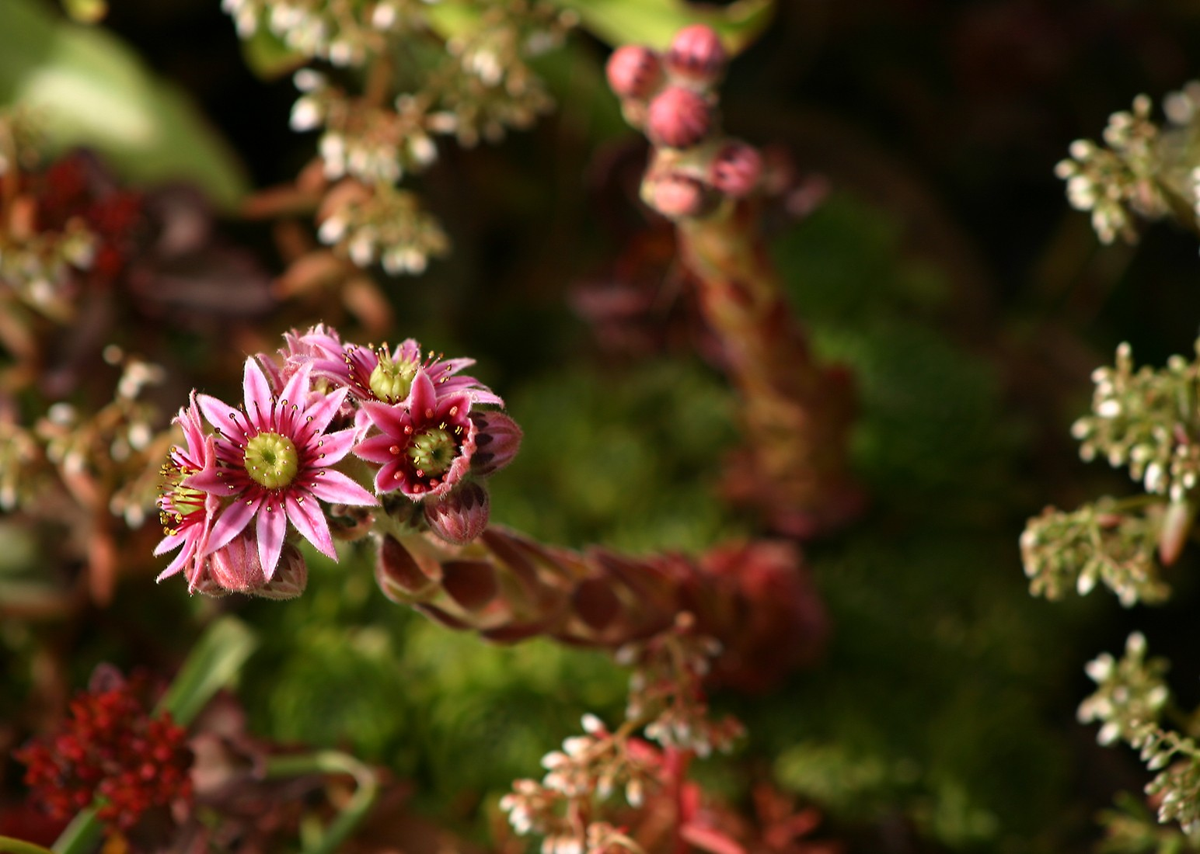
Pink, star-shaped flowers on a common houseleek grown in a garden in Randers, Denmark. Photograph: Malene Thyssen, Wikimedia Commons, CC BY-SA 3.0. Uncropped; resized for display.

Flowering and fruit
Summer stalks carry clusters of pink to reddish-purple, star-shaped flowers. Missouri Botanical Garden gives June–July as its flowering window; use that as a regional guide, not a promised Lafayette date. Dry fruits release small seeds. The flowering rosette then dies, while surviving offsets keep growing.
Sources: Missouri Botanical Garden — species size, flowering and hardiness.
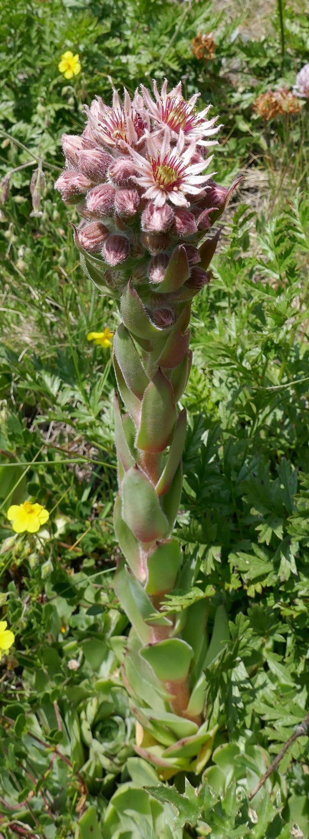
Common houseleek photographed in place near Val d’Isère in the French Alps. Photograph: Tiia Monto, Wikimedia Commons, CC BY-SA 4.0. Uncropped; resized for display.
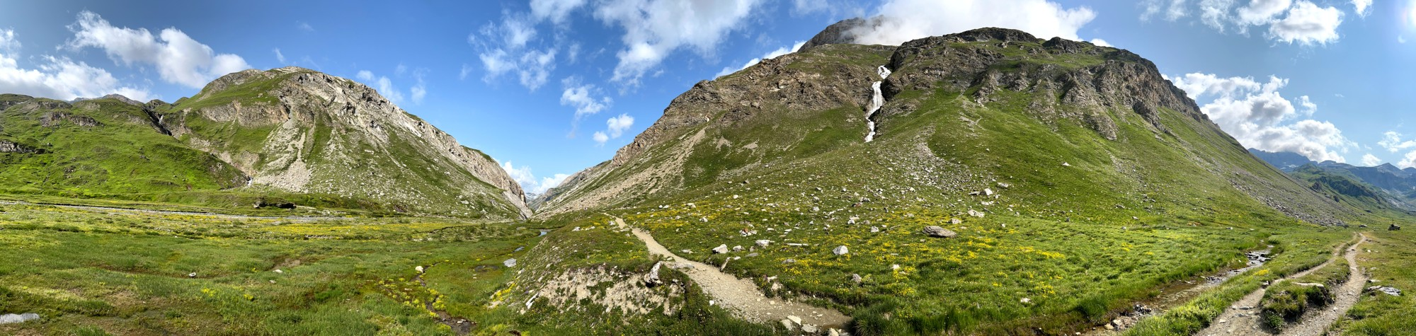
Alpine landscape in Vanoise National Park, France — regional context for the in-situ houseleek photograph. Photograph: Tiia Monto, Wikimedia Commons, CC BY-SA 4.0. Uncropped; resized for display.

Environment and native habitat
Kew places the native range from the Pyrenees to the western Balkan Peninsula. Rocky European sites illustrate the open light and drainage that matter in cultivation. The landscape photograph shows a representative setting; it does not establish plant presence everywhere in that view.
Continue with Environment and Climate for the distinction between local soil conditions and regional weather.
Sources: Kew Science — accepted name and native distribution.

Safety and responsible growing
Grow as an ornamental; do not use as food or medicine. NC State’s genus account reports possible skin irritation from sap. Avoid eye contact, wash after handling broken leaves, and use gloves if sensitive. The plant has pointed leaves rather than cactus spines.
Pet safety for this exact species is not verified by the sources used here. The ASPCA page called Hens and Chickens concerns Echeveria elegans; its non-toxic rating cannot be transferred by common name. Keep plants away from chewing pets and young children.
Use cultivated stock, retain unwanted offsets for sharing or dispose of them securely, and keep garden waste out of natural areas.
Sources: NC State Extension — Sempervivum genus and sap caution; ASPCA — a common-name trap: its Hens and Chickens record is Echeveria elegans.

Observe your plant
Photograph one marked rosette monthly with a ruler beside it. Record diameter, new offsets, leaf color, and any flower stalk. Follow both the flowering rosette and its neighbors so the life cycle becomes visible.

Sources and evidence
Reviewed 2026-09-23. Cultivation recommendations are adapted for home growers; unverified relationships are explicitly identified.
- Kew Science — accepted name and native distribution
- Missouri Botanical Garden — species size, flowering and hardiness
- NC State Extension — Sempervivum tectorum
- NC State Extension — Sempervivum genus and sap caution
- Indiana Plant Atlas — non-native status and specimen record
- ASPCA — a common-name trap: its Hens and Chickens record is Echeveria elegans

planteducationproject.com/hens-and-chicks/

2 Climate
Cold hardiness makes outdoor culture possible in Lafayette. Success still depends on the plant label, root-zone drainage, summer exposure, and the way the container or garden site behaves.
Online Climate sheet

Native climate and seasonality
This temperate European species occupies a broad mountain-region range. Elevation and slope exposure change temperature, rainfall, snow cover, and drying. One annual rainfall total or a single wet-and-dry-season schedule would misrepresent the whole range.
Winter slows growth while evergreen rosettes remain. Spring and summer offer the main opportunities for growth and reproduction. A dry planting pocket can occur within a region that receives substantial precipitation: rainfall and persistent root saturation are different conditions.
Sources: Kew Science — accepted name and native distribution; NC State Extension — Sempervivum genus and sap caution.

Documented cold tolerance
Missouri Botanical Garden lists USDA zones 3–8 for S. tectorum. RHS assigns H7 under its separate British rating system and advises protection from excessive winter wet. These are cultivation guides, not guarantees for every cultivar or exposed pot.
USDA zones describe the average annual extreme minimum winter temperature. They do not describe summer heat, humidity, rainfall, or the duration of freezing. Check the exact planting address and the plant’s label.
Sources: Missouri Botanical Garden — species size, flowering and hardiness; Royal Horticultural Society — Sempervivum tectorum profile; USDA — meaning and limitations of hardiness zones.

Comparison with Lafayette
Purdue identifies its Meigs research site in Lafayette as USDA zone 6a, a useful nearby reference. That supports trialing correctly identified, hardy plants outdoors. It does not certify every balcony or container.
Condition | Practical response
Cold and thawing weather | Keep drainage outlets clear and prevent water collecting around the crown.
Hot summer exposure | Inspect sun-facing pots; provide light afternoon shade if heat injury appears.
Rain and humid spells | Recheck soil moisture before watering; retain space for air movement.
Small exposed containers | Expect faster temperature and moisture changes; choose a sheltered outdoor position with drainage.
Indoor growing | Treat a warm, dim room as a different growing environment. Outdoor culture is the preferred starting point for a hardy houseleek.

Sources: Purdue Extension — Meigs research site in Lafayette, zone 6a; USDA — meaning and limitations of hardiness zones; NC State Extension — Sempervivum genus and sap caution.

What this means for growing it
Plan around actual conditions rather than a weekly watering appointment. Inspect the crown, test the mix, and note recent rain. Use the seasonal calendar to organize checks; adjust the dates to the season.

Observe the microclimate
For two weeks, record the time direct sun reaches and leaves the plant, recent rain, and whether the mix is damp before watering. Compare a sunny pot with a nearby garden planting without deliberately stressing either one.

Sources and evidence
Reviewed 2026-09-23. Cultivation recommendations are adapted for home growers; unverified relationships are explicitly identified.
- Kew Science — accepted name and native distribution
- Missouri Botanical Garden — species size, flowering and hardiness
- Royal Horticultural Society — Sempervivum tectorum profile
- USDA — meaning and limitations of hardiness zones
- Purdue Extension — Meigs research site in Lafayette, zone 6a
- NC State Extension — Sempervivum genus and sap caution

planteducationproject.com/hens-and-chicks/climate/

3 Environment
Build a sunny, freely draining planting pocket. Native rocky settings help explain the plant’s needs; the same conditions can be provided in a garden or container.
Online Environment sheet

Physical habitat
Rock fissures and open, stony ground provide rooting spaces with little competition from tall vegetation. The species is associated with European mountain regions, but a universal elevation limit is not assigned in this package. Long cultivation on walls and roofs also means that a European photograph alone does not prove a wild native population.
The two habitat photographs on the Plant sheet distinguish an in-situ plant view from a wider landscape.
Sources: NC State Extension — Sempervivum tectorum; Kew Science — accepted name and native distribution.

Site requirements
Light
Choose an open, sunny position. Consider light afternoon shade in an exceptionally hot exposure.
Substrate and drainage
Use a porous rooting medium with a clear path for excess water to leave. A gravel surface does not repair saturated soil underneath.
Moisture
Avoid persistent wetness around the crown. Establishing offsets need closer moisture checks than mature plants.
Soil reaction
RHS lists acid, neutral, and alkaline soils. Do not acidify a planting merely because one generic succulent recipe suggests it.
Terrain and exposure
A rock garden, raised pocket, or draining trough can work. Inspect low spots where runoff accumulates.
Sources: NC State Extension — Sempervivum tectorum; Royal Horticultural Society — Sempervivum tectorum profile; Royal Horticultural Society — growing and propagating Sempervivum.

Garden and container choices
Set rosettes at their existing soil level, with leaves above the wet surface. Use a container with an open drainage hole and room for offsets. Check the actual mix after rain; pot material, pot size, wind, and sun all affect drying.
For a bed, observe how water moves across the whole site before amending one small hole. A planting pocket surrounded by slowly draining soil can still hold water. Choose a raised position if needed.

What this means for growing it
Reproduce light, air, and drainage; do not try to copy a mountain’s appearance with decorative stones alone. The standard container recipe belongs in the growing sheet so there is one place to maintain it.

Test the planting site
After a normal rain or watering, record whether water escapes freely and whether the crown sits above puddled soil. Recheck the next day. Photograph any persistent wet spot before deciding whether the plant, pot, or location needs changing.

Sources and evidence
Reviewed 2026-09-23. Cultivation recommendations are adapted for home growers; unverified relationships are explicitly identified.
- NC State Extension — Sempervivum tectorum
- Royal Horticultural Society — Sempervivum tectorum profile
- Kew Science — accepted name and native distribution
- Royal Horticultural Society — growing and propagating Sempervivum

planteducationproject.com/hens-and-chicks/environment/

4 Ecology
A colony persists through offsets even though each flowering rosette eventually dies. Its value and behavior in an Indiana garden must be separated from its native European relationships.
Online Ecology sheet

Reproduction and spread
Offsets establish close to the parent and preserve its cultivar characteristics. Seed production adds genetic variation; seed-grown offspring may differ. A flowered rosette dies after its reproductive phase, leaving space for neighboring offsets.
Seeds emerge from dry fruits. A specific animal disperser has not been established here. Self-seeding is possible where conditions allow; local seedling frequency has not been measured. Keep this separate from visible spread by offsets.
Sources: NC State Extension — Sempervivum genus and sap caution; Royal Horticultural Society — growing and propagating Sempervivum.

Flowers and animals
Santa Fe Botanical Garden reports flower visits by butterflies and other insects. This supports observing the flowers as an insect resource; it does not establish a particular Indiana pollinator partnership.
No verified Tippecanoe County caterpillar-host relationship, important wildlife-food role, or species-specific shelter relationship is documented in this package. A visitor on a flower is not automatically evidence that the plant hosts its larvae.
Sources: Santa Fe Botanical Garden — houseleeks and observed flower visitors.

Competition and soil organisms
Keep taller neighbors from shading the rosettes. Small open patches allow offsets to establish; crowding changes light and available space. The response to fire or grazing is not sufficiently documented here to recommend either as management.
Species-specific fungal partners, nitrogen-fixing relationships, and benefits from purchased microbial inoculants are not verified in the reviewed sources. Do not add those claims to the care instructions.
Sources: Royal Horticultural Society — growing and propagating Sempervivum.

Native status and local evidence
The species is European, not native to the United States or Lafayette. The Indiana Plant Atlas labels it non-native and currently displays no specimens for its species entry. A Tippecanoe County wild occurrence therefore remains unverified in that source; absence of a specimen is not proof of absence.
Indiana invasive status has not been independently established in this review. A non-native label does not, by itself, establish invasiveness. Keep cultivation within managed spaces and monitor escapes.
A current global conservation assessment is not established here. Use propagated stock and leave wild populations undisturbed.
Sources: Kew Science — accepted name and native distribution; Indiana Plant Atlas — non-native status and specimen record.

What this means for growing it
Use houseleeks for an appropriate ornamental site and observe their actual visitors. For an Indiana habitat planting, select locally native plants with verified host and food relationships alongside any ornamental collection.

Watch without assuming
When flowers open, watch for ten minutes on three suitable days. Record date, time, weather, visitor type, and behavior. Photograph visitors if possible. Separately mark new seedlings and attached offsets to avoid counting both as self-seeding.

Sources and evidence
Reviewed 2026-09-23. Cultivation recommendations are adapted for home growers; unverified relationships are explicitly identified.
- NC State Extension — Sempervivum genus and sap caution
- Santa Fe Botanical Garden — houseleeks and observed flower visitors
- Indiana Plant Atlas — non-native status and specimen record
- Kew Science — accepted name and native distribution
- Royal Horticultural Society — growing and propagating Sempervivum

planteducationproject.com/hens-and-chicks/ecology/

5 Growing and Propagation
Start with a healthy, correctly identified plant. Provide drainage, establish new offsets carefully, and let observed conditions set the watering interval.
Online Growing and Propagation sheet

Standard container mix
Mix by volume: 1 part peat-free potting medium, 1 part loam-based potting medium, and 1 part washed coarse horticultural sand. This adapts the RHS three-part recipe without product names. Use graded horticultural material, not fine sand or unverified builders’ sand.
Use an open drainage hole. If the mixture stays wet under your conditions, revise the mix or location before adding another watering. See Standard Potting Mixes for general principles.
Sources: Royal Horticultural Society — growing and propagating Sempervivum.

Planting and ongoing care
Plant at the previous soil level. Water an established plant thoroughly when its root zone has dried, then allow drainage. In-ground plants need little feeding; container plants may need modest feeding during active growth according to the fertilizer label.
In spring, inspect crowded containers and repot or divide as needed; RHS suggests reviewing displays every two to three years. Remove spent flower stalks and dead rosettes without damaging live offsets. Avoid routine winter watering of exposed outdoor plants.
Sources: Royal Horticultural Society — growing and propagating Sempervivum; NC State Extension — Sempervivum tectorum.

Propagate by offsets
- In spring, select a healthy offset, preferably one with roots.
- Gently separate it, retaining roots, and set it into a small draining pot of gritty medium.
- Keep it in bright shelter from strong direct sun. Keep the rooting medium lightly moist, never saturated.
- After roots establish and new growth appears, gradually introduce stronger light and the established-plant watering routine.
RHS gives about four to six weeks as a typical rooting period. Conditions and offset size change the timing. Offsets are the preferred method for retaining a named cultivar.
Sources: Royal Horticultural Society — growing and propagating Sempervivum.

Seed germination and light
Surface-sow; do not bury the tiny seeds. A seed producer’s mixed-Sempervivum protocol specifies light for germination and about 70°F (21°C), often with emergence in four to five weeks. Keep the seed surface moist without flooding it.
This is a practical starting protocol for a mixed seed lot, not a demonstrated requirement for every S. tectorum accession. Follow the lot’s instructions. The producer reports chilling is often unnecessary; do not treat cold stratification as universally required. Record sowing conditions, emergence dates, and the fraction that germinates. Seedlings may differ from their parents.
Sources: Seed producer sowing protocol — Sempervivum mixed seed.

Lafayette seasonal calendar
For established hardy plants outdoors. These are working windows; adjust to actual growth, soil condition, and weather.
Season | Watch for | Actions
March–May | New growth and offsets | Clear trapped debris; check drainage; divide and establish offsets once conditions permit.
June–August | Flower stalks and possible seed ripening | Observe visitors; water only after checking the root zone; assess hot pots.
September–November | Slower growth and changing leaf color | Clear fallen leaves; confirm drainage; place exposed pots in a suitable winter position.
December–February | Slow growth and wet or frozen soil | Check runoff and outlets; avoid routine watering and feeding.

Troubleshooting
Use the checks to narrow the cause before treating. The suggested actions are practical guidance, not a diagnosis from appearance alone.
Symptom | Possible cause | Check and action
One rosette dies after blooming | Normal life cycle | Look for its spent stalk and healthy offsets; remove dead material.
Several soft or blackening crowns | Rot associated with persistent wetness | Inspect roots, outlets, and soil moisture; isolate damaged material and correct drainage.
Open, stretched growth | Insufficient light | Check sun hours; move gradually into stronger light.
Thin, wrinkled leaves | Drought or impaired roots | Check both moisture and root condition before adding water.
Rust-colored pustules or feeding damage | Possible disease or pest | Photograph the damage and identify its cause before treatment.

Sources: NC State Extension — Sempervivum tectorum; Missouri Botanical Garden — species size, flowering and hardiness.

Keep a propagation record
Label each pot with parent identity, method, and start date. Record mix proportions, watering, root establishment, and losses. Compare batches only when their light, temperature, and starting material are reasonably similar.

Sources and evidence
Reviewed 2026-09-23. Cultivation recommendations are adapted for home growers; unverified relationships are explicitly identified.
- Royal Horticultural Society — growing and propagating Sempervivum
- NC State Extension — Sempervivum tectorum
- Missouri Botanical Garden — species size, flowering and hardiness
- Seed producer sowing protocol — Sempervivum mixed seed

planteducationproject.com/hens-and-chicks/growing/

Revision record
2026-09-23 • Version 1.0. Introduced the five-part package, seasonal care, observation activities, troubleshooting, and the Word edition. Clarified species identification, local evidence limits, germination guidance, and photograph credits.
© 2026 James Taylor • Plant Education Project. Original text may be shared for educational, noncommercial use with attribution. Photographs remain subject to their individual licenses; their source and license links accompany each image.
Sharing and reuse
© 2026 James Taylor · Plant Education Project. The original human-authored text in these Information Sheets is licensed under Creative Commons Attribution–NonCommercial 4.0 International (CC BY-NC 4.0).
https://creativecommons.org/licenses/by-nc/4.0/
You may share and adapt this text for noncommercial purposes. Credit the author and Plant Education Project, link to the source and license, and identify any changes. These permissions cannot be withdrawn from users who comply with the license, including for copies already released.
Photographs, illustrations, logos, quotations, and other third-party material are excluded from this text license and retain their individual rights and permissions. Separately published articles and book manuscripts are not licensed by this notice.

